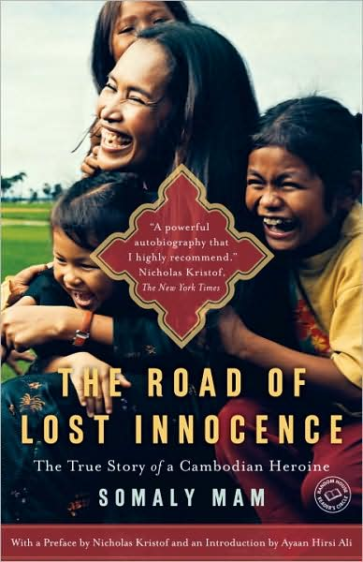
Reading the Globe
The TAMIU Freshman Experience
Fall 2010 Essay Competition for
“The Road of Lost Innocence”
Trip to Cambodia
As part of TAMIU’s “Reading the Globe: The TAMIU Freshman Experience,” students will have the opportunity to compete for a paid trip to Cambodia during Spring Break 2011. Students will bisit Phnom Penh, Siem Reap, and the famous temple Angkor Wat as well as other important historical sites and will participate in service learning activities. A two day rural home stay will be included.
ESSAY COMPETITION GUIDELINES:
You must be a first time freshman in Fall 2010 and be 18 years old prior to travel departure date.
Length: 1000-15 – words Format: MS Word
Deadline: October 11, 2010, Midnight. Submitted electronically on Angel in the “Reading the Globe, Fall 2010, Essay Competition” drop box.
Selection Process: Each essay that meets the submission guidelines will be read by committee. The top 25 essays will be selected; these students will be scheduled for an interview, then 15 will be chosen to go on the trip. A list of ranked alternates will be in place should some of the chosen students not be able to travel.
Essays will be chosen for their personal, thoughtful, well-written reaction or response to the following topic: “How has reading “The Road of Lost Innocence” influenced your view of the world and your particular place in it?”
Travel Dates: Spring Break 2010, March 11th – 20th
Travel Requirements: Malaria medication as a preventive measure, a current Passport, visa, and personal spending money. Students who are allergic to peanuts and bee or ant stings should not participate.

