TEXAS A&M INTERNATIONAL UNIVERSITY



BIOLOGICAL SAFETY PROGRAM MANUAL

TABLE OF CONTENTS

I. Biosafety Oversight 1
II. Roles and Responsibilities 1
III. Biosafety Principle and Working in the Laboratory 3
IV. CDC and NIH Biosafety Levels 4
V. Recombinant DNA Research 6
VI. Risk Assessment 7
VII. Biohazard Signage 8
VIII. General Biosafety Guidelines: Standard Microbiological Practices 9
IX. General Biosafety Guidelines: Special Microbiological Practices 14
X. Biological Safety Cabinets (BSCs) 15
XI. Clean Benches 20
XII. Vacuum Aspiration of Biohazardous Materials 20
XIII. Centrifuge Safety 21
XIV. Cleaning, Disinfection, and Sterilization 22
XV. Importing and Shipping Biological Materials 28
XVI. Biological Spill Response 28
XVII. Incident Response and Reporting 29
XVIII. Biohazardous Waste Disposal 30

Biosafety Oversight

As required by Texas A&M System Regulation (15.99.06 Use of Biohazardous Material in Research, Teaching and Testing) and the University’s Rule (15.99.06.L1 Use of Biohazardous Material in Research, Teaching, and Testing), Texas A&M International University (TAMIU) Institutional Biosafety Committee (IBC) approval is required for all research, teaching, or testing activities conducted by faculty or staff of TAMIU prior to initiating work with:
- Biological agents (bacteria, rickettsia, fungi, viruses, protozoa, parasites, and prions) that may cause disease in humans, animals or plants;
- Recombinant or Synthetic Nucleic Acid Molecules as defined in the National Institutes of Health (NIH) NIH Guidelines for Research Involving Recombinant or Synthetic Nucleic Acid Molecules (NIH Guidelines), and plant pests as defined by the U.S. Department of Agriculture (USDA) Animal and Plant Health Inspection Service (APHIS) and the Coordinated Framework for Regulation of Biotechnology;
- Human and non-human primate blood, tissue, cells, and cell lines;
- Toxins of biological origin as defined in the Biosafety in Microbiological and Biomedical Laboratories (BMBL) document.

The following information is provided to assist TAMIU Departments in developing procedures to meet biological safety requirements to protect students, employees, and the environment. This program sets forth recommended minimum requirements that need to be followed to maximize the safety of all workers.

Roles and Responsibilities

TAMIU is committed to protecting faculty, staff, students, visitors, the general public, and the environment from the risk of exposure to biohazardous materials, and to ensuring that all activities involving biohazardous materials and the facilities used to conduct such work are in compliance with applicable federal and state laws, regulations, and guidelines.

- Institutional Official (IO)
  - The President has appointed the Provost and VP for Academic Affairs to serve as the Institutional Official (IO) with administrative authority to commit institutional resources to ensure that use of biohazardous materials will comply with system, state, and federal requirements.
  - The IO has been delegated authority by the President to appoint members to and remove members from the Institutional Biosafety Committee (IBC).
  - The IO ensures ongoing compliance with applicable state and federal law and may collaborate with appropriate institutional officials to place sanctions on faculty failing to comply with these laws or failing to comply with System policies and regulations and TAMIU procedures and guidelines.

- Institutional Biosafety Committee
  - The IO shall ensure the IBC meets the membership requirements articulated in the current version of the NIH Guidelines.
  - The IBC is responsible for developing written procedures, including procedures relating to the review of Biohazardous Material protocols and reporting guidelines.
  - The IBC is responsible for the review and approval of all activities involving the use of biohazardous materials, for assessing and setting containment levels for activities utilizing biohazardous materials, and for notifying faculty of the outcome of this review.
  - The IBC will regularly review approved research, teaching, and other activities at intervals appropriate to the degree of risk, but no less than once per year.
  - The IBC will review activities involving the use of biohazardous materials in accordance with the criteria outlined in the most current versions of the NIH Guidelines, select agent regulations, the BMBL, and other federal, state, and TAMIU rules and procedures.
  - The IBC may suspend or terminate approval for use of biohazardous materials if such use poses a risk to personnel, public health and safety, or for issues of non-compliance.
  - The IBC Chair in coordination with the Office of Research and Sponsored Projects will maintain IBC registration with the NIH at all times, even if not required by federal requirements.
  - The storage and use of biohazardous materials within TAMIU, whether for research, teaching, or testing purposes, shall be described in an IBC Protocol Application (Protocol). The Protocol is a form designed to capture relevant information regarding the appropriate use of the biohazardous materials in research, teaching, or testing activities.
  - IBC approval is required prior to possession or use of biohazardous materials.
  - All modifications to approved storage and use of biohazardous materials must be approved prior to initiation of the changes.
  - The IBC Chair shall be responsible for registering with either the Department of Health and Human Services (HHS)/Centers for Disease Control and Prevention (CDC)/Division of Select Agents and Toxins (DSAT) or U.S. Department of Agriculture (USDA)/Animal and Plant Health Inspection Service (APHIS)/Agriculture Select Agent Services (AgSAS) (collectively known as the Federal Select Agent Program) prior to possession, use, or transfer of any select agent or toxin, including receipt of select agents and toxins from outside the United States.

- Biological Safety Officer (BSO)
  - The IO shall appoint a Biological Safety Officer (BSO) if TAMIU engages in large-scale research or production activities involving viable organisms containing recombinant or synthetic nucleic acid molecules.
  - The BSO’s duties include, but are not limited to, those articulated in the most recent version of the NIH Guidelines.

- Principal Investigator (PI): are primarily responsible for compliance with all federal and state laws and regulations involving activities covered by TAMIU Rule and are responsible for:
  - assuring all responsibilities of PIs as articulated in the most recent version of the NIH Guidelines are met;
  - assuring all activities with biohazardous materials are appropriately reviewed and approved prior to initiation of any activities or changes to approved activities. Regardless of funding sources, a Protocol must be prepared and signed by the PI and must be reviewed and approved by the IBC. If research is collaborative or involves other institutions, approval must be obtained from each institution;
  - assuring conduct of research, teaching, or testing activities involving biohazardous materials is restricted to that described in the approved Protocol or approved amendments and is in congruence with funding grants, if applicable;
  - assuring all participants in activities with biohazardous materials are appropriately qualified through training and education to perform their responsibilities as listed in the Protocol;
  - assuring all participants in activities with biohazardous materials are enrolled in an Occupational Health and Safety program, if required by their approved Protocol;
  - abiding by all determinations of the IBC including, but not limited to, directives to terminate participation in designated research, teaching, or testing activities;
  - notifying the IBC as soon as possible after the discovery of any reportable incident or noncompliance that involves biohazardous materials.

Biosafety Principle and Working in the Laboratory

The primary principle of biological safety (i.e., biosafety) is containment. The term containment refers to a series of safe methods for managing infectious agents in the laboratory. Containment aims to reduce the possibility of agents from being released into the environment outside the laboratory, to prevent transmission of the biological agents being handled in the lab to laboratory personnel exposure, and to protect the biological integrity of the agents in use. Containment is achieved by a combination of good laboratory practices and techniques, proper use of safety equipment and adequate facility design and construction. Four distinct biosafety levels are designed to effectively contain biohazards based on their risk; each biosafety level builds upon the controls of the preceding levels.

- Primary and Secondary Containment
There are two levels of biological containment--primary and secondary. Primary containment protects people and the immediate laboratory environment from exposure to infectious agents. Good microbial techniques and safety equipment provide sufficient primary containment. Examples of primary barriers include safety equipment such as biological safety cabinets, enclosed containers, and safety centrifuge cups. Occasionally, when it is impractical to work in biological safety cabinets, personal protective equipment, such as lab coats and gloves may act as the primary barrier between personnel and infectious materials.

Secondary containment protects the environment external to the laboratory from exposure to infectious materials. Good facility design and operational practices provide secondary containment. Examples of secondary barriers include work areas that are separate from public areas, decontamination facilities, handwashing facilities, special ventilation systems, and airlocks.

- Elements of Containment
Ultimately, the three key elements of biological containment are laboratory practices, safety equipment, and facility design. To ensure minimal exposure, employees must assess the hazards associated with their work and determine how to apply the biosafety principle appropriately.

IMPORTANT:
Employees working with infectious agents or potentially infectious materials must be aware of the hazards associated with their work. These workers must be trained and proficient in biosafety procedures and techniques.

CDC and NIH Biosafety Levels

The Centers for Disease Control (CDC) U.S. Department of Health and Human Services (HHS) and the National Institute of Health (NIH) guidance document, Biosafety in Microbiological and Biomedical Laboratories (BMBL) have established four biosafety levels consisting of recommended laboratory practices, safety equipment, and facilities for various types of infectious agents. Each biosafety level accounts for the following:
- Operations to be performed
- Known and suspected routes of transmission
- Laboratory function

  - Biosafety Level One (BSL-1)
Biosafety Level 1 is the most basic level of containment and is appropriate for well-characterized agents not known to consistently cause disease in healthy adults and which present no more than a minimal hazard to the environment and laboratory personnel At, BSL-1, lab work is typically conducted on the open bench and precautions rely on standard microbial practices without special primary or secondary barriers. BSL-1 criteria are suitable for undergraduate and secondary education laboratories.

  - Biosafety Level Two (BSL-2)
Biosafety Level 2 is suitable for work with biological agents known to cause disease (of varying severity) in humans. Biological agents requiring BSL-2 containment are not typically transmitted by aerosols in nature, rather transmission of these agents generally occurs by ingestion, percutaneous or mucous membrane exposure. BSL-2 containment differs from BSL-1 containment in that personnel require enhanced training and supervision when handling disease causing pathogens and procedures resulting in aerosol generation must be conducted inside a biosafety cabinet (BSC) or other containment equipment. Access to BSL-2 labs should be restricted to personnel who meet all entry requirements. BSL-2 precautions are necessary when working with human blood, body fluids, or tissues where the presence of an infectious agent is unknown.

  - Biosafety Level Three (BSL-3)
Biosafety Level 3 is required for work with biologically hazardous agents transmitted by the aerosol route. Agents worked with in a BSL-3 laboratory cause serious diseases which have the potential to be lethal. Often these diseases are treatable with antibiotics and may be preventable by vaccination, but nevertheless, enhanced training and precautions are necessary to protect personnel. BSL-3 differs from BSL-2 in that all manipulations of biohazardous agents at this biosafety level must be limited to the BSC or other primary containment. Additionally, BSL-3 labs have specialized design and engineering features. Personnel who work in BSL-3 labs must receive agent- and laboratory-specific training and be part of a robust mentoring program.

  - Biosafety Level Four (BSL-4)
Biosafety Level 4 is required when working with exotic biohazards known to cause life threatening, generally untreatable diseases in humans for which no vaccinations are available. There are two models for BSL-4 laboratories. Personnel conduct all work with agents inside a Class III BSC or personnel must wear a positive pressure supplied-air protective suit and conduct all work with agents inside a Class II BSC. BSL- 4 labs have highly specialized engineering features to contain microorganisms inside the lab and prevent their release into the environment. Personnel who work at BSL-4 require specialized training and mentoring to ensure they understand how to work safely with extremely dangerous and exotic agents and how to properly perform the procedures requiring BSL-4 containment. In addition, isolated facilities, specialized ventilation, and waste management systems are required.

IMPORTANT:
Currently, TAMIU does not own or operate a Biosafety Level 3 or 4 lab. If Level 3 or 4 labs are needed, prior consultation regarding purchase, installation and maintenance of safety equipment is needed, as there is no containment facility or facility design currently available for research.

Table 1: Biosafety Summary

BSL Level | Agent Characteristics | Special Practices | Primary Barrier and Personal Protective Equipmentª | Facilities (Secondary Barriers)ª
1 | Well-characterized  agents not known to consistently cause disease in immunocompetent adult humans and present minimal potential hazard to laboratory personnel and the environment. | Standard microbiological practices | No primary barriers required; protective laboratory clothing; protective face, eyewear, as needed | Laboratory doors; sink for handwashing; laboratory bench;  windows fitted with  screens; lighting adequate for all activities
2 | Agents associated with human disease and pose moderate hazards to personnel and the environment | Limited access; occupational medical services including medical evaluation, surveillance, and treatment, as appropriate; all procedures that may generate an aerosol or splash conducted in a BSC; decontamination process needed for laboratory equipment | BSCs or other primary containment device used for manipulations of agents that may cause splashes or aerosols; protective laboratory clothing; other PPE, including respiratory protection, as needed | Self-closing doors; sink located near exit; windows  sealed or fitted with  screens; autoclave available
3 | Indigenous or exotic agents; may cause serious or potentially lethal disease through the inhalation route of exposure | Access limited to those with need to enter; viable material removed from laboratory in primary and secondary containers; opened only in BSL-3 or ABSL-3 laboratories; all procedures with infectious materials performed in a BSC | BSCs for all procedures with viable agents; solid front gowns, scrubs, or coveralls; two pairs of gloves, when appropriate; protective eyewear, respiratory protection, as needed | Physical separation from access corridors; access through two consecutive self-closing doors; hands-free sink near exit; windows are sealed; ducted air ventilation system  with negative airflow  into laboratory; autoclave available, preferably in laboratory
4 | Dangerous and exotic agents that pose high individual risk of aerosol-transmitted laboratory infections and life-threatening disease that are frequently fatal, for which there are no vaccines or treatments; and related agents with unknown risk of transmission | Clothing change before entry; daily inspections of essential containment and life support systems; all wastes decontaminated prior to removal from laboratory; shower on exit | BSCs for all procedures with viable agents; solid front gowns, scrubs, or coveralls^{b} gloves^{b} full-body, air-supplied, positive-pressure suit^{c} | Entry sequence; entry through airlock with airtight doors^{c} walls, floors, ceilings  form sealed internal shell; dedicated, non-recirculating ventilation system required; double-door, pass-through autoclave required
- Each successive BSL contains the recommendations of the preceding level(s) and the criteria in the cell.
- Applies to Cabinet Laboratory
- Applies to Suit Laboratory

  - Animal Biosafety
Four biosafety levels are also described for infectious disease work with laboratory animals. Safety practices, equipment, and facilities are designated by Animal Biosafety Levels 1, 2, 3, and 4. Refer to the TAMIU Institutional Animal Care and Use Guidelines for more information regarding the use of hazardous materials with laboratory research animals.

Recombinant DNA Research

TAMIU is obligated to ensure that all recombinant DNA (rDNA) work conducted by its faculty and staff conforms to Federal rDNA guidelines. This task falls jointly to the TAMIU’s Institutional Biosafety Committee (TAMIU’s IBC) and TAMUS Biological Safety Officer (BSO). TAMIU’s IBC reviews all protocols involving rDNA, rules on the appropriateness of proposed containment procedures, and sets suitable biosafety levels. The BSO inspects individual laboratories and verifies that practices and facilities meet the requisite biosafety level assigned by TAMIU’s IBC.

The Federal rDNA guidelines define rDNA as "...molecules which are constructed outside of living cells by joining natural or synthetic DNA segments to DNA molecules that can replicate in a living cell." The Federal definition also includes the replicated progeny of these molecules as well as cells, plants, and animals that harbor such molecules. Transgenic plants and animals also come under the guidelines, even if the transgenic DNA was not cloned prior to introduction.

Investigators who possess rDNA in any form must file a rDNA protocol with TAMIU’s IBC. Refer to the TAMIU’s Policies and Procedures for Research Involving Recombinant DNA for more information.

Risk Assessment

- Risk Groups
Biohazardous agents are categorized into risk groups based on consideration of at least the following six criteria:
        - Pathogenicity of the agent;
        - Virulence of the agent;
        - Host range of the agent;
        - Route of transmission of the agent;
        - Stability of the agent in the environment; and
        - The availability of preventative or therapeutic measures.

Similar to the four biosafety levels, there are four risk groups within which biological agents are classified.

- Risk Group 1 (RG1) agents are well-characterized microbes not known to cause disease in otherwise healthy, immunocompetent humans. Likewise, RG1 plant microbes are those non-exotic microorganisms (or recombinantly modified plants) with no recognized potential for rapid or widespread dissemination or for any serious, negative damage to the environment.

- Risk Group 2 (RG2) agents are those that have the ability to cause disease in humans, but for which preventative or therapeutics are often available. RG2 agents are not typically transmitted by the aerosol route in nature. Likewise, this risk group designation may also apply to plants, modified by recombinant DNA, that are noxious weeds or can breed with noxious weeds in the immediate environment, plants containing the whole genome of a non-exotic infectious plant pathogen, or to plant associated, non-exotic microorganisms with a recognized potential to cause damage to the environment.

- Risk Group (RG3) agents are those microbes associated with serious disease in humans, typically transmitted by the aerosol route, and for which preventative or therapeutic interventions may be available. Risk Group 3 would also include exotic plant pathogens with a recognized potential for serious damage to the environment or plants when they contain cloned genomes of readily transmissible exotic, infectious agents posing a serious threat to the environment.

- Risk Group 4 (RG4) agents are those agents associated with serious, often fatal, human diseases for which preventative or therapeutic treatments are usually not available. RG4 agents transmissible to humans includes a variety of viral agents only. Risk Group 4 would also include a small number of readily transmissible, exotic, infectious agents with a recognized potential of being serious pathogens of major U.S. crops.

Recognizing and managing the risks associated with the microorganisms (or recombinantly modified plants or animals) in use and identifying the optimum containment strategies to prevent personnel exposure or damage to the environment are the hallmarks of biosafety.

  - Routes of Transmission
The most common routes of disease transmission in the laboratory are:
- Direct exposure to skin, eyes, or mucus membranes
- Parenteral inoculation by needle stick or other contaminated sharps
- Ingestion of liquid suspension of an infectious agent or hand-to-mouth exposure
- Inhalation of infectious aerosols

Biohazard Signage

All Biosafety Levels 1 and 2 laboratories are required to display biohazard signage on all entrance doors.

Entrance signs are posted on the outside of all doors entering the laboratory space and must include (refer to Figure 1 below):
- Universal biohazard symbol
- Biosafety Level 1/2 (BSL-1/BSL-2)
- List of agents/organisms in use or stored in the laboratory
- Entry and PPE requirements
- Emergency contact information for the Principal Investigator (PI) of the lab and at least one additional person who is knowledgeable about lab operations and who can be reached in an emergency

Exit signs posted on the inside (lab side) of all doors exiting the laboratory space must include (refer to Figure 1 below):
- Universal biohazard symbol
- Biosafety Level 1/2 (BSL-1/BSL-2)
- Exit instructions/procedures (PPE must never be worn outside the lab)

Figure 1: Entrance Sign Example Figure 2: Exit Sign Example

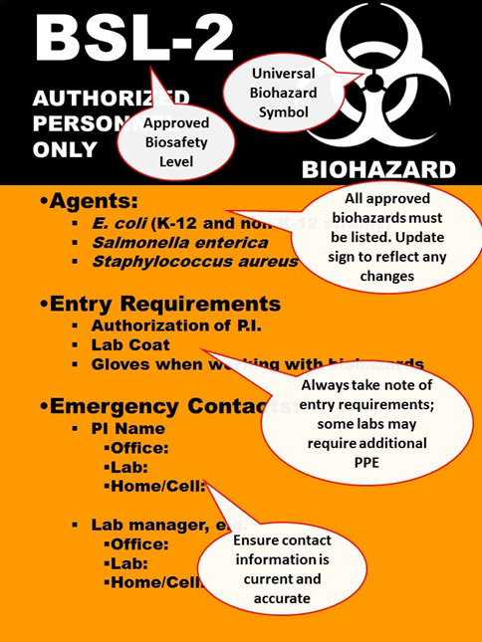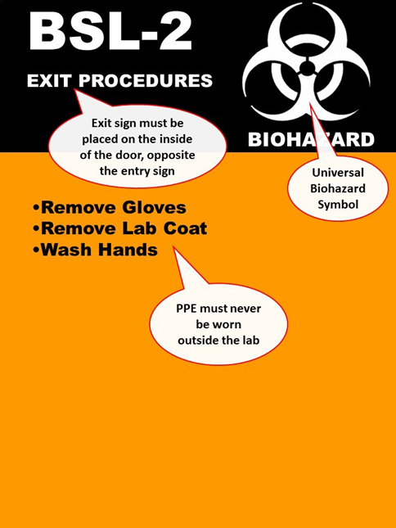

General Biosafety Guidelines: Standard Microbiological Practices

Biohazardous materials require special safety precautions and procedures. Follow these guidelines when working with infectious agents:

- Personal Hygiene Guidelines:
    - Wash your hands thoroughly, as indicated below:
      - After working with any biohazard
      - After removing gloves, laboratory coat, and other contaminated protective clothing
      - Before leaving the laboratory area
    - Do not touch your face when handling biological material.
    - Never eat, drink, smoke, chew gum or tobacco, handle contact lenses, or apply cosmetics in the work area.
    - Do not store food for human consumption in the lab.
    - Restrain long hair so that it can’t contact hands, samples or equipment.

- Clothing/Personal Protective Equipment (PPE) Guidelines:
Appropriate laboratory attire and proper selection of personal protective equipment (PPE) are important for protecting workers from exposure to the various hazards present in the laboratory. All personnel working in a biosafety laboratory must wear long pants and closed toe shoes in addition to PPE. To prevent injury and contamination, long hair should be tied back, areas of exposed skin should be minimized (i.e., no halter tops or other types of clothing that bare large areas of skin), and dangling jewelry should not be worn. The selection of PPE depends on the risks associated with all hazards, including biohazards, in use and the procedures being performed in the laboratory. PPE is considered the last line of defense and should be used in combination with proper microbiological practices and engineering controls (e.g., a biological safety cabinet).

    - Always wear appropriate personal protective equipment (PPE). Appropriate PPE includes but is not limited to; gowns or scrub suit, gloves, goggles and surgical masks when working with infectious agents or infected animals. It is the responsibility of the PI to provide all laboratory personnel with appropriate PPE.
    - Wear gloves over gown cuffs, when appropriate.
    - Whenever possible, consider using disposable lab coats in your laboratory. Disposable lab coats negate the need for laundering and can be reused unless they become contaminated or damaged. Disposable lab coats must be disposed of as solid biohazardous waste.
    - Gloves are single use and should not be reworn or washed. Don’t leave them on the bench to reuse later. Change gloves when contaminated or when glove integrity is compromised, or when otherwise necessary.
    - Gloves should not be sprayed with disinfectant. This makes them slippery and increases the chance you will drop something. If gloves need to be disinfected, they need to changed.
    - Gloves should be disposed of as biohazardous waste. Gloves and other lab waste is not appropriate to “black bag” waste that is collected by custodial staff.
    - Do not wear potentially contaminated clothing outside the laboratory area.
    - Minimum required PPE at BSL-1:
      - Lab coats and gloves are work when working with hazardous materials. Alternatives to latex gloves should be available.
      - Eye protection is worn when conducting procedures with the potential to result in splashes or sprays of biological agents or other hazardous materials.
    - Minimum required PPE at BSL-2 (includes minimum required PPE at BSL-1):
      - Additional PPE may be required based on a risk assessment.
    - To remove contaminated clothing, follow these steps:

Figure 3: Doffing Procedures – Example 1

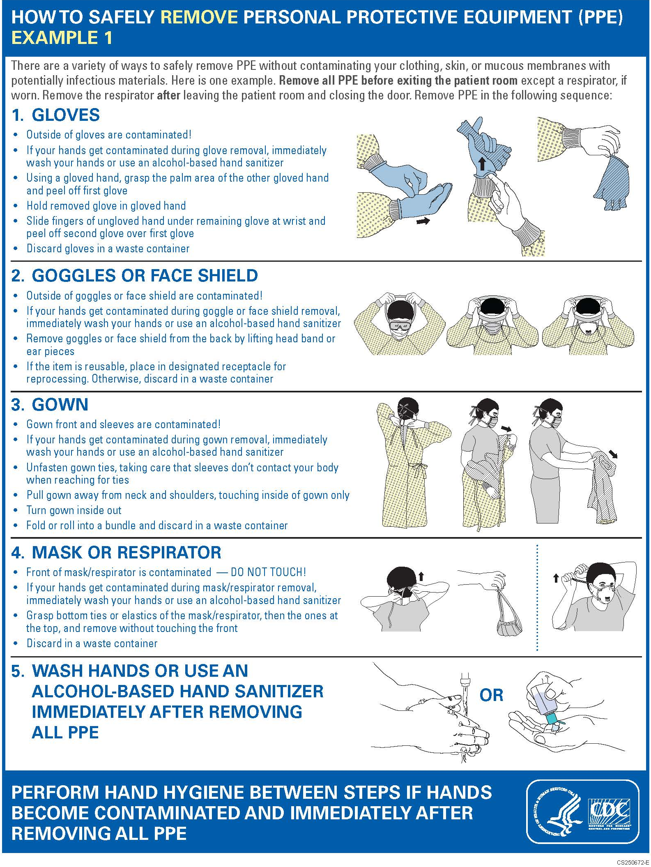
Figure 4: Doffing Procedures – Example 2

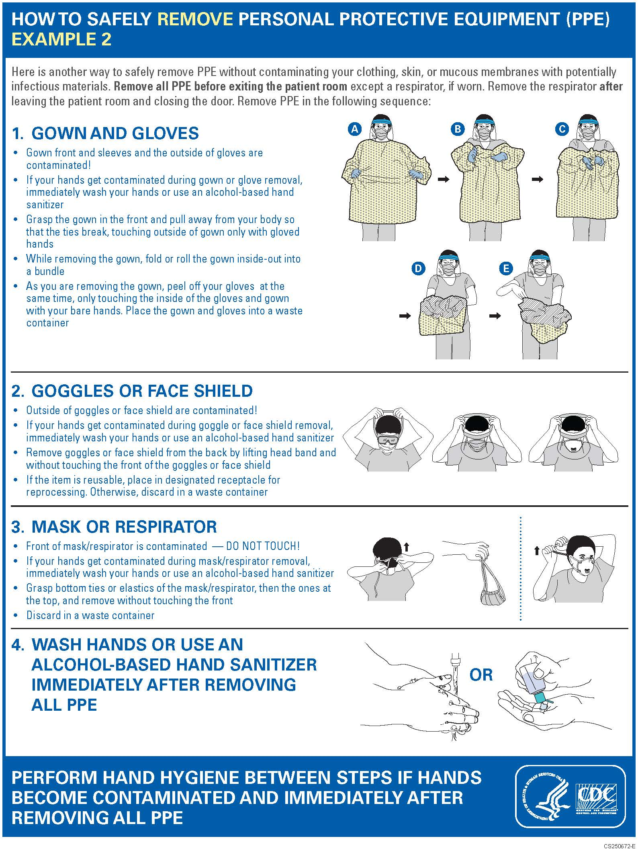
- Handling Procedures:
    - Use mechanical pipette devices. Do not mouth pipet.
    - Minimize aerosol production.
    - Add disinfectant to water baths for infectious substances.
    - Use trunnion cups with screw caps for centrifuging procedures. Inspect the tubes before use.
    - Use secondary leak-proof containers when transporting samples, cultures, inoculated petri dishes, and other containers of biohazardous materials.

- Sharps, (i.e., syringes, needles, scalpels, razor blades, pipette tips and broken glassware):
Careful management of needles and other sharp is essential to prevent injuries while working with sharps. Avoid using syringes and needles whenever possible. If a syringe is necessary, handle with caution to prevent injury to personnel and minimize your chances of exposure by following these guidelines:
    - Use a needle-locking or disposable needle unit.
    - Take care not to stick yourself with a used needle.
    - Do not place used syringes in pan containing pipettes or other glassware that requires sorting.
    - Do not recap, bend or break used needles.
    - Dispose of needles in an approved sharp container. Sharps containers should be placed within arm’s reach of your work area.
    - Store reusable sharps in a hard-walled container when not in use and during transport, if necessary.
    - Unprotected sharps should not be passed to another person for disposal.
    - Do not pick up broken glass with your hands. Use a broom and dustpan or forceps and dispose of glass in a sturdy cardboard box.
    - Contaminated, broken glass should always be decontaminated BEFORE being discarded.
    - Disinfected, broken glass should be discarded in a sturdy cardboard box. When choosing a cardboard box, consider ease of disposal. Larger boxes take much longer to fill, will be heavier, and can pose an additional risk.

- Work Area:
    - Control access to the laboratory. The laboratory supervisor/PI enforces the institutional policies that control safety in and access to the laboratory. The lab must have a door, it should be kept closed and should be locked when the lab is unoccupied.
    - Keep laboratory doors shut when experiments are in progress.
    - Limit access to laboratory areas when experiments involve biohazardous agents.
    - All persons entering the laboratory or facility are advised of potential hazards, instructed on the appropriate safeguards, and read and follow instructions on practices and procedures. EHS and/or trained PI will be present during routine inspections and/or scheduled repairs when visitors/contractors are present.
    - Ensure that warning signs are posted on laboratory doors. These signs should include the universal biohazard symbol and the approved biosafety level for the laboratory.
    - Make sure everyone is aware of the biohazards that are approved for use in your lab. Post a Biohazard laboratory sign on each door into the lab. Review posted signage regularly and revise as necessary to ensure signs are accurate and up to date.
    - A safety manual must be developed to describe the biosafety and containment practices required for the organisms in use. The safety manual should describe appropriate decontamination methods and should contain instructions to follow in case of emergency, including exposures, medical emergencies, equipment or facility malfunctions, etc.
    - The PI must make sure that all personnel receive appropriate training regarding:
      - their duties in the lab
      - potential hazards
      - manipulations of the infectious agents
      - necessary precautions to prevent exposures and hazard/exposure evaluation procedures
      - how and where to report injuries, accidents or incidents in the lab which may have resulted in exposure of personnel
      - how their personal health status impacts their risk of infection. Provide all personnel with information regarding immune competence and conditions that may predispose them to infection.
    - The facility must have an effective integrated pest management program. If you see any insects, rodents, or other pests (or evidence of their presence) in your lab, notify your supervisor or PI right away.
    - Do not bring plants or animals to the laboratory unless they are associated with the work being performed.
    - Conduct procedures carefully and in a manner that limits splashes or sprays of biohazards.
    - Disinfect work surfaces and equipment regularly. Keep work surfaces clear and tidy so routine decontamination is easy.
    - Decontaminate work surfaces daily and after each spill.
    - Decontaminate all potentially contaminated equipment.
    - Transport contaminated materials in durable leak-proof containers labeled with the biohazard symbol. Disinfect the outer surface of the container prior to transport.
    - Keep miscellaneous material (i.e., books, journals, etc.) away from contaminated areas.
    - Completely decontaminate equipment before having maintenance or repair work done.

- Universal Precautions:
Clinical and diagnostic laboratories often handle specimens without full knowledge of the material's diagnosis; these specimens may contain infectious agents. To minimize exposure, observe universal precautions when handling any biological specimen. Consider all specimens to be infectious and treat these materials as potentially hazardous.

General Biosafety Guidelines: Special Microbiological Practices

In addition to the standard microbiological practices, work in BSL-2 laboratory requires the following special practices:
    - Access to the laboratory is controlled when work is conducted; all personal must be aware of the potential hazards and meet entry/exit requirements:
      - Personnel must complete all IBC-required trainings before being allowed to work in the lab with biohazardous agents.
      - Laboratory and agent specific training must be provided by the PI. PIs should summarize the content and document the delivery of this training for all personnel.
      - Personnel must demonstrate proficient microbiological practices before working with risk group 2 agents.
      - Personnel must be provided agent specific training whenever a new risk group 2 agent is being added to the permit. This training should be documented.
    - Incidents involving exposure to biohazards must be reported immediately to the PI.
    - Perform aerosol-generating procedures involving infectious materials inside a properly maintained biosafety cabinet.
    - Used sealed rotors or safety cups when centrifuging infectious materials in the open lab. Open rotors and safety cups only when they are inside the biosafety cabinet.
    - Routinely decontaminate laboratory equipment after spills or splashes and before repair, maintenance or removal from the laboratory.
    - A method (e.g. autoclave, chemical means or other validated decontamination method) for decontaminating laboratory wastes is available.
    - BSL-2 laboratories must meet the laboratory facility requirements below:
      - Laboratories must have a door. BSL-2 labs require self-closing doors that can be locked.
      - Laboratories must have a sink for handwashing, unless special considerations prevail (e.g. microscope rooms). The sink in a BSL-2 lab should be located near an exit.
      - An eyewash station must be readily available (in the lab) and properly maintained by activating it weekly. This activity should be performed and documented by lab personnel.
      - The laboratory should be maintained in a manner that facilitates cleaning and surface disinfection. Carpets or rugs in labs are not appropriate; chairs should be covered with a non-porous material. Likewise, bench tops should be resistant to heat and chemicals and impervious to water so they stand up to frequent disinfection.
      - If windows are present, they should not open to the outside.
      - Illumination in the lab should be adequate and avoid reflections and glare that could interfere with vision.
      - If vacuum lines are present in BSL-2 labs, they must be protected with an in-line HEPA (or equivalent) filter.
      - There are no specific requirements for ventilation in BSL-1 and BSL-2 labs, but planning of new BSL-2 facilities should consider ventilation systems that provide
inward, directional airflow without recirculation to other, non-laboratory areas.

Biological Safety Cabinets (BSCs)

Biological safety cabinets (BSCs) are primary engineering controls typically used for microbiological studies, cell culture, pharmaceutical procedures and toxicology. Sometimes they are referred to as “hoods”. It’s important to know that there are several pieces of equipment in laboratories that may be commonly referred to as “hoods” and they may be very different in the types of personal and sample protection that they provide. The most common items called “hoods” in labs include:

    - Chemical fume hoods protect personnel from chemical fumes by pulling air away from the user. They may be ducted to the outside or filtered and recirculating. Questions about chemical fume hoods should be directed to Environmental Health and Safety.
    - Clean benches protect samples by directing filtered air across the samples and into the room. This air is often blown directly at the user. Clean benches do not provide any protection to personnel or the environment and must not be used with potentially hazardous agents.
    - Biosafety Cabinets (BSCs) are sometimes called “tissue culture hoods” or “microbiology hoods”. When used correctly, most BSCs protect personnel, samples, and the environment from particulate matter. Only certain types of BSCs provide limited protection from small amounts of chemical fumes. There are three classes of BSCs:
      - Class I BSCs offer protection to personnel and environment, but no sample protection. They pull air away from the user and filter it before blowing it into the room. The air on the work surface is not filtered and thus the agent being worked with is not protected.
      - Class II BSCs are the most common type of BSC in research laboratories. Air is pulled away from the user, air is filtered before flowing to the work surface, and air is filtered prior to re-entering the ambient atmosphere. There are several different types of Class II BSCs. All offer protection from particulate matter to users, samples, and the environment, but they differ in the amount of hazardous chemicals that may be used in them.
        - Type A1 and A2 BSCs work in slightly different ways, but both will protect users, samples, and the environment from particulate matter if used correctly. They offer no protection from chemical fumes if they exhaust directly into the room. If they exhaust through a canopy directly into the building exhaust system, then they offer protection from minute amounts of chemical fumes.
        - Type B1 BSCs are hard ducted into the building exhaust. They offer the same level of protection from particles as A2s, but slightly better chemical fume protection. 40% of the filtered air is still recirculated onto the work surface, so fumes can build up and concentrate.
        - Type B2 BSCs exhaust 100% of filtered air into the building exhaust after a single pass of the work surface. If you need protection from particles and moderate amounts of chemical fumes in the same sample, this type of BSC is the best option.
      - Class III BSCs are pressure-tested glove boxes with passive, filtered supply air exhausted through at least two filters via dedicated facility exhaust. Users do not come into direct contact with samples. Class III BSCs are primarily used in high containment laboratories.

Table 2 and 3 outline the selection of BSCs through a risk assessment and a summary of the various types of BSCs and their characteristics. and is a primary barrier against biohazardous or infectious agents. Although biological safety cabinets surround the immediate workspace involving an agent, they do not provide complete containment (i.e., aerosols can escape). Therefore, careful work practices are essential when working with agents that require a biological safety cabinet.

All biological safety cabinets contain at least one High Efficiency Particulate Air (HEPA) filter. These cabinets operate with a laminar air flow (i.e., the air flows with uniform velocity, in one direction, along parallel flow lines.).

Biological safety cabinets must be inspected and certified:
- When newly installed
- After filter or motor replacement
- After being moved
- Annually

The following sections discuss safety procedures and guidelines for working with various types of biological safety cabinets.

The following tables outline various types of biological safety cabinets:

Table 2: Selection of a Safety Cabinet through Risk Assessment:

Biosafety Level | Personnel | Protection Provided Product | Environmental | BSC Class
BSL-1 to 3 | Yes | No | Yes | I
BSL-1 to 3 | Yes | Yes | Yes | II (A1, A2, B1, B2)
BSL-4 | Yes | Yes | Yes | III; II-when used in suit room with suit

Table 3: Comparison of Biosafety Cabinet Characteristics

BSC Class | Face Velocity | Airflow Pattern | Application: Nonvolatile Toxic Chemicals and Radionuclides | Application: Volatile Toxic Chemicals and Radionuclides
I | 75 | In at front through HEPA to the outside or into the room through HEPA | Yes | When exhausted outdoors, b
II, A1 | 75 | 70% recirculated to the cabinet work area through HEPA; 30% balance can be exhausted through HEPA back into the room or to outside through a canopy unit | Yes (small amounts)^{b} | Yes (small amounts)^{a,b}
II, B1 | 100 | 30% recirculated, 70% exhausted. Exhaust cabinet air must pass  through a dedicated, internal cabinet duct to the outside through a HEPA filter | Yes | Yes (small amounts)^{a,b}
I, B2 | 100 | No recirculation; total exhaust to the outside through a HEPA filter | Yes | Yes (small amounts)^{a,b}
II, A2 | 100 | Similar to II, A1, but has 100 lfm intake air velocity exhaust air can be ducted to the outside through a canopy unit | Yes | When exhausted outdoors (formally B3), (small amounts)^{a,b}
II, C1 | 100 | 30% recirculated, 70% exhausted. Exhaust cabinet air must pass through a dedicated, internal cabinet duct to the outside through a blower and HEPA filter | Yes | Yes (small amounts)^{a,b}
III | N/A | Supply air is HEPA-filtered. Exhaust air passes through two HEPA filters in series and is exhausted to the outside via a hard connection | Yes | Yes (small amounts)^{a,b}
- Installation requires a special duct to the outside, and may require an in-line charcoal filter, and/or a spark-proof (explosion-proof) motor and other electrical components in the cabinet. Discharge of a Class I or Class II, Type A2 cabinet into a room should not occur if volatile chemicals are used.
- A risk assessment should be completed by laboratory and safety facility personnel to determine amounts to be used. In all cases, only the smallest amounts of the chemical(s) required for the work to be performed should be used in the BSC. In no instance should the chemical concentration approach the lower explosion limits of the compounds.
- Class II A1 cabinets built prior to 2010 were allowed to have potentially contaminated, positively pressurized plenums. After 2010, All Class II cabinets must have potentially contaminated plenums under negative pressure or surrounded by negatively pressurized plenums.

- Working in a Biological Safety Cabinets
BSCs are powerful protective tools, but they must be used correctly if maximum protection is to be achieved. Follow these tips to ensure that you, your samples, and the environment are protected from contamination:
  - Always wear appropriate PPE (e.g. lab coats, gloves, and eye protection) when working in the BSC.
  - Ensure the UV lamp is turned off when people are in the lab and before working in the BSC. Note: UV lamps are not recommended for disinfection.
  - Never work in a unit with the UV light illuminated. (UV light will damage your eyes.)
  - Ideally, leave the blower fan running at all times. If your BSC is not already running when you need to use it, allow it to run for ten minutes to establish proper airflow before working.
  - Turn on the light, inspect the air intake grilles for obstructions and foreign materials, and remove any obstructions found.
  - Disinfect the interior surfaces of the BSC using an appropriate disinfectant. Don’t forget to wipe the interior walls of the BSC including the inside of the sash. If your disinfectant is corrosive (e.g. bleach, Wescodyne), make sure to rinse it thoroughly or the stainless steel will rust over time.
  - Place supplies at least four inches from the back and front grilles. Items should be within easy reach so you can minimize arm movements within the BSC. Never cover the front or rear grilles with equipment, papers, your arms, etc. The middle third of work surface is the ideal area to be used.
  - Segregate clean and contaminated items.
  - Minimize movements inside the cabinet. Any movement should be done slowly and, in a direction perpendicular to the back of the cabinet. Avoid making unnecessary or side-to-side movements within the BSC. If your arms must exit the cabinet, do so in a slow and steady manner.
  - Never use a Bunsen burner inside a BSC. Properly used, BSCs provide semi-sterile environments that do not require the use of a flame to maintain. If you need to heat-sterilize equipment within the BSC, utilize alternative devices such as Bacti- cinerators or Touch-o-matic burners.
  - Place everything needed for your procedure inside the cabinet prior to beginning work. Remove unnecessary items; excessive material may disrupt the air flow. Arrange the equipment in logical order.
  - Place a disinfectant-soaked towel on the work surface to contain any splatters or spills that may occur during the procedure.
  - Keep the laboratory door shut and post signs stating "CABINET IN USE" on all the doors. Restrict activities that will disturb the cabinet's airflow, such as entry, egress, and walking traffic.
  - Control all tissues, needle packages and other small loose paper or plastic products which may be caught in the air stream and pulled to the motor or HEPA filter.
  - When finished working, decontaminate all items with an appropriate disinfectant and remove them from the BSC. Do not store supplies in the BSC. Contaminated wastes should be collected inside the BSC and placed into the proper biohazard waste receptacle. Cover all waste containers.
  - Disinfect all surfaces thoroughly. Leave the blower fan running. If you cannot leave the BSC running, then allow the blower to run for a minimum of 5 minutes after work has ceased and reentry into the cabinet is no longer necessary.
  - Cover all waste containers.

- Annual Certification of BSCs
Biosafety cabinets must be field tested and certified at the time of installation and at least annually thereafter, using the methods detailed in Annex F, “Field Tests”, of NSF/ANSI Standard 49. Additionally, BSCs must be recertified when filters are changed, repairs are made to internal parts, or the cabinet is relocated or sent to surplus. TAMIU requires that certifications be performed by experienced, qualified personnel. The University maintains a service contract with an appropriate third-party vendor to inspect and certify biosafety cabinets.

IMPORTANT:
Biological safety cabinets are not a substitute for good laboratory practices. Because aerosols can escape, take precautions to minimize aerosol production and to protect yourself from contamination.

Clean Benches

A clean bench has horizontal laminar air flow. The HEPA-filtered air flows across the work surface towards the operator, providing protection for the product, but no protection for the user. Because clean benches offer no protection, use a clean bench only to prepare sterile media. Do not use clean benches when working with pathogenic organisms, biological materials, chemicals, or radioactive materials.

Vacuum Aspiration of Biohazardous Materials

Vacuum aspiration is an aerosol generating procedure that is routinely performed in cell culture labs. An optimal aspiration system includes a primary collection flask, an overflow flask, flexible tubing, a vacuum source and an in-line filter. Protecting yourself and your co-workers from exposure to potentially infectious bioaerosols during aspiration is key. The following guidance is provided to ensure personnel and environmental safety throughout this process:
  - Avoid the use of glass and select a shatterproof primary collection flask.
- Label the flask with the biohazard symbol
- Add fresh, concentrated bleach to achieve a final concentration of 10%
  - Include a second, overflow flask
  - Select tubing that withstands disinfection or is disposable.
  - Do not allow contaminated liquids to collect longer than one week.
    - Once per week, or when the primary collection flask is no more than 2/3 full (whichever is sooner), stop collection.
    - Carefully swirl the flask and allow a minimum of 30 minutes following the final collection (overnight is ideal) to ensure disinfection.
    - Discard decontaminated liquid down the sink with lots of water.
    - Clean equipment; replace disinfectant.
  - Ideally, the vacuum assembly should be placed inside the BSC. Do not block the front or the rear grille of the BSC.
    - If the system cannot be housed within the BSC, collection flasks must be secured and placed inside a secondary container of adequate size and depth to contain a possible spill or leak.
    - Do not place collection flasks directly on the floor.
  - Include a biological, hydrophobic, HEPA or HEPA-like filter between the collection flash and the vacuum source.
    - DO NOT USE the 0.2 micron filters designed for filter-sterilizing solutions. These allow liquid to pass through the filter.
    - Orient the filter so that the inlet is on the fluid side and the outlet is on the vacuum side.
    - Label the filter with the date of installation.
    - Change filters regularly, depending on use.
    - Dispose of used filters as biohazardous waste.

Centrifuge Safety

- Types of Centrifuges
Centrifuges are used routinely in laboratories to separate substances according to size and density differences by using centrifugal forces. They can generate massive forces so it’s important to use them carefully. There are several general classes of centrifuges:
- Ultra-speed – Floor models that spin at up to 1,000,000 x g. These require extensive special training from vendors or experienced users.
- Super speed – Floor models that spin at up to 75,000 x g
- High speed – Benchtop models that spin up to 24,000 x g
- Low speed – Benchtop models that spin up to 7,333 x g

Rotors are the parts of the centrifuge that holds the samples and spin. They can be fixed-angle, have swinging buckets, or be highly specialized for a particular use.

- Hazards of Centrifugation
If used and/or maintained improperly, all centrifuges (including microcentrifuges) can present various hazards including:
- Physical hazards – mechanical failure due to mechanical stress, metal fatigue, and corrosion of the rotor over time.
- Exposure hazards – aerosolization of biohazardous, chemical, or radioactive materials.

Common causes of centrifuge malfunctions include:
- Incorrect loading or balancing
  - Failure to place the lid on the rotor.
  - Failure to properly secure the rotor lid.
  - Failure to properly balance the load.
  - Using a swinging bucket rotor with missing buckets.
  - Buckets hooked incorrectly and unable to swing freely.
  - Overloading the rotor’s maximum mass
- Incorrect attachment
  - Failure to properly secure the rotor to the drive.
- Consumable failure – tubes, plates, etc.
  - Failure to inspect tubes carefully and to seal them adequately.
  - Tubes have maximum rated speeds. If in doubt, contact the manufacturer.
- Corrosion
  - Failure to properly clean and maintain rotors. Chemicals left in contact with rotors can cause pitting and destruction of surfaces, weakening the rotor.
- Fatigue
  - Using a rotor that has been dropped.
  - Using a rotor that has outlived its rated life span.

- Preventative Maintenance
- Establish a preventive maintenance schedule, as necessary, including regular cleaning of the centrifuge interior and rotors to prevent damage and avoid costly repairs. Reference the centrifuge operator’s manual or contact the manufacturer for guidance. Equipment repair and adjustments shall only be conducted by a qualified service technician.
- Only use cleaning and disinfecting products that are compatible with your rotor.
- After thoroughly cleaning rotors, store them upside down so they drain and dry completely.
- Remove all adapters between spins.
- Never use a rotor that’s been dropped. If it happens, or you notice any sign of damage, report this to your laboratory Principal Investigator immediately.

- Centrifuging Risk Group 2 or Higher Materials
Centrifuges create aerosols every time they are used. Potentially hazardous aerosols must always be properly contained. Special considerations must be made when centrifuging Risk group 2 or 3 agents.
- Gaskets must be inspected before every use. Ensure broken or cracked gaskets are replaced before using.
- Lightly lubricate gaskets regularly to prolong their life and create a better seal.
- Load and unload rotors only inside the BSC. Sealed containers can only protect you from aerosols if you contain them while they’re opened.
- Transport rotors to and from centrifuges on carts to prevent dropping.
- Thoroughly decontaminate tubes as they are removed from the rotor. Thoroughly decontaminate the rotor before it is removed from the BSC

Cleaning, Disinfection, and Sterilization

Decontamination renders an area, device, item, or material safe to handle (i.e. safe in the context of being reasonably free from a risk of disease transmission). The primary objective of decontamination is to protect the laboratory worker, the environment, and anyone who enters the laboratory or handles laboratory products away from the laboratory. Reduction of cross-contamination in the laboratory is an added benefit.

In order to manage biohazardous laboratory waste properly, it is important to understand the principles of sterilization, disinfection and decontamination and the differences between them. Biological safety depends on proper cleanup and removal of potentially harmful agents. Cleaning, disinfection and sterilization are ways to help ensure biological safety in the laboratory.

- Cleaning:
A process to reduce or remove adherent organic and inorganic soil (e.g., blood proteins, debris and biological matter, and other material) from surfaces usually with detergent and water. Cleaning is often an essential pre-requisite to disinfection or sterilization processes to ensure the optimal activity of the antimicrobial effects of disinfectants or sterilization processes.

- Disinfection:
A process that destroys pathogens and other microorganisms, except prions, by physical or chemical means. Generally, a less-lethal process than sterilization; it eliminates nearly all recognized pathogenic microorganisms, but not necessarily all microbial forms (e.g., bacterial spores) present on inanimate objects. Disinfection does not ensure a kill level and lacks the margin of safety achieved by sterilization procedures. The effectiveness of a disinfection procedure is controlled by several factors, each one of which may have a pronounced effect on the end results. Factors affecting disinfection include the following:
- Nature and number of contaminating microorganisms (especially the presence of bacterial spores);
- Amount of organic matter present (e.g., soil, feces, blood);
- Type and condition of surfaces, instruments, devices, and materials to be disinfected;
- Temperature; and
- Contact (exposure) time.

- Sterilization:
A physical or chemical process that kills or inactivates all microbial life forms including highly resistant bacterial spores. Any item, device, or solution is sterile when it is completely free of all forms of living microorganisms, including spores and viruses. Sterilization can be accomplished by dry or moist heat, gases or vapors (e.g., chlorine dioxide, ethylene oxide, formaldehyde, hydrogen peroxide, methyl bromide, nitrogen dioxide, ozone, propylene oxide), plasma sterilization technology, and radiation (e.g., gamma, e-beam in industry) or steam autoclaving.

- Responsibilities of Researchers
- Researchers must properly treat solid and liquid wastes prior to disposal.
- In BSL-1 and BSL-2 laboratories: Solid biohazardous wastes must be autoclaved; liquid biohazards must be autoclaved OR chemically disinfected prior to disposal (refer to Figure 3).
- Researchers must prepare agent appropriate disinfectants for use in the lab following manufacturer’s guidelines.
- Researchers must regularly disinfect work surfaces and equipment following use and especially after a spill or splash of biohazardous material.
- Researchers must promptly clean and disinfect spills and report them to their supervisor or PI and EH&S, as described in the section titled, “Biological Spill Response.”

- General Guidelines: Disinfectants
When selecting appropriate disinfectants for your laboratory, consider the following:
- Degree of microbial killing required (how difficult is your agent to kill?)
- Nature of item/surface to be disinfected
- Ease of preparation and use
- Contact time
- Safety (it should not be harmful to laboratory staff)
- Cost

Requirements for preparing and using laboratory disinfectant solutions:
- Wear appropriate PPE (including lab coats, gloves and eye protection).
- Prepare working stocks of disinfectants following manufacturer’s guidelines:
- 70-80% ethanol and 10% bleach are broad acting disinfectants commonly used in the laboratory.
- Label disinfectants properly with:
  - Product Name
  - Concentration
  - Date of expiration
- Do not use expired disinfectant.
- Dispose of expired, unused disinfectant solutions down the drain, flushing with lots of water.

Once you have chosen the proper method for disinfection or sterilization, follow these guidelines to ensure laboratory safety:
    - Frequently disinfect all floors, cabinet tops, and equipment where biohazardous materials are used.
    - Use autoclavable or disposable materials whenever possible. Keep reusable and disposable items separate.
    - Minimize the amount of materials and equipment present when working with infectious agents.
    - Sterilize or properly store all biohazardous materials at the end of each day.
    - Remember that some materials may interfere with chemical disinfectants-use higher concentrations or longer contact time.
    - Use indicators with autoclave loads to ensure sterilization.
    - Clearly mark all containers for biological materials (e.g., BIOHAZARDOUS - TO BE AUTOCLAVED).
    - The proper way to decontaminate biohazard sharps containers at TAMIU is by autoclaving them. Unfortunately, not all sharps containers are made to be autoclaved. Find the product number on the label of your sharps container and look it up online. On the product specifications sheet, it should specify if it is appropriate for the autoclave. If your container is not autoclavable or if you are unsure, do not use it. If it already has sharps inside it, place it inside of a container that is known to be autoclave safe before autoclaving it. Check future purchases to ensure only autoclave safe sharps containers are stocked in your lab.
    - Only place decontaminated glass in the broken glass container. If necessary, chemically decontaminate the glass before placing it in the box.
    - Any sturdy cardboard box can be a suitable broken glass container. Don’t use a box that is so large that it is difficult to handle when it is full.

- Types of Disinfectants
Use the following table to aid in the selection of disinfectants:

Table 4: Types of Disinfectant(s) and Uses

Disinfectant | Uses
Alcohols | Ethyl and isopropyl alcohols, in concentrations of about 70% to 95%, are the most common alcohol disinfectants. They are effective against vegetative forms of bacteria, fungi, and lipid-containing viruses. Alcohols are relatively inexpensive, have low toxicity, and do not cause corrosion of surfaces. However, alcohols evaporate quickly and must be continually applied to achieve adequate disinfection and are highly flammable. Alcohols are less effective against non-lipid viruses, and completely ineffective against bacterial spores and mycobacterium tuberculosis (TB). Contact time: depends on the organism; 20 minutes is generally effective.
Chlorine Compounds | Chlorine-containing compounds are probably the most commonly used laboratory disinfectants or benchtops, and floors, and spill cleanups as they are strong oxidizers and are highly corrosive. The most prevalent form, sodium hypochlorite (the form found in household bleach), contains 5.25% available chlorine (50,000 ppm) and can be diluted 10 to 100 fold (5,000 ppm to 500 ppm) to produce an acceptable disinfectant solution. At these concentrations, sodium hypochlorite exhibits broad-spectrum activity against vegetative bacteria, fungi, lipid, and non-lipid viruses. Higher concentrations and extended contact time can be used to inactivate bacterial spores. The efficacy of hypochlorite as a disinfectant is reduced in the presence of organic materials, high pH, and exposure to light-only freshly prepared solutions should be used. Chlorine dioxide gas is used to sterilize medical and laboratory equipment, surfaces, rooms and tools. It is a very strong oxidizer and it effectively kills pathogenic microorganisms such as fungi, bacteria and viruses. It also prevents and removes bio film. As a disinfectant and pesticide it is mainly used in liquid form. Chlorine dioxide is efficacious against protozoan parasites (Giardia) and spore forming bacteria. Contact time: >10 minutes for surface disinfection; 30 minutes for immersion.
Formaldehyde/  Formalin | Formalin is 37% solution of formaldehyde in water. Dilution of formalin to 5% results in an effective disinfectant with good activity against vegetative bacteria, spores, and viruses. Formaldehyde is a human carcinogen and creates respiratory problems at low levels of concentration. Use only in a fume hood or other well-ventilated area.
Glutaraldehyde | Glutaraldehyde (2.5%) displays a broad spectrum of activity, including bacteria spores, and rapid kill. It is active in the presence of organic matter, noncorrosive toward metals, and more active than the chemically-related formaldehyde. One of the main uses has been the rapid, “cold” chemical sterilization of medical equipment that is sensitive to heat. However, because glutaraldehyde is toxic and damaging to the eyes, restrict its use to inside a fume hood and not on the open bench.
Hydrogen peroxide | Hydrogen peroxide produces destructive hydroxyl free radicals and exhibits bactericidal, virucidal, tuberculocidal, sporicidal, and fungicidal properties. Higher concentrations (6-25%) have promise as chemical sterilants. It can be easily broken down by heat or by the enzymes catalase and peroxidase to form the end products, oxygen and water. Vaporized forms of hydrogen peroxide are also used for biosafety cabinet and room decontaminations.
Iodophors | Iodophors are a complex of iodine and a carrier that provides sustained release and increased solubility of the iodine (70-150 mg/l available iodine). Iodophors are commonly used to decontaminate surfaces and equipment, are relatively nontoxic, and can be used as an antiseptic scrub. Although iodophors show a wide spectrum of antimicrobial and antiviral activity, they have variable effect on hepatitis B virus, and do not inactivate bacterial spores. Contact time: check product labels for directions; dilute to manufacturers’ directions to achieve optimal antimicrobial activity.
Phenols | Phenol disinfectants (in concentrations of 0.5-5%) are used as preservatives and antibacterial agents in germicidal soaps and lotions. They are also used to disinfect various surfaces such as benches, walls, and floors. Phenolics inactivate vegetative bacteria including Mycobacterium tuberculosis, fungi, and lipid-containing viruses, but are not active against bacterial spores or non-lipid viruses. Halogen substitution or the addition of detergents enhances the efficacy of phenolics. Contact time: >10 minutes; depends upon product and concentration; follow manufacture’s guidelines.
Quaternary Ammonium Compounds | Quaternary ammonium compounds (0.5-1.5%) are cationic agents that are relatively non-toxic and widely used as a general, non-specific disinfectant for walls, floors, and equipment. They are effective against many bacteria and lipid-containing viruses, but are not active against bacterial spores, non-lipid containing viruses (e.g., hepatitis B), and Mycobacterium tuberculosis. Organic materials and salts found in water can inactivate quaternary ammonium compounds. Contact time: >10 minutes for surface disinfection; check product label for directions.

- Sterilization Methods
The most common method for sterilization of laboratory materials is through the use of a steam autoclave. A steam autoclave may be used to sterilize media, glassware, waste, instruments, etc. To accomplish the desired end goal and to protect the user and the environment from hazardous materials, the autoclave must be used correctly. Additionally, wastes must be managed in compliance with state and local regulations.

For the autoclave process to be effective in achieving sterilization, sufficient temperature, time and direct steam contact are essential. Air must be completely removed from the sterilizer chamber and from the materials to allow steam penetration so that the material being autoclaved will be at treatment temperature for sufficient time to achieve kill. Factors that affect air removal include type and quantity of material to be autoclaved, packaging, load density and configuration, and container type, size, and shape.

- General Procedures
  - All potentially infectious materials must be autoclaved before being washed and stored or disposed.
  - Personnel who use an autoclave must be trained to understand proper packaging, loading, labeling, and operation procedures.
  - Biohazardous materials must be labeled as such and must be sterilized by the end of each workday or must be secured appropriately. Do not leave biohazardous materials in an autoclave overnight in anticipation of autoclaving the next day.
  - Do not autoclave materials that also contain toxic or volatile chemical or radiological agents.

- Packaging
  - Use bags or other containers labeled “Biohazard” for items that contain or may be contaminated with potentially infectious agents.
  - Use plain, unmarked containers for items that are not hazardous.
  - Do not double bag waste or tightly seal containers as this will impede steam penetration.
  - Do not put sharp objects such as broken glassware into an autoclave bag.
  - Open, shallow metal pans are more effective in conducting heat and allowing air removal than tall, plastic tubs.
  - Vessels with liquid should not be plugged or tightly capped.
  - It is advisable to add some water to bags of solid wastes (the water will vaporize into steam that will drive out residual air once sterilization temperature has been reached inside the bag).
  - When using an autoclave bag with a ‘Biohazard’ symbol on it, place a strip of tape that produces the word “autoclaved” across the symbol. This must be done for any autoclave bag that has a Biohazard symbol.

- Loading
  - Place containers of liquid, bags of agar plates, or other items that may boil over or leak inside a secondary pan in the autoclave.
  - Never place autoclave bags or glassware in direct contact with the bottom of the autoclave.
  - Do not overload the autoclave; leave sufficient room for thorough steam circulation.
  - Make sure the plug screen in the bottom of the autoclave is clean.
  - Do not mix loads of liquids with solids.

- Operating Parameters
  - The parameters for the sterilization cycle will depend upon the amount and type of material. Usually 121 C° at 15 psi for a minimum of 30 minutes is recommended. However, the temperature and cycle time should be determined using a worst case load and using a biological indicator as verification that sterilization was achieved (e.g., ampoule of B. stearothermophilus spores placed in the middle of the full load). A biological indicator should be used frequently enough (e.g., once per month) to ensure that the sterilization parameters are effective in treating biohazardous waste.
  - Make sure chart paper or printer paper is in place to document the cycle parameters for the load. If a recording system is not available, it is critical to verify that sterilization parameters were achieved by another means such as spore strips, an autoclave thermometer, etc.
  - The exact operating procedure for each model of autoclave will differ. The user should develop an SOP to describe proper steps to operate the autoclave.

- Removing Sterilized Items
  - Open the sterilizer door no more than 0.5 inch; wait 10 minutes before unloading items.
  - Wear heat resistant gloves to unload items.
  - Be very careful of liquids, molten agar, etc. to avoid getting splashed with scalding liquid. Do not agitate containers of super-heated liquid or remove caps before unloading.
  - Unload hot items onto a cart for transport.
  - Take bags of autoclaved disposable waste to the dumpster.

NOTE:
If a faulty condition exists (e.g., sterilizer did not finish the cycle, or water leaks out when the door is unlocked), contact a service technician.

- Recordkeeping
  - Document the treatment of each load of biohazardous waste in a log which lists: the date of treatment; the amount of waste treated; the method or conditions of treatment; and the printed name and initials of the person performing the treatment. Keep charts or printout strips with the logbook as documentation of the autoclave operation.
  - Document the date and results of each verification test using biological indicators.

- Non-Sterilization Procedures
For procedures where an autoclave treatment is used for purposes other than acquiring sterilization, the time and temperature parameters will vary as needed to accomplish the intended goal of the user.

- Repairs / Maintenance
When maintenance work or repairs are needed, the user must provide a safe work environment for the service technician. Remove all items from the sterilizer chamber, clean any spills or leaks inside the chamber, remove untreated biohazardous materials from the vicinity, etc.

Importing and Shipping Biological Materials

For shipping biological materials, please contact the Office of Environmental Health and Safety.

Biological Spill Response

Although biohazards present in a BSL-1 laboratory should not be a significant health hazard to humans, they may present a hazard to plants, animals, and the environment. Biohazards present in a BSL-2 laboratory have the potential to cause disease in humans. Regardless of whether a spill occurs in a BSL-1or BSL-2 laboratory, personnel have the responsibility to minimize exposure of themselves and others to biohazards and to minimize the release of biohazards from the laboratory. The exact procedure for responding to a biological spill depends on the material, amount, and location of the spill. The following procedures are provided as guidance for responding to a spill involving biohazards in a BSL-1 or BSL-2 laboratory.

In the event of a spill:
- Take care of yourself first! If any biohazardous material gets in your eyes, flush your eyes at the nearest eyewash immediately.
- Remove any contaminated clothing or PPE and wash any exposed areas of skin with soap and water. Put on clean clothing (if necessary) and fresh PPE (i.e. lab coat, gloves, and eye protection). Attempt to keep a change of clothes available in the lab.
- Assess the magnitude of the spill, denote the area, and notify others. Don’t underestimate the magnitude of the spill. Nearby vertical surfaces (i.e., cabinets, walls, etc.) should be decontaminated.
- Immediately report/notify PI of any spill regardless of amount spilled.

Follow these steps to clean up a biological spill:
- Wait for any aerosols to settle.
- Put on protective clothing, as appropriate.
- Cover the area with absorbent material (i.e. paper towels, kitty litter, etc.) to absorb the disinfectant.
- Apply/pour agent-appropriate disinfectant over the entire contaminated area. Work from the outside the margins of the spill towards the center. Allow for sufficient contact time (NOTE: the minimum contact time depends on the agent and may vary).
- Ensure area is thoroughly cleaned and disinfected. Repeat disinfection of the spill site as necessary.
- Pick up broken glass with forceps, tongs, or broom and dustpan. NEVER pick up glass with your bare hands. Ensure glass is decontaminated before disposing in broken glass container.
- Bleach soaked paper towels or kitty litter may be placed into the regular waste can. Other solid waste should be collected into a biohazard waste bag and autoclaved. Bleach should NOT be autoclaved.
- Autoclave all contaminated wastes.
- Replenish spill kit as necessary.

NOTE:
Spill cleanup must be appropriate for the hazards involved. If spill is large and cleanup assistance is needed contact Principal Investigator. If additional assistance is needed, contact EH&S at (956) 326-2194.

If a spill occurs inside a biological safety cabinet, follow these steps:
- Decontaminate materials while the cabinet is operating to prevent contaminants from escaping.
- Spray or wipe all affected equipment with an appropriate disinfectant. (Wear gloves while doing this.)
- If the spill is large, flood the work surface with disinfectant and allow it to stand for 10 to 15 minutes before removing it.

Incident Response and Reporting

If an incident occurs and those involved require immediate medical attention, call 911, and follow all instructions provided by the emergency response provider. Incidents should be reported to the Principal Investigator (PI)/Supervisor and Environmental Health & Safety (EH&S). Examples of incidents that should be reported that may result in a potential exposure to biohazardous materials:
- Exposure of person(s) to infectious biohazards and/or chemicals and/or recombinantly modified materials
- Spill of infectious biohazards outside of the biosafety cabinet
- Loss of containment
- Sharps injuries that may result in exposure to infectious biohazards and/or chemicals
- Physical hazards

- Exposure Incident Response – Small Injuries:
For small injuries (e.g. needle sticks, nicks, small cuts or punctures):
- Wash the injured area immediately with soap and water.
- For very small wounds where bleeding is minimal, encourage the injury to bleed while washing.
- Notify your PI/Supervisor as soon as possible with the details of what occurred.

- Exposure Incident Response – Mucous Membrane/Open Wound Exposure
For mucous membrane or open wound exposure (e.g. a splash or spill into your eyes, nose or mouth, or onto broken skin):
- Wash the affected broken skin immediately with soap and water.
- Flush the affected mucous membrane(s) immediately at the eyewash station or at the sink with running clean water.
- Notify your PI/Supervisor as soon as possible with the details of what occurred.

Biohazardous Waste Disposal

The purpose of this section is to provide information, requirements, guidelines and procedures for the handling and disposal of hazardous and nonhazardous biohazardous waste for all departments and laboratories of the TAMIU.

Figure 5 below contains guidelines which summarizes requirements for treatment and disposal of biohazardous waste disposal at TAMIU. Table 5 provides a model form for maintaining the record of treatment of biohazardous waste when using an autoclave.

"BIOHAZARDOUS WASTE" means any solid or liquid biological waste that is hazardous because of its physical and/or biological nature and is differentiated from that which contains hazardous chemicals or radioactive materials. All waste that contains infectious material or which, because of its biological nature, may be harmful to humans, animals, plants or the environment is biohazardous waste. This includes: waste from infectious animals; bulk human blood or blood products; infectious microbiological waste (including contaminated disposable culture dishes and disposable devices used to transfer, inoculate and mix cultures); pathological waste; sharps; and hazardous products of recombinant DNA biotechnology and genetic manipulation. Biohazardous waste may be generated from teaching and research laboratories/operations or clinical settings.

Biohazardous waste generated at TAMIU is treated by thermal or chemical disinfection, or by a third-party contractor. Certain disinfected liquid waste may be discharged into the TAMIU Sanitary Sewer System (hereafter referred to as the Sewer System). All animal carcasses (except those contaminated with radioactive material which must be disposed of differently) and recognizable body parts must be disposed of by following local, state, and federal guidelines.

All infectious material should be disinfected before removal from the laboratory. (CAUTION: Refrain from using chemical treatments that cause the waste to be a chemical hazard.) Sharps must be segregated from other waste and placed in puncture resistant containers; all metallic sharps, regardless of their use, are considered biohazardous. Liquid waste should be disinfected and discharged into the Sewer System. Treatment of all laboratory biological waste prior to disposal is good laboratory practice, and is highly recommended. Biohazardous waste must be treated and properly labeled and records must be maintained. Personnel with potential for contact with biohazardous material must be appropriately trained.

The key requirements for disposal of TAMIU's biohazardous waste are that it must be (1) segregated from other waste; (2) treated to eliminate the biological hazard; (3) specifically labeled to indicate the method of treatment; (4) securely packaged; (5) transported to, and placed in the dumpster by appropriately trained personnel and (6) documented by maintenance of appropriate records.

Biohazardous waste, which is mixed with hazardous chemical waste, radioactive waste, or both, must be treated to eliminate the biohazard prior to disposal. After treatment, the waste must be managed as hazardous chemical waste through the EH&S or as radioactive waste through the EH&S.

- RESPONSIBILITY
The Principal Investigator (PI), researcher, or other person with operational responsibility shall assure compliance with these requirements within their laboratory or area of responsibility.

PIs, researchers or other person with operational responsibility must properly treat solid and liquid biohazardous wastes prior to disposal. In BSL-1 and BSL-2 laboratories: solid biohazardous wastes must be autoclaved; liquid biohazards must be autoclaved OR chemically disinfected prior to disposal.

- SEGREGATION OF BIOLOGICAL WASTE IN THE LABORATORY
- Any waste that could produce laceration or puncture injuries must be disposed of as "SHARPS". Sharps must be segregated from other waste. Metal sharps and broken glass may be commingled with each other, but not with non-sharp waste.
- Biohazardous waste must not be commingled with chemical waste or other laboratory trash.
- Biohazardous waste that includes a hazardous chemical should be segregated from other biohazardous waste and treated as chemical waste.

Figure 5: Waste Disposal Guide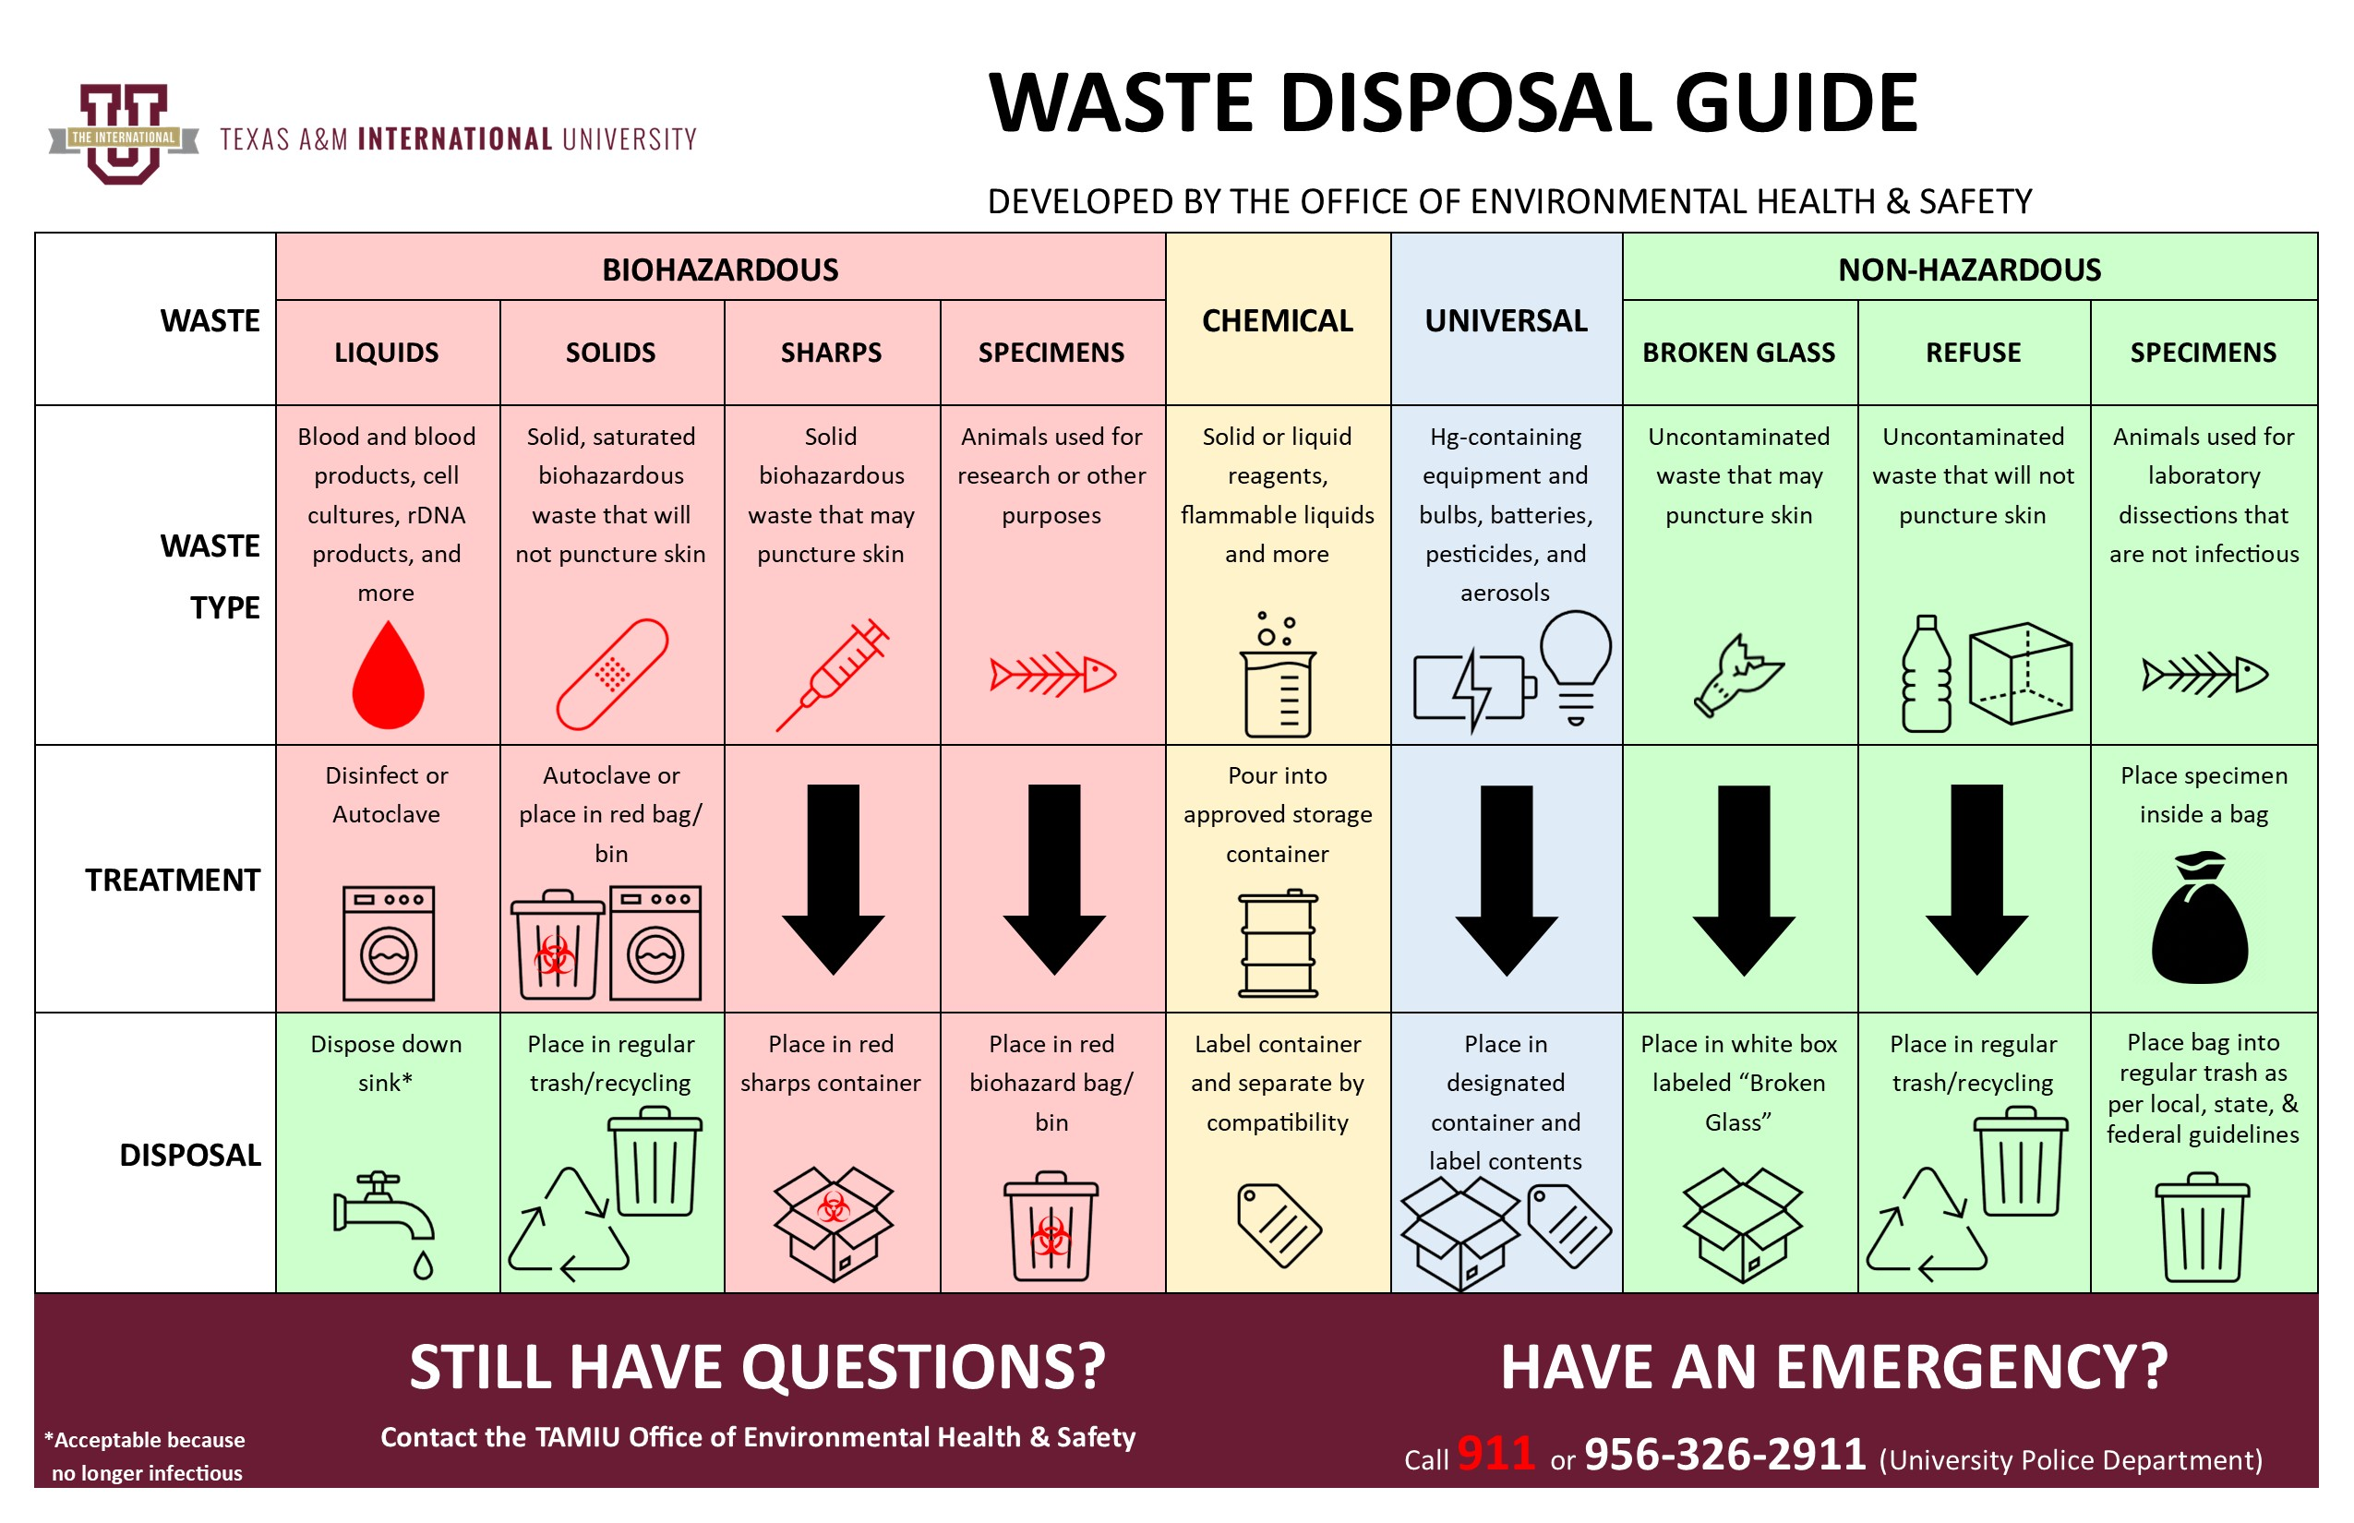

- CONTAINERS
Containers must: be appropriate for the contents; not leak; be properly labeled; and maintain their integrity if chemical or thermal treatment is used. Containers of biohazardous material should be kept closed.
- SHARPS – Place in a rigid, puncture resistant container (heavy walled plastic is recommended). Never attempt to retrieve items from a sharps container. Do not place sharps in plastic bags or other thin-walled containers. Click to see additional “Sharps” guidance.
- BROKEN GLASSWARE – Place in a rigid, puncture resistant container (plastic, heavy cardboard or metal), seal securely and clearly label "BROKEN GLASS". Click to see additional “Broken Glass” guidance.
- SOLID BIOHAZARDOUS WASTE – Use heavy duty plastic "BIOHAZARD BAGS" (autoclave bags) or containers for solid biohazardous waste (including contaminated disposable plastic labware, paper, bedding, etc. [NOT SHARPS]).
- NONHAZARDOUS BIOHAZARDOUS WASTE – Heavy duty plastic bags or other appropriate container without a biohazard label are preferred. Red or orange biohazard bags or containers should not be used for nonhazardous material.
- LIQUIDS – Should be placed in leak-proof containers able to withstand thermal or chemical treatment. DO NOT USE PLASTIC BAGS TO CONTAIN LIQUIDS.

- STORAGE OF BIOHAZARDOUS WASTE
Biohazardous waste should be treated and disposed of promptly and not allowed to accumulate. Containers holding biohazardous material must be clearly labeled, including the biohazard symbol. Biohazardous waste may be held temporarily under refrigeration, prior to disposal, in a safe manner that does not create aesthetic (visual or odor) problems. Storage enclosures must be clean and orderly with no access to unauthorized persons (warning signs must be posted).

- TREATMENT OF BIOHAZARDOUS WASTE
Biohazardous waste must be rendered harmless by appropriate treatment prior to disposal. Waste should be treated as near the point of origination as possible. Treatment methods include:
- Autoclave [120 C.;15 psi; 30 min. (minimum)]. Longer times may be required depending on the amount of waste, the presence of water and the type of container used.
- Chemical disinfection - 10% hypochlorite or EPA-approved chemical disinfectant or sterilant used according to manufacturer's direction.

- HANDLING AND TRANSPORT
- Properly trained laboratory personnel (not custodial) shall be responsible for transporting treated biohazardous waste from the generation site to the dumpster or incinerator. Untreated biohazardous waste shall be handled only by properly trained technical personnel.
- Treated waste must be properly contained and labeled before transport to the disposal site or placement in a TAMIU dumpster for disposal.
- Transport of untreated biohazardous materials or foul or visually offensive material through non-lab or populated areas should be avoided.

- LABELING OF BIOHAZARDOUS WASTE
- Each container of untreated biohazardous waste must be clearly identified as such and must be labeled with the Biohazard Symbol.
- Each container of treated biohazardous waste intended for disposal in the Landfill must be labelled to indicate the method of treatment and to cover biohazard markings.
- Label autoclave bags with commercially available autoclave tape that produces the word "AUTOCLAVED" upon adequate thermal treatment. Apply this tape across the Biohazard Symbol on the bag before autoclaving.

NOTE:
Containers of nonhazardous biohazardous waste are not required to be labelled, but it is recommended that such containers are labelled as "NONHAZARDOUS BIOHAZARDOUS WASTE".

- DISPOSAL METHODS
Material that remains hazardous because it contains hazardous chemicals must be disposed of through EH&S. DO NOT send hazardous chemicals to the Landfill or discharge into the Sewer System.
- ANIMAL CARCASSES AND BODY PARTS: must be disposed of by following local, state, and federal guidelines.
- SOLID ANIMAL WASTE: All animal waste, including bedding, that is infectious or harmful to animals, humans or the environment, should be appropriately treated prior to disposal, regardless of the origin of contamination. The following disposal methods are acceptable:
- Thermal or chemical disinfection followed by deposition in the Landfill.
- LIQUID WASTE: including bulk blood and blood products, cultures and stocks of etiologic agents and viruses, cell culture material and products of recombinant DNA technology should be disinfected by thermal or chemical treatment then discharged into the Sewer System.

NOTE:
Excess proteinaceous material can clump and cause drain clogging. Grinding of treated waste may be necessary. Do not grind untreated biohazardous material.

- SHARPS: Discarded sharps (contaminated or not) that may cause puncture or cuts, MUST be contained and disposed of in a manner that prevents injury to laboratory, custodial and Landfill workers. Needles, blades, etc., are considered BIOHAZARDOUS even if they are sterile, capped and in the original container.
- Disposal Method: In a sealed puncture resistant container; place in a TAMIU dumpster for deposition in the Landfill.
- Needles, such as those used for gas chromatography, should be thoroughly rinsed to remove hazardous chemicals, then disposed with non-contaminated broken glassware.
- Do not attempt to recap, bend, break or cut discarded needles.

NOTE:
NEVER PLACE SHARPS IN A TRASH CONTAINER OR PLASTIC BAG THAT MIGHT BE HANDLED BY CUSTODIAL STAFF.

- PASTEUR PIPETS AND BROKEN GLASSWARE:
- CONTAMINATED WITH BIOHAZARDOUS MATERIAL:
- Place in a properly labeled, leak proof and puncture resistant container; disinfect by thermal or chemical treatment; place in a TAMIU dumpster for deposition in the Landfill; OR
- NOT CONTAMINATED: Place in a puncture resistant container, then place in a TAMIU dumpster for deposition in the Landfill. The container must be clearly labeled to indicate that it contains BROKEN GLASS.
- PLASTIC WASTE:
- CONTAMINATED WITH BIOHAZARDOUS MATERIAL: Place in a properly labeled, leak proof container; disinfect by thermal or chemical treatment; place in a TAMIU dumpster for deposition in the Landfill.
- NOT CONTAMINATED: Place in a TAMIU dumpster for disposal in the Landfill.
- MICROBIOLOGICAL WASTE:
- SOLID: Place in a properly labeled, leak proof container; disinfect by thermal or chemical treatment; place in a TAMIU dumpster for disposal in the Landfill.
- LIQUID waste should be disinfected by thermal or chemical treatment then discharged into the Sewer System.
- GENETIC MATERIAL: Disposal of materials containing recombinant DNA or genetically altered organisms must be consistent with applicable NIH Guidelines, in addition to complying with the requirements contained in this document.
- NONHAZARDOUS BIOLOGICAL WASTE:
- Biological waste (other than animal carcasses or body parts) that is not infectious or otherwise hazardous to humans, animals, plants or the environment may be discarded as regular municipal waste (solid) or sewage (liquid). Animal carcasses and body parts must be disposed of by following local, state, and federal guidelines.
- There are no record keeping or labeling requirements for nonhazardous biological waste.
- It is good laboratory practice to autoclave or disinfect all microbial products. Culture materials and biological specimens, including bacterial or "normal" cell cultures and primary tissues should be autoclaved or treated with a 10% sodium hypochlorite (or equivalent) solution. Liquid waste should be discharged into the Sewer System. Avoid conditions that may create visual or odor problems.
- Nonhazardous waste should not be identified as hazardous. Containers should be labeled "NONHAZARDOUS LABORATORY WASTE". Do not use Biohazard bags or "red bags" for nonhazardous waste.
- Nonhazardous bedding (laboratory animal) and agricultural waste such as bedding, manure, etc. should be used as compost or fertilizer whenever practical. Minimize deposition of recyclable material in the Landfill.
- RADIOACTIVE WASTE: Please contact EH&S for biological waste that contains radioactive material.
- CHEMICAL WASTE: Biohazardous waste which also contains hazardous chemicals must be treated to eliminate the biohazard, then managed as hazardous chemical waste through EH&S. Hazardous chemicals must not be sent to the Landfill or discharged into the Sewer System.

- WRITTEN PROCEDURES AND RECORDS
Each biohazardous waste generating entity at TAMIU is required to maintain written records which, at a minimum, contain at least the following information:
- Date of treatment
- Quantity/amount of waste treated
- Method/conditions of treatment
- Name (printed) and initials of the person(s) performing the treatment
- Records must be maintained for at least 3 years for biohazardous waste treated.

NOTE:
There are no record requirements for nonhazardous biological waste.

Table 5: Example of an Autoclave Treatment Log
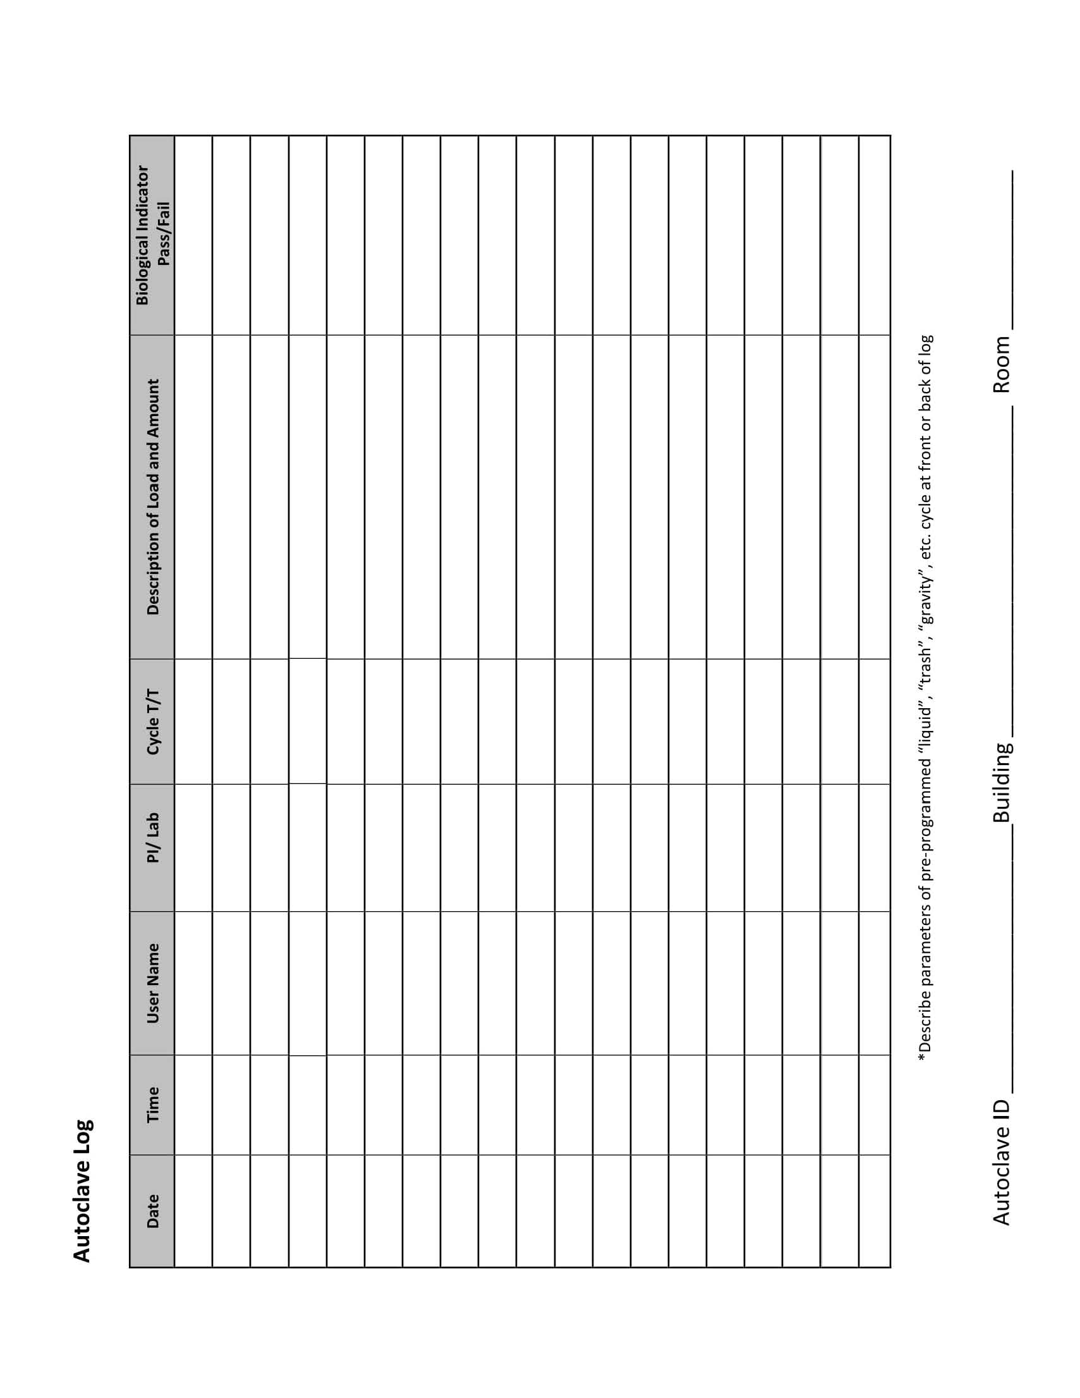
Table 6: Example of an Autoclave Validation
