

# **Texas A&M International University**

# **Laboratory Safety Manual**

Prepared by the Office of Environmental Health and Safety

**TABLE OF CONTENTS**

Chapter 1: Introduction 3

Section 1: Contact Information 3

Section 2: EH&S Laboratory Safety - Programs and Services 3

Section 3: Laboratory Safety Is Everyone’s Responsibility 4

Chapter 2: Mitigating Hazards in the Laboratory 9

Section 1: General Laboratory Safety Practices 9

Section 2: Physical Safety 12

Section 3: Equipment Safety 17

Section 4: Biological and Animal Safety 25

Section 5: Radiological and Laser Safety 25

Chapter 3: Chemical Safety 26

Section 1: Overview 26

Section 2: Hazard Communication Program 26

Section 3: Hazard Identification 27

Section 4: Chemical Safety Guidelines 28

Section 5: Safety Data Sheets 29

Section 6: Safe Handling Guidelines 30

Section 7: Chemical Storage Guidelines 30

Section 8: Hygiene and Chemical Safety 32

Section 9: Types of Chemical Hazards 33

Section 10: Protecting Oneself When Working With Chemicals 44

Section 11: Chemical Waste Disposal 44

Section 12: Transporting Hazardous Materials 44

Chapter 4: Laboratory Waste Disposal 46

Section 1: Hazardous Chemical Waste 46

Section 2: Biological Waste 48

Section 3: Glass Waste 49

Section 4: Metal Sharps 49

Section 5: Radiological Waste 50

Chapter 5: How to Protect Yourself 51

Section 1: Administrative Controls 51

Section 2: Laboratory Ventilation Equipment 53

Section 3: Personal Protective Equipment 59

**CHAPTER 1: INTRODUCTION**

It is the policy of Texas A&M International University (TAMIU) to provide and maintain a safe environment for its faculty, staff, students, and visitors.

Environmental Health & Safety (EH&S) is committed to working with faculty and staff to ensure that campus laboratories are a safe place in which to work and learn. With over 40 laboratories on the TAMIU campus, laboratory safety is a big and critical aspect of overall campus safety. It is the responsibility of *all* who work or study in laboratories to do so in a safe and environmentally responsible manner.

EH&S has established this **Laboratory Safety Manual** as a resource for faculty and laboratory personnel, as well as anyone interested in laboratory safety. This manual is intended to comply with federal, state, and local regulations, as well as industry best practices. The **Laboratory Safety Manual** is a compilation of suggested work practices, protocols, and procedures to work safely in TAMIU laboratories. The document is *not* exhaustive and should not be considered as the only reference for health and safety concerns. In addition to this manual, Environmental Health and Safety is always available to address health and safety concerns.

**SECTION 1: CONTACT INFORMATION**

*1.1 EMERGENCY*

To reach emergency responders (police, fire department, or ambulance), dial 9-911 from any campus phone line. If dialing from an outside line (i.e., cell phone), dial 911.

*1.2 NON-EMERGENCY*

* Ethics Point: 1-888-501-3850. This anonymous tip line may be called to report risk (generally unsafe conditions) or misconduct (waste of campus resources, fraud, etc.) on campus.
* Environmental Health & Safety (EH&S): 956-326-2194.
* Office of Graduate Studies and Research: 956-326-3027.
* University Police Department (UPD): 956-326-2100.
* UPD Dispatch: 956-326-2911. This phone line is manned 24 hours a day, 365 days a year to report any issues needing immediate attention, such as broken water pipes, gas odors, etc.

**SECTION 2: EH&S LABORATORY SAFETY - PROGRAMS AND SERVICES**

Programs and services provided by EH&S include the following:

* Develop policies and protocols concerning safety and health issues.
* Disseminate information concerning safety regulations, policies, protocols, and practices to members of the TAMIU community.
* Evaluate facilities through laboratory safety inspections. These evaluations help assure compliance with safety and health regulations, protocols, and practices in order to maintain safe work environments.
* Inspect/test safety equipment such as fume hoods and safety showers.
* Coordinate testing/certification of biological safety cabinets, laminar flow hoods, and cryogenic cylinders.
* Report results of evaluations, tests, etc., along with recommended corrective measures, as necessary, to appropriate personnel for action.
* Review construction plans for compliance with codes and standards.
* Respond to emergencies such as gas odors or chemical spills.
* Measure environmental parameters such as chemical vapors or noise.
* Provide the TAMIU Hazard Communication Program as required by the Texas Hazard Communication Act.
* Develop and provide safety-related training, including the Introduction to Laboratory Safety Training course (which includes general Hazard Communication Training).
* Investigate reported laboratory accidents, especially those resulting in injury, to evaluate for trends. Recommend action with the purpose of reducing the likelihood of another accident.
* Provide technical guidance on matters of laboratory safety.
* Assist laboratory personnel in the development of a Plan of Action for responding to incidents in the laboratory.
* Participate in safety committees and task forces.
* Maintain a library of relevant safety regulations and nationally recognized codes and standards.
* Assist laboratory personnel in evaluating, preventing, and controlling hazards.
* Oversee the adoption and implementation of TAMIU safety policies.
* Submit reports and other required documentation to pertinent State agencies, including the TIER II report.

**SECTION 3: LABORATORY SAFETY IS EVERYONE’S RESPONSIBILITY**

Ensuring laboratory safety is an endeavor of many individuals on the TAMIU campus, including deans, department heads, faculty, and staff. Anyone providing direct or administrative oversight of laboratory facilities is responsible for maintaining safety in those areas. Specific responsibilities are as follows.

*3.1 RESPONSIBILITIES OF EH&S*

EH&S has a variety of responsibilities, as outlined above. Provided below is more detailed information on some of those responsibilities.

**Laboratory Inspections**

EH&S is responsible for conducting safety inspections in laboratory facilities. Inspections are conducted annually and as needed or requested. While the checklist is thorough, EH&S is not limited to inspecting only those items included in it. *Any* unsafe condition noted in a laboratory environment can and will be reported.

Additional safety surveys may be required if Class III or Class IV lasers, radioactive materials, or biological materials are used in the laboratory. EH&S will notify the appropriate oversight group within TAMIU if an unsafe condition involving one or more of these items is observed.

* EH&S will make every attempt to schedule laboratory inspections with faculty members, building proctors and/or departmental safety officers. However, if the appropriate contact is unavailable or is unresponsive, EH&S will proceed with the safety inspection.
* EH&S may conduct unannounced safety inspections or accident investigations. Please be aware that federal, state and local inspectors may also conduct unannounced inspections.

**Reporting Laboratory Inspection Results**

Following the laboratory inspection, a Laboratory Safety Evaluation report listing noted safety violations is sent to the person responsible for the laboratory (a principal investigator (PI), laboratory manager, etc.). A report summarizing inspection results for the building will be sent to the Department Head, PI, and other pertinent personnel as deemed necessary.

The PI is responsible for correcting or coordinating correction of the safety violations noted in the evaluation report. Inspection items will be identified either as a **Deficiency**, as an **Item of Concern**, or as **Information**.

* Items designated as **Deficiencies** are in violation of safety codes and/or are significant hazards and must be corrected within 45 days of the date the inspection report is sent. After that time, the laboratory will be re-inspected to ensure compliance.
* **Items of Concern** are in conflict with the TAMIU Safety Manual and/or good laboratory practices. These items should be corrected expediently and will be re-evaluated at the next annual inspection.
* Items designated as **Information** indicate that the issue is not an immediate safety concern, but the information provided can help make the work area safer for laboratory personnel and/or emergency responders.

If a Laboratory Safety Evaluation indicates there are significant hazards (Deficiencies), the laboratory will be re-inspected by EH&S to verify that these hazards have been mitigated. This inspection will take place 45 days after the initial evaluation report is sent. The Laboratory Safety Evaluation report will be updated to show which deficiencies have been corrected and the date this was verified. The updated report will be sent to the PI.

Following re-inspection, EH&S will send a letter to the college dean, the department head, and other pertinent personnel as deemed necessary. This letter will indicate whether or not all significant deficiencies noted in the original inspection report have been corrected.

In addition to EH&S inspections, laboratory personnel should routinely conduct self-surveys of their work areas to ensure continued compliance with safety requirements.

**Fume Hood Inspections**

Chemical fume hood testing will be coordinated by EH&S on an annual basis.

Fume hoods that pass testing will have a certification sticker affixed to them, indicating the date of testing. If a fume hood does not pass testing requirements, a sign will be posted on the fume hood indicating that it is not to be used.

***NOTE:*** *Signs indicating a fume hood is inoperable may only be removed by EH&S personnel.*

EH&S will notify the appropriate maintenance group to schedule maintenance and/or repair of improperly performing fume hoods.

**Biological Safety Cabinet and Laminar Flow Hood Certifications**

EH&S coordinates with an outside vendor for testing and certification of biological safety cabinets and laminar flow hoods. Generally, biological safety cabinets should be certified on an annual basis. For more information of certification requirements, please see the section titled Laboratory Ventilation Equipment in Chapter 5.

To schedule certification of a biological safety cabinet or laminar flow hood, please contact EH&S at 956-326-2194.

**Laboratory Construction and Renovation Projects**

EH&S may be notified before any major laboratory modifications are made (for example, installing or removing a fume hood).

*3.2 RESPONSIBILITIES OF TAMIU ADMINISTRATION, PERSONNEL, AND STUDENTS*

**TAMIU Administrators, Including Deans**

Deans are responsible for the following:

1. Providing and maintaining the facilities and equipment required for a safe work environment.
2. Establishing methods for disseminating safety information and policies.
3. Establishing criteria for implementing safety policies and protocols.
4. Establishing a system for safety accountability.
5. Ensuring that uncorrected significant safety issues are immediately resolved.

**Department Heads and Directors**

Department Heads and Directors are responsible for the following:

1. Promoting safety and loss prevention.
2. Controlling or eliminating occupational hazards.
3. Conducting periodic safety and loss control evaluations, including those necessary for teaching laboratories.
4. Ensuring that employees are adequately trained in safety policies and protocols and maintaining training documentation.
5. Ensuring that employees are provided with appropriate personal protective clothing and equipment for safe job performance.
6. Notifying faculty and staff of TAMIU health and safety policies.
7. Ensuring that significant safety issues identified in Laboratory Safety Evaluation Reports have been corrected.

**Faculty/Principal Investigators (PIs)**

Faculty and PIs are responsible for the following:

* 1. Performing their jobs in the safest prescribed manner.
  2. Eliminating and/or reporting workplace hazards.
  3. Reporting injuries to EH&S. Reporting other accidents and incidents to their supervisors and/or EH&S and correcting unsafe practices or conditions.
  4. Complying with and implementing all applicable safety and health policies and protocols in their laboratories.
  5. Developing written standard operating procedures, including safety procedures, applicable to their research and workers.
  6. Implementing laboratory practices and providing/using engineering controls that reduce the potential for exposure to hazards.
  7. Informing all laboratory staff and students of the potential hazards associated with laboratory operations, including the hazardous properties associated with chemicals in the laboratory (e.g., toxic, flammable, peroxidizable, explosive).
  8. Informing all laboratory personnel of the proper procedures for dealing with accidents and spills.
  9. Ensuring employees and students are trained as required by the Texas Hazard Communication Act and by EH&S.
  10. Supervising laboratory personnel and/or students to ensure that safe practices and engineering controls are utilized.
  11. Instructing laboratory personnel on the location and use of all safety equipment in the facility.
  12. Designating at least one person to serve as a safety contact in the absence of the faculty member or PI.
  13. Posting telephone numbers for all emergency response and safety contacts in a noticeable area in the laboratory and on the door to the laboratory. Ensure the posting is updated during sabbaticals or other absences or when there is a change in staff.
  14. Correcting issues identified by Laboratory Safety Evaluation Reports within 45 days.
  15. Ensuring that pertinent Safety Data Sheets (SDS) are available.

**Employees and Students**

Employees and Students are responsible for:

* 1. Following all safety and health procedures specified in the Laboratory Safety Manual and by their laboratory supervisor.
  2. Completing required health and safety training sessions.
  3. Reporting accidents, unhealthy and unsafe conditions, near misses, and minor injuries to their supervisor.
  4. Notifying their personal physician if any personal health conditions could lead to serious health situations in the laboratory. For example, someone with a compromised immune system may need to take extra precautions when working with biological agents.

***NOTE:*** *Accidents resulting in injury must be reported within 24 hours of the incident. See the TAMIU Safety Manual for more information.*

**CHAPTER 2: MITIGATING HAZARDS IN THE LABORATORY**

The type of work performed in laboratories is wide-ranging. Hazards found in laboratories can vary depending on the nature of the work performed. Laboratory safety may include one or more areas of safety: chemical safety, fire safety, electrical safety, radiation safety, physical/equipment safety, laser safety and biological safety. In this chapter the variety of hazards that may be found in a laboratory and the methods for mitigating the risks are discussed.

**SECTION 1: GENERAL LABORATORY SAFETY PRACTICES**

*1.1 SAFE PRACTICES*

1. Know the hazards associated with the materials (chemical, electrical, biological, etc.) and equipment in your laboratory. Refer to the appropriate safety information, such as Safety Data Sheets (SDSs), Standard Operating Procedures (SOPs), and equipment operating instructions, and follow the recommended safe practices. Consider the hazards of procedures to be performed and what training, background information, safety equipment, etc. are required to do the procedure safely.
2. Develop a plan of action for how to respond to emergencies in your laboratory. Review this plan often so that you will be ready to respond as needed.
3. Use appropriate safety equipment, such as fume hoods and biological safety cabinets, to minimize exposure to hazardous materials. Verify that safety equipment is working properly prior to use.
4. Follow proper operating procedures when using a chemical fume hood. Keep the hood sash at a comfortable working height (less than 18”), and close the sash completely when the hood is unattended.
5. Wear appropriate personal protective equipment (PPE) and clothing. Remove PPE and wash hands before leaving the laboratory.
6. Avoid working alone in a laboratory, especially when conducting hazardous procedures or handling hazardous materials.
7. Keep doors closed and the laboratory secured when it is unattended. Limit unauthorized entry into laboratories, especially when hazardous procedures are being conducted.
8. Do not eat, drink, use tobacco products, chew gum, apply cosmetics, or handle contact lenses in the laboratory.
9. Do not store food and drinks in laboratories or in laboratory refrigerators or freezers. Do not prepare food in the laboratory or wash utensils used for food and drink in laboratory sinks. Refrigerators and freezers used for the storage of food and beverages should be kept in a separate room (break area) with a door separating the laboratory from the break area. Label these units “Food Use Only.”
10. Laboratory equipment that could be used for the preparation of food or beverages (such as microwave ovens, hot plates, and ice machines) should be dedicated exclusively for laboratory use. Clearly label such equipment to indicate “Lab Use Only,” “No Food or Drink,” and/or “Not for Human Consumption.”
11. Do not pipet chemicals or biological materials by mouth. Use mechanical pipettes or pipetting devices instead.
12. Do not leave reactions or other potentially hazardous procedures unattended. Protect operations from utility failures and other potential problems that could lead to overheating or other hazardous events.
13. Clean equipment contaminated with chemical, biological or radiological materials immediately upon completion of the task. Have a spill kit on hand and clean up minor spills immediately. Call EH&S for radiological spills or major chemical spills.
14. Avoid using dry ice in enclosed areas. Dry ice can produce elevated carbon dioxide levels.
15. Avoid contaminating equipment with mercury. Replace mercury thermometers with a non-hazardous type. Contact EH&S immediately if a mercury spill occurs.
16. Children under the age of 15 years are not permitted in laboratories or other hazardous areas unless approval is obtained by the PI, EH&S, lab manager or designee. Underage individuals shall be monitored at all times while in the lab. The age limit may be higher for certain specific hazards, such as the presence of radiological materials or BSL-2 labs
17. Keep work areas neat, clean, and free of clutter.
18. Keep hallways, corridors, and exit ways clear of equipment or clutter.

***IMPORTANT:*** *Never underestimate the hazards associated with a laboratory. If you are unsure about what you are doing, get assistance. Do not use unfamiliar chemicals, equipment, or procedures without proper training and supervision.*

*1.2 SECURITY*

Laboratory security is vital to ensure safety on campus. Not only should you protect your work area from theft and mischievous activities, but you should also keep unauthorized or unsuspecting persons from potentially becoming exposed to hazardous conditions. Follow these steps to secure your laboratory:

1. Close and lock laboratory doors when the laboratory is unoccupied.
2. Secure stocks of organisms and hazardous chemicals, especially when the laboratory is unoccupied. Lock refrigerators, freezers, and chemical storage cabinets that are located in areas open to public access.
3. Keep an accurate record of chemicals, stocks, cultures, etc. and any items or equipment that support project activities.
4. Notify the University Police Department (UPD) if materials are damaged or missing from laboratories or if unauthorized entry into a laboratory has been attempted.
5. Inspect all packages arriving into the laboratory. Do not accept suspicious or unexpected packages.
6. At the end of the day, ensure that all hazardous materials, whether chemical or biological have been properly stored and secured.
7. Greet all visitors to the laboratory immediately, and determine their reason for entering your laboratory. Ask them to exit the room if they are not authorized to be there.
8. Implement other security requirements as necessary for your work.
9. Post current Emergency Contact Information (ECI) cards on all laboratory doors.
10. Never prop open a laboratory door, except for a brief time to move items in and out.

*1.3 WORKING IN THE LABORATORY*

Every person who works in a laboratory, whether an employee or a student, is responsible for being aware of the hazards in that laboratory and for working in a safe manner. This includes:

1. Knowing where emergency contact information is posted;
2. Knowing and following emergency response procedures (including spill response, first aid response, evacuation routes, etc.);
3. Ensuring they have received proper safety training *before* working with hazardous materials or equipment;
4. Wearing appropriate Personal Protective Equipment; and
5. Reporting unsafe conditions to their supervisor and/or to EH&S.

Laboratory personnel should avoid working alone. If procedures require a person to work at a time when others may not be present (such as after hours or on weekends) and when hazardous conditions exist, the person shall:

1. Obtain written permission to work alone in the laboratory (e.g., e-mail or letter from the Principal Investigator or Laboratory Supervisor);
2. Ensure that a means to contact emergency response personnel is available when working alone in the laboratory; and
3. Make arrangements for someone to check on them at regular intervals.

***NOTE:*** *According to the National Safety Council, the term* ***alone*** *means that a person is beyond the visual or auditory range of any other individual for more than a few minutes at a time.*

*1.4 HOUSEKEEPING*

Maintaining a neat and clean laboratory work area is instrumental to minimizing accidents in the laboratory. The following steps should be taken:

1. Keep aisles clear of clutter to eliminate tripping hazards and to maintain a clear exit path in the event of an emergency, such as a fire in the laboratory or building.
2. Dispose of empty boxes and other unneeded items that take up space.
3. Keep bench tops clear of clutter. Properly store chemicals and sharps when they are not in use or at the end of the work day. A clear work space will reduce the likelihood of accidental contact with hazardous items.
4. Clean up spills, even minor ones, promptly.
5. Replace bench liners regularly or when they become dirty or contaminated.

*1.5 SIGNAGE AND CONTACT INFORMATION*

Contact information should be posted outside the entrance to every laboratory. This information should at minimum include the principal investigator (PI) or other person primarily responsible for the laboratory, the PI’s office and laboratory phone numbers, and after-hours emergency contact information.

Depending upon the hazards located in the laboratory, such as biological or radiological, additional signage may be required. This information is critical for emergency personnel responding to an incident in the laboratory. Consult the appropriate section or authority for more information on signage requirements.

**SECTION 2: PHYSICAL SAFETY**

There are a variety of physical hazards that can be found in a laboratory environment. Many of these hazards are similar to those found in every home, and if common sense is applied, risks are fairly easy to minimize. This section will focus on common physical hazards and how to reduce the risk associated with them.

*2.1 AEROSOL PRODUCTION*

Liquid or solid particles suspended in air are referred to as “aerosols.” Aerosols containing infectious agents and hazardous materials can pose a serious health risk. If inhaled, small aerosol particles can readily penetrate and remain deep in the respiratory tract. Also, aerosol particles can easily contaminate equipment, ventilation systems, and human skin. Because they may remain suspended in the air for long periods of time after they are initially discharged, steps should be taken to minimize the production of and exposure to aerosols.

The following may produce aerosols:

* Centrifuge
* Blender
* Shaker
* Magnetic stirrer
* Sonicator
* Pipette
* Vortex mixer
* Syringe and needle
* Vacuum-sealed ampoule
* Grinder, mortar, and pestle
* Test tubes and culture tubes
* Heated inoculating loop
* Separatory funnel
* Animals
* Hot plate (if chemicals are spilled onto the hot surface)
* Chemical or biological spills

Follow these guidelines to eliminate or reduce the hazards associated with aerosols:

1. Conduct procedures that may produce aerosols in a certified biological safety cabinet or a chemical fume hood.
2. Keep tubes stoppered when vortexing or centrifuging.
3. Allow aerosols to settle for five to ten minutes before opening a centrifuge, blender, or tube.
4. Place a cloth soaked with disinfectant over the work surface to kill any biohazardous agents.
5. Slowly reconstitute or dilute the contents of an ampoule.
6. When combining liquids, discharge the secondary material down the side of the container or as close to the surface of the primary liquid as possible to avoid splattering the material.
7. Avoid splattering by allowing inoculating loops or needles to cool before touching biological specimens.
8. Use a mechanical pipetting device.

*2.2 ELECTRICAL SAFETY*

Electrical safety is an important component of laboratory safety. When using electrical equipment in a laboratory, the guidelines below should be followed:

* 1. Check electrical cords and switches for damage prior to using equipment or appliances. Damaged cords (cords with frayed or exposed wires or with damaged or missing plug prongs) should be repaired promptly or the equipment should be locked/tagged out until the cord can be repaired.
  2. Use extension cords only when necessary and only on a temporary basis (less than eight hours). Do not use extension cords in place of permanent wiring. Contact Physical Plant to request new outlets if your work requires equipment in an area without an outlet.
  3. Use extension cords that are the correct size or rating for the equipment in use. The diameter of the extension cord should be the same or greater than the cord of the equipment in use.
  4. Do not run electrical cords above ceiling tiles, through walls or across thresholds.
  5. Keep electrical cords away from areas where they may be pinched and areas where they may pose a tripping or fire hazard (e.g., doorways, walkways, under carpet, etc.).
  6. Avoid plugging more than one appliance in each outlet. If multiple appliances are necessary, use a single approved power strip with surge protection and a circuit breaker. Do not overload the circuit breaker.
  7. Avoid “daisy-chaining” or “bird-nesting.” Connecting power strips and/or extension cords in a series or cluster is against fire and electrical codes.
  8. Use ground fault circuit interrupters when using electrical equipment near water sources.
  9. Keep access to electrical panels clear of obstructions.

For additional information on electrical safety, see the Electrical Safety chapter in the TAMIU Safety Manual.

*2.3 MECHANICAL/EQUIPMENT SAFETY*

There are four fundamental elements of equipment safety:

1. Use the correct equipment for the job.

Equipment should be used for its intended purpose only. Never modify or adapt equipment without guidance from the equipment manufacturer or EH&S. Do not defeat, remove, or override equipment safety devices! Doing so can result in injury or even death. (Example: Defeating a fume hood sash lock.)

1. Know how to properly operate equipment.

This may require documented, specific training. Also the user must be familiar with applicable safeguards and maintenance requirements.

1. Inspect equipment for damage and for required safety features prior to use.

Ensure that equipment meets the following requirements:

* 1. Controls and safeguards are adequate and functional (e.g., interlocks that shut-off equipment automatically and guards that protect moving parts and belts).
  2. The location is safe (and well-ventilated, if necessary).
  3. Equipment works properly.

***IMPORTANT:*** *Disconnect any equipment that is unsafe or does not work properly, and remove it from service (lock out/tag out). Notify other users of the problem*.

1. Use equipment properly.

Do not use the equipment in ways it was not designed or intended to be used.

Refer to other sections in this chapter and manual for specific information on operating laboratory equipment, such as fume hoods, heating devices, vacuums, etc.

*2.4 NOISE/AUDITORY SAFETY*

Many laboratory environments are noisy due to the number and type of equipment used in them. While some equipment is inherently noisy, others only become noisy when there is a problem, such as a loose belt. In noisy environments, precautions should be taken to protect personnel from hearing loss. Ear plugs or other hearing protection may be necessary. If equipment is operating at a louder than normal noise level, maintenance may need to be scheduled. EH&S can recommend hearing protection devices based on noise levels in the workspace and on individual needs.

For more information on auditory safety, please see the TAMIU Safety Manual.

*2.5 GLASS & METAL SHARPS*

Accidents involving glassware are a leading cause of laboratory injuries. Careful handling and disposal of metal and glass sharps can minimize the risk of cuts and puncture wounds, not only for laboratory personnel, but for other university employees as well.

**Laboratory Glassware**

Follow these practices for using laboratory glassware safely:

* 1. Prevent damage to glassware during handling and storage.
  2. Inspect glassware before and after each use. Discard or repair any cracked, broken, or damaged glassware.
  3. Thoroughly clean and decontaminate glassware after each use.
  4. 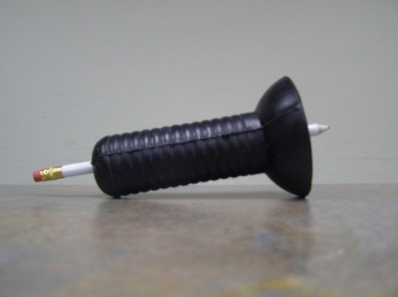When inserting glass tubing into rubber stoppers, corks, or tubing, follow these guidelines:

1. Use adequate hand protection, such as a glass tubing insertion tool.
2. Lubricate the tubing.
3. Hold hands close together to minimize movement if the glass breaks
   1. When possible, use plastic or metal connectors instead of glass connectors.
   2. Heat and cool large glass containers slowly to reduce the risk of thermal shock.
   3. Use Pyrex or heat-resistant glass for heating operations.
   4. Never use laboratory glassware to serve food or drinks or wash laboratory glassware in the same sink in which food and beverage utensils are washed.
   5. Use thick-walled and/or round-bottomed glassware for vacuum operation. Flat-bottomed glassware is not as strong as round- bottomed glassware.
   6. Use a mesh glass sleeve around glassware or tape glassware that is under pressure. This will contain the glass in one place should it break.
   7. Use a standard laboratory detergent to clean glassware.

***IMPORTANT***: *Do not use chromic acid to clean glassware. Use a standard laboratory detergent. Chromic acid is extremely corrosive and expensive to dispose of. Chromic acid must not be disposed of in the sanitary sewer system.*

When handling glassware, follow these safety guidelines:

1. When handling cool flasks, grasp the neck with one hand and support the bottom with the other hand.
2. Lift cool beakers by grasping the sides just below the rim. For large beakers, use two hands: one on the side and one supporting the bottom.
3. Never carry bottles by their necks.
4. Use a cart or specially designed secondary container to transport large and/or heavy bottles.
5. Do not pick up broken glass with bare or unprotected hands. Use a brush and dust pan to clean up broken glass. Remove broken glass in sinks by using tongs for large pieces and cotton held by tongs for small pieces and slivers.

**Metal Sharps**

Metal sharps should be carefully stored and handled properly. Follow these guidelines:

1. Do not uncap a needle by placing the cap in your mouth.
2. Never re-cap a used syringe needle by hand or mouth, and never manipulate (bend, break, shear, remove from syringe, etc.) a needle. Immediately place used/contaminated sharps in a sharps disposal container.
3. Do not leave sharps, including razor and scalpel blades, lying unprotected on bench tops. Place in a secondary container when not in use or when being transported.
4. If a needle/syringe must be reused:
   * 1. Use self-sheathing syringes or other safety devices for re-capping sharps whenever possible. The one-handed scoop method may be used as a last resort.
     2. Place the uncapped syringe/needle in cork or foam, or place it in a tray or other type of secondary container when not in use and when being transported.

For information on glass waste and sharps disposal procedures, see Chapter 4 – Laboratory Waste Disposal.

*2.6 TEMPERATURE*

Equipment that produce extreme temperatures are often used in laboratories. Whether the equipment is a -80 freezer, a walk-in cooler or freezer, cryogenic liquids, a hotplate, an oven, or an autoclave, caution should be taken whenever extreme temperatures may be encountered. Not using appropriate protective equipment, such as temperature resistant gloves, when using this equipment can lead to painful injuries.

Before using temperature generating equipment, become familiar with proper procedures and handling techniques. Pay special attention to the personal protective equipment required for that equipment. Posting signs that warn of the hazard may help reduce the likelihood of someone accidentally touching an extremely hot or cold surface – such as a hot plate - especially if it is not obvious that the equipment is on.

*2.7 PRESSURIZED SYSTEMS*

Pressurized systems have the potential to cause extensive damage and injury if extreme precaution is not taken. Pressurized systems include compressed gases, liquid cryogenic cylinders, and vacuum systems, among others. When working with pressurized systems, remember:

* 1. Do not conduct a reaction in, or apply heat to, a closed system apparatus unless the equipment is designed and tested to withstand pressure. See [American Society of Mechanical Engineers (ASME)](http://www.asme.org/) Code, Section VIII for more information about maximum allowable working pressure (MAWP).
  2. Pressurized systems should have an appropriate relief valve set at the MAWP.
  3. Pressurized systems must be fully shielded and should not be conducted in an occupied space until safe operation has been assured. Until safe operation is assured, remote operation is mandatory.

Safety points to remember:

1. Limit exposure to pressurized systems to minimize risk.
2. Identify and assess all hazards and consequences prior to beginning operations.
3. Use remote manipulations whenever possible.
4. Minimize pressure, volume, and temperature.
5. Design pressurized systems conservatively relative to the operating temperature and pressure.
6. Use material with a predictably safe failure mode.
7. Ensure that the components of the pressurized system will maintain structural integrity at the maximum allowable working pressure.

***IMPORTANT:*** *Do not use glass containers for pressurization, unless the glass item is designed to be pressurized and is rated for pressurization by the manufacturer.*

1. Only use equipment designed for use under pressure. Avoid material that may become brittle at extreme temperatures.
2. Operate within the original design parameters.
3. Ensure safety mechanisms (e.g., pressure relief valves, fail-safe devices) are in place.
4. Use quality hardware.
5. Use protective shield or enclosures.
6. Use tie-downs to secure tubing and other equipment.
7. Do not leave a pressurized system unattended.

**SECTION 3: EQUIPMENT SAFETY**

*3.1 COMPRESSED GASES*

Compressed gases in the laboratory present chemical and physical hazards. The gases may be toxic, corrosive, flammable, or explosive (reactive). If compressed gases are accidentally released, they may cause the following:

* Depleted oxygen atmosphere, potentially resulting in asphyxiation (includes inert gases)
* Fire or explosion
* Adverse health effects from chemical exposure
* Physical damage to facilities or injuries to personnel as a result of the sudden release of potential energy

Cylinders that fall or are knocked over or dropped can be very dangerous and can cause serious injuries. If a valve is knocked off a compressed gas cylinder, the cylinder can become a high speed, potentially lethal projectile.

***IMPORTANT:*** *Cylinders can travel through walls much like a torpedo travels through water. They can cause structural damage, severe injury, and even death.*

Because disposal of compressed gas cylinders is difficult and expensive, be sure to arrange a return agreement with suppliers prior to purchase.

**Guidelines to ensure safe storage of gas cylinders:**

* 1. Check the label. The cylinder must be clearly marked with its contents and with any hazard warnings. Do not rely on color to identify container contents.
  2. Secure all cylinders to a wall or bench using brackets or clamping devices designed for such. Cylinders may also be stored in gas cylinder racks or floor stands. (A cylinder dolly should not be used for storage.)
     1. Fasten cylinders individually (not ganged or grouped).
     2. Fasten cylinders with a sturdy chain or strap; bungee cords and rope are not acceptable as a means of securing compressed gas cylinders.
  3. Store cylinders in a well - ventilated area that is cool and dry. Ignition sources such as heat, sparks, flames, and electrical circuits should be kept away from gas cylinders.
  4. When not in use (i.e., the regulator has been removed), gas cylinders should be stored with a safety cap attached.
  5. Minimize the number of hazardous gas cylinders in a laboratory. Do not exceed the following:
     1. Three 10" x 50" flammable gas and/or oxygen cylinders, and
     2. Two 9" x 30" liquefied flammable gas cylinders, and
     3. Three 4" x 15" cylinders of severely toxic gases (e.g., arsine, chlorine, diborane, fluorine, hydrogen cyanide, methyl bromide, nitric oxide, phosgene).
  6. Store cylinders of flammables and oxidizing agents at least 20 feet apart, or separate these items with a fire wall.
  7. Do not store cylinders with corrosive materials.
  8. Do not store cylinders on the tops of shelves or cabinets.
  9. Keep flammable gases away from doorways or exit routes.
  10. Separate full cylinders from empty cylinders. Label empty cylinders “Empty.”
  11. Do not store gas cylinders in hallways or public areas. Cylinders should be stored in a secure area.
  12. Close valves, and release pressure on the regulators when cylinders are not in use.
  13. Dispose of old lecture bottles. Return lecture bottles to the supplier or dispose of them as hazardous waste.

**Handling and working with compressed gas cylinders:**

1. Never move a gas cylinder unless the cylinder safety cap is in place.
2. When working with particularly hazardous gases use special procedures and work in approved gas storage cabinets.
3. The gas cylinder should be chained or otherwise secured to an approved cylinder cart or dolly when being transported. Do not move a cylinder by rolling it on its base.
4. Only use regulators approved for the type of gas in the cylinder. Do not use adapters to interchange regulators. Also, never try to repair or modify a gas regulator or its pressure gauges.
5. Do not use Teflon tape when attaching the regulator.
6. When opening a cylinder valve, follow these guidelines:
   * 1. Direct the cylinder opening away from people.
     2. Open the valve slowly. Never open a cylinder valve without a regulator.
7. For a leaking cylinder:
8. Close the valve if it is open and contact the supplier to pick it up.
9. If the valve is already closed, leave the laboratory and shut the door behind you. Contact EH&S immediately.
10. Do not use oil or other lubricant on valves and fittings.
11. Do not use oxygen as a substitute for compressed air.
12. Do not lift cylinders by the safety cap.
13. Do not tamper with the safety devices on a cylinder. Have the manufacturer or supplier handle cylinder repairs.
14. Do not change a cylinder's label or color. Do not refill cylinders yourself.
15. Do not heat cylinders to raise internal pressure.
16. Do not use compressed gas to clean your skin or clothing.
17. Do not completely empty cylinders. Maintain at least 30 psi pressure.
18. Do not use copper (>65% copper) connectors or tubing with acetylene. Acetylene can form explosive compounds with silver, copper, and mercury.
19. Always wear impact resistant glasses or goggles when working with compressed gases.
20. Do not subject compressed gas cylinders to cryogenic temperatures.

*3.2 CRYOGENIC LIQUIDS*

Cryogenic fluids are extremely cold liquefied gases, such as liquid nitrogen or liquid oxygen, and are used to obtain extremely cold temperatures. Most cryogenic liquids are odorless, colorless, and tasteless. When cryogenic liquids are exposed to the atmosphere, however, they create a highly visible and dense fog.

Cryogens pose numerous hazards. A person who is exposed to cryogens can have significant health consequences. All cryogens, with the exception of oxygen, can displace breathable air and can cause asphyxiation. Cryogens can also cause frostbite on exposed skin and eye tissue.

***IMPORTANT:*** *Be aware of the tremendous expansion and threat of asphyxiation when a cryogenic liquid vaporizes at room temperature.*

There is also an increased risk of fire in areas where liquid cryogens are stored and used. For example, cryogenic vapors from liquid oxygen, liquid hydrogen or other flammable cryogens may cause a fire or explosion if ignited. Materials that are normally noncombustible (e.g., carbon steel) may ignite if coated with an oxygen-rich condensate. Liquefied inert gases, such as liquid nitrogen or liquid helium, are capable of condensing atmospheric oxygen and causing oxygen entrapment or enrichment in unsuspected areas. This enrichment can significantly increase the flammability of materials that would not normally burn in the air. Extremely cold metal surfaces are also capable of entrapping atmospheric oxygen.

Because the low temperatures of cryogenic liquids may affect physical properties of materials such as stainless steel or aluminum, take care to select equipment materials accordingly.

Follow these guidelines when working with cryogenic liquids:

* 1. Before working with cryogenic liquids, complete documented cryogenic safety training. Training must be conducted initially and refreshed annually, or when new equipment or procedures are being introduced.
  2. Reject delivery of unsafe cylinders.
  3. Keep equipment and systems extremely clean.
  4. Avoid skin and eye contact with cryogenic liquids. Wear appropriate personal protective equipment, such as a laboratory coat, temperature resistant gloves, and chemical splash goggles. Also, do not inhale cryogenic vapors.
  5. Pre-cool receiving vessels to avoid thermal shock and splashing.
  6. Use tongs to place and remove items in cryogenic liquid.
  7. When discharging cryogenic liquids, purge the line slowly. Only use transfer lines specifically designed for cryogenic liquids.
  8. Rubber and plastic may become very brittle in extreme cold. Handle these items carefully when removing them from cryogenic liquid.
  9. Store cryogenic liquids in double-walled, insulated containers (e.g., Dewar flasks) which are designed for this use.
  10. Tape exposed glass on cryogenic containers. In the event the container breaks or implodes, the tape will reduce fragmentation and violent dispersal of glass shards.
  11. Do not store cylinders of cryogenic liquids in hallways or other public areas.

*3.3 VACUUM SYSTEMS*

All vacuum equipment is subject to possible implosion. Take precautions to minimize damage and injuries that can result from an implosion. When using a vacuum system, follow these guidelines and requirements to ensure system safety:

* 1. Ensure that vacuum pumps are equipped with belt guards in place during operation.
  2. Ensure that service cords and switches are intact, undamaged, and properly grounded.
  3. Always use a trap on vacuum lines to prevent liquids from being drawn into the pump, vacuum line, or water drain. An in-line High Efficiency Particulate Air (HEPA) filter is required whenever biohazardous or recombinant DNA materials are used in a vacuum system.
  4. Replace and properly dispose of vacuum pump oil that is contaminated with condensate. Used pump oil must be collected in a designated container and disposed of as hazardous waste.
  5. Place a pan under pumps to catch oil drips.
  6. Do not operate pumps near containers of flammable chemicals.
  7. Do not place pumps in an enclosed, unventilated cabinet. Dangerous carbon monoxide gas and heat can build up in enclosed spaces.
  8. Conduct all vacuum operations behind a table shield or in a fume hood. glassware should be taped or otherwise shielded to minimize the effects of an implosion.
  9. Use only heavy-walled round-bottomed glassware for vacuum operations. The only exception to this rule is glassware specifically designed for vacuum operations, such as an Erlenmeyer filtration flask.
  10. Wrap exposed glass with laboratory-grade tape to prevent flying glass if an implosion occurs.
  11. Carefully inspect vacuum glassware before and after each use. Discard any glass that is chipped, scratched, broken, or otherwise stressed.
  12. Wear appropriate PPE, including safety glasses, lab coat, or goggles and a face shield when approaching a system under pressure.
  13. Glass desiccators often have a slight vacuum due to contents cooling. When possible, use molded plastic desiccators with high tensile strength. For glass desiccators, use a perforated metal desiccator guard or place a behind a blast shield.

***CAUTION:*** *Do not underestimate the pressure differential across the walls of glassware that can be created by a water aspirator.*

**Cold Trap**

A cold trap is a condensing device used to prevent moisture contamination in a vacuum line. Follow these guidelines for using a cold trap:

1. Locate the cold trap between the system and vacuum pump.
2. Ensure that the cold trap is of sufficient size and cold enough to condense vapors present in the system.
3. Check frequently for blockages in the cold trap.
4. Use isopropanol/dry ice or ethanol/dry ice instead of acetone/dry ice to create a cold trap. Isopropanol and ethanol are cheaper, less toxic, and less prone to foam.
5. Do not use dry ice or a liquefied gas refrigerant bath as a closed system. These can create uncontrolled and dangerously high pressures.

**Vacuum Systems and Biohazardous Materials**

Refer to the Biological Safety Manual for more information on using vacuum systems with biohazardous materials.

*3.4 CENTRIFUGES*

A centrifuge is a common piece of laboratory equipment, and using a centrifuge properly is essential to preventing accidents which could result in serious injury or destruction of the equipment. The hazards associated with centrifuges can be related to the equipment itself, the materials used in the centrifuge, or improper use of the centrifuge. It is vital that the centrifuge operator has been thoroughly trained on how to safely use the centrifuge and on how to properly maintain it.

**Guidelines for Centrifuge Use**

* 1. Centrifuge operators must be trained in the proper use, handling, storage, and maintenance of the equipment.
  2. Use a centrifuge only if it has a disconnect switch that deactivates the rotor when the lid is open. Replace older models that do not have this safety feature.
  3. Always keep the lid closed and locked during operation and shut down. Do not open the lid until the rotor is completely stopped or attempt to brake the head rotation by hand;

***IMPORTANT:*** *Attempting to defeat safety mechanisms and/or to brake the rotor by hand could result in severe injury!*

* 1. Use the centrifuge in a well-ventilated area.
  2. Low-speed and small portable centrifuges that do not have aerosol- tight chambers may allow aerosols to escape. Use a safety bucket to prevent aerosols from escaping or use the centrifuge in a biological safety cabinet or fume hood.

**Safe Operating Techniques**

The following safe operating techniques should be followed for proper centrifuge operation:

1. Inspect the inside of each tube cavity or bucket prior to using the centrifuge. The rotor and tubes should be clean and dry. Remove any glass or other debris from the rubber cushion.
2. Before loading the rotor, examine the tubes for signs of stress, and discard any tubes that are damaged.
3. Ensure that centrifuge tubes are not filled more than three-fourths full. Overfilling can result in leaks or spills. Also, do not fill tubes to the point where the rim, cap, or cotton plug becomes wet.
4. When balancing the rotors, match the tubes, buckets, adapters, and inserts against each other, and consider any added solution. Tubes, etc. should be spaced or distributed evenly around the rotor, and the density of the contents of the tubes should also be similar.
5. Do not use aluminum foil to cap a centrifuge tube. Foil may rupture or detach.
6. Ensure that the centrifuge has adequate shielding to guard against accidental ejection.
7. Stop the rotor and discontinue operation if you notice anything abnormal such as a noise or vibration.

**High Speed Centrifuges**

High-speed centrifuges pose additional hazards due to the higher stress and force applied to their rotors and tubes. It is necessary to understand the basic mechanics of the equipment and to know how to maintain it properly to ensure overall safety and reduce risk. In addition to the safety guidelines outlined above, follow these guidelines for high-speed centrifuges:

1. Be sure the centrifuge rotor and tubes are clean and dry prior to use.
2. The centrifuge should be cleaned periodically to help prevent corrosion or other damage. Routinely wash rotors with a mild dish soap to prolong rotor life. Rinse and let air dry.
3. Clean any spills in the centrifuge immediately, especially if the materials are corrosive.
4. Frequently inspect the rotor and other parts for corrosion, wear, or other damage; turn the spindle by hand. Rotors or parts exhibiting corrosion or other damage should be removed from use and evaluated by a service technician.
5. Check the expiration date of both the rotor and centrifuge. Always follow the manufacturer’s retirement date for rotors and other centrifuge parts.
6. Do not exceed manufacturer recommendations for safe operating speeds.
7. Keep a record of rotor usage and follow the manufacturer’s recommendations on when to replace the rotor.
8. For centrifuges that have been refrigerated, wipe away any excess moisture and allow the open unit to dry.
9. Filter the air exhausted from the vacuum lines.

*3.5 ELECTROPHORESIS*

Electrophoresis equipment may be a major source of electrical hazard in the laboratory. The presence of high voltage and conductive fluid in this apparatus presents a potentially lethal combination.

Many people are unaware of the hazards associated with this apparatus; even a standard electrophoresis operating at 100 volts can deliver a lethal shock at 25 milliamps. In addition, even a slight leak in the device tank can result in a serious shock.

Protect yourself from the hazards of electrophoresis and electrical shock by taking these precautions:

1. Use physical barriers to prevent inadvertent contact with the apparatus.
2. Use electrical interlocks.
3. Frequently check the physical integrity of the electrophoresis equipment.
4. Use warning signs to alert others of the potential electrical hazard.
5. Use only insulated lead connectors.
6. Turn the power off before connecting the electrical leads.
7. Connect one lead at a time using one hand only.
8. Ensure that your hands are dry when connecting the leads.
9. Keep the apparatus away from water and water sources.
10. Turn the power off before opening the lid or reaching into the chamber.
11. Do not disable safety devices.
12. Follow the equipment operating instructions.

*3.6 HEATING SYSTEMS*

Common hazards associated with laboratory heating devices include electrical hazards, fire hazards, and hot surfaces. Devices that supply heat for reactions or separations include the following:

* Open flame burners
* Hot plates
* Heating mantles
* Oil and air baths
* Hot air guns
* Ovens
* Furnaces
* Ashing systems

Follow these guidelines when using heating devices:

1. Before using any electrical heating device:
2. Ensure that heating units have an automatic shutoff to protect against overheating.
3. Ensure that heating devices and all connecting components are in good working condition.
4. Use caution when heating chemicals, as heated chemicals can cause more damage more quickly than would the same chemicals at a lower temperature.

***RULE OF THUMB:*** *Generally, reaction rates double for each 10° C increase in temperature.*

1. Use heating baths equipped with timers to ensure that they turn on and off at appropriate times.
2. Use a chemical fume hood when heating flammable or combustible solvents. Arrange the equipment so that escaping vapors do not contact heated or sparking surfaces.
3. Use non-asbestos thermal-heat resistant gloves to handle heated materials and equipment.
4. Perchloric acid digestions must be conducted in a perchloric fume hood.

***IMPORTANT:*** *See Chapter 3 - Chemical Safety for more information on using perchloric acid.*

1. Minimize the use of open flames. *Never* leave an open flame unattended*.*

*3.7 REFRIGERATORS/FREEZERS*

Using a household refrigerator to store laboratory chemicals is extremely hazardous for several reasons. Many flammables solvents are still volatile at refrigerator temperatures. Refrigerator temperatures are typically higher than the flashpoint of most flammable liquids. In addition, the storage compartment of a household refrigerator contains numerous ignition sources including thermostats, light switches, heater strips, and light bulbs. Furthermore, the compressor and electrical circuits, located at the bottom of the unit where chemical vapors are likely to accumulate, are not sealed.

Laboratory-safe and explosion-proof refrigerators typically provide adequate protection for chemical storage in the laboratory. Laboratory-safe refrigerators, for example, are specifically designed for use with flammables since the sparking components are located on the exterior of the refrigerator. Explosion-proof refrigerators are required in areas that may contain high levels of flammable vapors (e.g., chemical storage rooms with large quantities of flammables).

Follow these rules for using refrigerators and freezers in the laboratory:

1. Never store flammable chemicals in a household refrigerator.
2. Do not store food or drink in a laboratory refrigerator/freezer.
3. Ensure that all refrigerators are clearly labeled to indicate suitable usage.
4. Laboratory-safe and explosion-proof refrigerators should be identified by a manufacturer label.
5. "Not Safe for Flammable Storage" labels are available from EH&Sand must be applied to any household style refrigerator or freezer used in a laboratory.
6. Refrigerators used to hold food should be labeled "For Food Only" and should be located outside of the laboratory.

**SECTION 4: BIOLOGICAL AND ANIMAL SAFETY**

Many laboratories on campus use biological materials, including biological pathogens, toxins and allergens derived from biological agents, and recombinant DNA materials. Some laboratories work with animals in their research or in clinical settings. In these laboratories, biological and/or animal safety is integral to overall laboratory safety.

For research involving biological materials or animals, oversight by the [Office of Graduate Studies and Research](http://www.tamiu.edu/gradschool/) may be required. Three committees within the ORC oversee and grant approval for conducting such research.

* The [Institutional Review Board (IRB)](http://www.tamiu.edu/gradschool/irb.shtml) manages research involving human subjects.
* The [Institutional Animal Care and Use Committee (IACUC)](http://www.tamiu.edu/gradschool/grant/IACUCHomepage.shtml) oversees any research involving the use of animals.
* The Institutional Biosafety Committee (IBC) manages research involving recombinant DNA materials, biological pathogens, and biological toxins (including those on the Select Agent List).

Specific information on biological safety may be obtained from EH&S.

More information on Animal Safety may be found in the Agricultural Safety section in the TAMIU Safety Manual.

**SECTION 5: RADIOLOGICAL AND LASER SAFETY**

Radioactive materials and lasers pose unique hazards, and their use is regulated by the State of Texas. Refer to the TAMIU Safety Manual for more information.

**CHAPTER 3: CHEMICAL SAFETY**

***NOTE:*** *This chapter on chemical safety also appears in the TAMIU Safety* *Manual in its entirety.*

**SECTION 1: OVERVIEW**

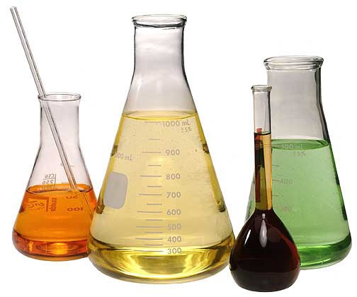Almost everyone works with or around chemicals and chemical products every day. Chemical safety is inherently linked to other safety issues including engineering controls, laboratory procedures, personal protective equipment, electrical safety, fire safety, and hazardous waste disposal. Many chemicals have properties that make them hazardous: they can create physical hazards (fire, explosion) and/or health hazards (toxicity, chemical burns, and dangerous fumes). However, there are many ways to work with chemicals which can both reduce the probability of an accident to a negligible level and minimize the consequences should an accident occur.

Risk minimization depends on safe practices, appropriate engineering controls for chemical containment, the proper use of personal protective equipment, the use of the least quantity of material necessary, and substitution of less hazardous chemicals. Before beginning an operation, one should ask "What would happen if . . .?" The answer to this question requires an understanding of the hazards associated with the chemicals, equipment and procedures involved. The hazardous properties of the material and intended use will dictate the precautions to be taken.

It is important to distinguish the difference between *hazard* and *risk*. The two terms are sometimes used as synonyms. In fact, the term “hazard” is a much more complex concept because it includes conditions of use. The hazard presented by a chemical has two components: (1) its inherent capacity to do harm by virtue of its toxicity, flammability, explosiveness, corrosiveness, etc.; and (2) the ease with which the chemical can come into contact with a person or other object of concern. The two components together determine “risk” – the likelihood or probability that a harmful consequence will occur. Thus, an extremely toxic chemical such as strychnine cannot cause poisoning if it is in a sealed container and does not contact the handler. In contrast, a chemical that is not highly toxic can be lethal if a large amount is ingested.

It should be noted that not all chemicals are considered *hazardous*. Examples of nonhazardous chemicals include pH neutral buffers, sugars, starches, agar, and naturally occurring amino acids. This chapter will focus on hazardous chemicals.

**SECTION 2: HAZARD COMMUNICATION PROGRAM**

TAMIU has a written program (the [TAMIU Hazard Communication Program)](http://www.tamiu.edu/adminis/safety/documents/TAMIUHazardCommunicationProgram.pdf) for hazardous chemicals that complies with the Texas Hazard Communication Act (THCA). This program is available from EH&S. It requires the following:

1. Employee training (including recognition of signs of exposure):
2. General – Provided by EH&S
3. Work Area Specific – Provided by individual’s supervisor (PI, laboratory manager, etc.)
4. Employee supervision
5. Labeling requirements:
6. Primary container labels – Must have the original manufacturer’s label, which includes the chemical name, hazards, and manufacturer’s information.
7. Secondary container labels – Must identify the chemical as it is on the Safety Data Sheet (SDS) and the hazards.

***EXEMPTIONS* –** Research laboratories are exempt from the secondary container labeling requirements under THCA. However, TAMIU requires that all containers be labeled so as to somehow identify the contents.

1. Availability of SDSs
2. Provision of personal protective equipment (PPE)
3. Work area chemical inventories
4. Recordkeeping requirements
5. Emergency response procedures

Refer to the [TAMIU Hazard Communication Program](http://www.tamiu.edu/adminis/safety/documents/TAMIUHazardCommunicationProgram.pdf) and other sections in this manual for more information on these topics.

**SECTION 3: HAZARD IDENTIFICATION**

An integral part of hazard communication is hazard identification. Everyone who works with hazardous chemicals should know how to read and interpret hazard information. Signs, labels, placards, and symbols alert employees to the known hazards in a particular location.

The National Fire Protection Association (NFPA) diamond in the illustration below is one method of identifying chemical hazards. NFPA uses a scale of 0 – 4 to rate each hazard, with 0 indicating “no hazard” and 4 indicating the most extreme hazard. The following is a detailed explanation of the NFPA hazard classification codes:

1. Health (Blue):

4 - Can cause death or major injury despite medical treatment

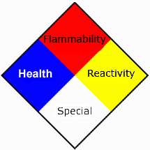3 - Can cause serious injury despite medical treatment

2 - Can cause injury. Requires prompt medical treatment

1 - Can cause irritation if not treated

0 - No hazard

1. Flammability (Red):

4 - Very flammable gases or liquids

3 - Can ignite at normal temperatures

2 - Ignites with moderate heat

1 - Ignites with considerable preheating

0 - Will not burn

1. Reactivity (Yellow):

4 - Readily detonates or explodes

3 - May detonate or explode with strong initiating force or heat under confinement

2 - Normally unstable, but will not detonate

1 - Normally stable. Unstable at high temperature and pressure.

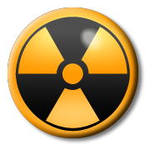0 - Normally stable and not reactive with water

1. Specific Hazard (White):

Oxidizer - OX Acid - ACID Alkali - ALK Corrosive - COR

Use No Water - ~~W~~

Radioactive – (see image at right)

Many chemicals fall under more than one hazard class. Extra care should be taken when handling or storing chemicals with multiple hazards.

Other labeling systems may also be used. For instance, the Department of Transportation (DOT) has a labeling system for the shipment of hazardous materials. Examples of DOT placards are shown within the text of this chapter.

**SECTION 4: CHEMICAL SAFETY GUIDELINES**

Always follow these guidelines when working with chemicals:

1. 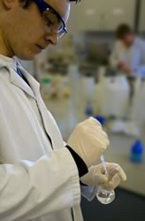Assume that any unfamiliar chemical is hazardous and treat it as such.
2. Know all the hazards of the chemicals with which you work. For example, perchloric acid is a corrosive, an oxidizer, and a reactive. Benzene is an irritant that is also flammable, toxic, and carcinogenic.
3. Never underestimate the potential hazard of any chemical or combination of chemicals. Consider any mixture or reaction product to be at least as hazardous as – if not *more* hazardous than – its most hazardous component.
4. Never use any substance that is not properly labeled. It may not be what you think it is!
5. Date all chemicals when they are received and again when they are opened.
6. Follow all chemical safety instructions, such as those listed in Safety Data Sheets or on chemical container labels, precisely.
7. Minimize your exposure to any chemical, regardless of its hazard rating, and avoid repeated exposure.
8. Use personal protective equipment (PPE), as appropriate for that chemical.
9. Use the buddy system when working with hazardous chemicals. Don’t work in the laboratory alone.

**SECTION 5: SAFETY DATA SHEETS**

Before using any chemical, read the appropriate Safety Data Sheet (SDS). An SDS is a document that details information about chemicals and along with the container label is a good source of information for chemical safety. It provides the following information:

1. Identity of the chemical
2. The manufacturer’s name and address
3. Hazardous ingredients
4. Exposure limits
5. Permissible Exposure Limit (PEL) or Recommended Exposure Limit (REL) – This is the amount of a chemical that a person can be exposed to, averaged over an eight hour period, before it causes him/her harm.
6. Short Term Exposure Limit (STEL) – This is the amount of a chemical that a person can be exposed to, averaged over a 15 minute period, before it causes him/her harm.
7. Immediately Dangerous to Life and Health (IDLH) – This is the amount of chemical that immediately puts a person a risk of serious injury or death. If this level is reached or exceeded, the area should be evacuated immediately!
8. Physical characteristics, such as:
9. Boiling point
10. [](http://www.grainger.com/product/ACCUFORM-SIGNS-Safety-Data-Sheets-Safety-WP117944/_/N-/Ntt-Safety+Data+Sheets?sst=subset&s_pp=false&picUrl=//static.grainger.com/rp/s/is/image/Grainger/38W968_AS01?$smthumb$)Vapor pressure
11. Chemical hazards, including the following:
12. Flammability
13. Explosiveness
14. Reactivity
15. Health hazards, including chemicals that are:
16. Toxins (both acute and long-term)
17. Carcinogens
18. Reproductive Toxins
19. Teratogens
20. Mutagens
21. Neurotoxins
22. Irritants
23. Routes of Entry
24. Emergency and first-aid procedures
25. Proper leak, spill, and disposal techniques
26. Proper storage and handling procedures
27. Other special provisions

Each person working with chemicals should have access to the SDS for all chemicals they use. “Access” may be:

* A current hard copy kept in a work area file or binder.
* An electronic copy.

**SECTION 6: SAFE HANDLING GUIDELINES**

Employees should treat all chemicals and equipment with caution and respect. When working with chemicals, remember to do the following:

1. 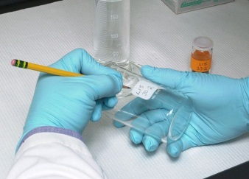Wear appropriate personal protective equipment (PPE) for the chemical hazard.
2. Remove and use only the amount of chemicals needed for the immediate job at hand.
3. Properly seal, label, and store chemicals in appropriate containers. Keep the containers clearly marked and in a well-ventilated area.
4. Segregate and store chemicals by their hazard class.
5. Check stored chemicals for deterioration and for damage to the containers.
6. Learn how to dispose of chemicals safely and legally. Follow TAMIU waste disposal requirements. (See Chapter 4 – Laboratory Waste Disposal)
7. Clean up spills and leaks immediately.
8. Develop a Plan of Action for how to respond in an emergency. Review this plan regularly to be familiar with it.
9. 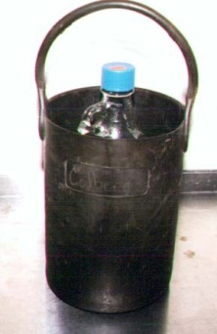Do not store chemicals near heat, in sunlight, or near substances which might initiate a dangerous reaction.
10. When transporting chemicals between the work area and other areas, use secondary containment (such as a tray, rack, cart or rubber carrier) to protect against spills, leaks or container breakage. Always use a secondary container when transporting hazardous or highly odorous chemicals on an elevator.
11. Never pour any chemicals down the sink. Use proper hazardous waste disposal procedures for all excess or unused chemicals.

**SECTION 7: CHEMICAL STORAGE GUIDELINES**

Proper chemical storage is as important to safety as proper chemical handling. Often, seemingly logical storage ideas, such as placing chemicals in alphabetical order, may cause incompatible chemicals to be stored together.

*7.1 GENERAL STORAGE GUIDELINES*

Follow these guidelines for safe chemical storage:

1. Read chemical labels and the SDS for specific storage instructions.
2. Store chemicals in a well-ventilated area; however, *do not* store chemicals in a fume hood.
3. Date all chemicals when they are received and again when they are opened.
4. Maintain an inventory of all chemicals in storage. A copy of the inventory should be maintained at a location outside of the laboratory.
5. Return chemical containers to their proper storage location after use.
6. Store glass chemical containers so that they are unlikely to be broken. Glass containers should never be stored directly on the floor.
7. Store all hazardous liquid chemicals below eye level of the shortest person working in the laboratory.
8. Never store hazardous chemicals in a public area or corridor. Hazardous chemicals must be kept in a secured area.

*7.2 SEPARATING AND STORING HAZARDOUS CHEMICALS*

In addition to the guidelines above, there are storage requirements for separating hazardous chemicals. Follow these guidelines to ensure that hazardous chemicals are stored safely:

1. Group chemicals according to their hazard category (i.e., corrosives, flammables, toxins, etc.), not alphabetically, and separated by some sort of physical barrier. An alphabetical storage system may place incompatible chemicals next to each other.
2. Separate acids from bases and inorganic acids or bases from organic acids or bases. Store these chemicals near floor level.
3. Isolate perchloric acid from all other chemicals and from organic materials. Do not store perchloric acid on a wooden shelf or spill paper.
4. Separate highly toxic chemicals and carcinogens from all other chemicals. This storage location should have a warning label and should be locked.
5. Time-sensitive chemicals, such as those that form peroxides, should not be kept longer than twelve months from purchase or six months after opening. If stratification of liquids, precipitate formation, and/or change in color or texture is noted, contact EH&S immediately.
6. Picric acid *must* be stored under a layer of liquid, as picric crystals are highly explosive. If picric acid dries out (forming yellow crystals), do not touch the container! Contact EH&S immediately!
7. If flammables need to be chilled, store them in a laboratory-safe refrigerator, not in a standard (household style) refrigerator.
8. Chemicals may be stored in the cabinets underneath a chemical fume hood provided the cabinetry is designed for that use.
9. Cabinetry designed for flammable storage vents into the fume hood exhaust duct.
10. Cabinetry designed for corrosives storage vents directly into the fume hood. Flammable chemicals should *never* be stored in this type of cabinets!
11. Some cabinetry is only designed for general storage or with a drying rack. These cabinets are not meant to be used for hazardous chemical storage.
12. Flammables should be stored in a well-ventilated area and large quantities in a flammable storage cabinet. Contact EH&S for more information on allowable storage of flammable liquids per NFPA Code.

The following table provides examples of incompatible chemicals:

|  |  |  |
| --- | --- | --- |
| **CHEMICAL** |  | **INCOMPATIBLE WITH . . .** |
| Acetic acid | Chromic acid, nitric acid, hydroxyl compounds, ethylene glycol, perchloric acid, peroxides, and permanganates | |
| Acetylene | Chlorine, bromine, copper, fluorine, silver, and mercury | |
| Acetone | Concentrated nitric and sulfuric acid mixtures | |
| Alkali metals | Water, carbon tetrachloride or other chlorinated hydrocarbons, carbon dioxide, and halogens | |
| Ammonia | Mercury, chlorine, calcium hypochlorite, iodine, bromine, and hydrofluoric acid | |
| Chlorates | Ammonium salts, acids, powdered metals, sulfur, finely divided organic or combustible materials | |
| Chlorine | Ammonia, acetylene, butadiene, butane, methane, propane (or other petroleum gases), hydrogen, sodium carbide, benzene, finely divided metals, turpentine | |
| Cyanide | Acids |  |
| Fluorine | Most other chemicals |  |
| Nitrates | Sulfuric acid |  |
| Oxygen | Oils, grease, hydrogen, flammable liquids, solids, or gases | |
| Perchloric acid | Acetic anhydride, bismuth and its alloys, alcohol, paper, wood, grease, and oils | |
| Sodium | Carbon tetrachloride, carbon dioxide, water | |
| Sulfides | Acids |  |

**SECTION 8: HYGIENE AND CHEMICAL SAFETY**

Good personal hygiene will help minimize exposure to hazardous chemicals. When working with chemicals, follow these guidelines:

1. 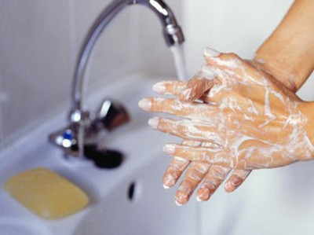Wash hands frequently and before leaving the laboratory. Also, wash hands before eating, drinking, smoking or applying makeup.
2. Wear appropriate personal protective equipment (PPE). Always wear protective gloves when handling any hazardous chemicals.
3. Remove PPE before leaving the laboratory and before washing hands.
4. Remove contaminated clothing immediately. Do not use the clothing again until it has been properly decontaminated.
5. 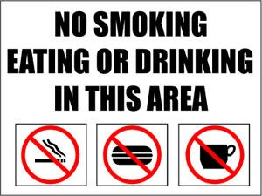Follow any special precautions for the chemicals in use.
6. Do not eat, drink, smoke or apply makeup around chemicals.
7. Tie back long hair when working in a laboratory or around hazardous chemicals.
8. Do not keep food, beverages, or food and beverage containers anywhere near chemicals or in laboratories where chemicals are in use.
9. Do not use laboratory equipment, including laboratory refrigerators/freezers, to store or serve food or drinks.
10. Do not wash food and beverage utensils in a laboratory sink.
11. Do not sniff or taste chemicals.
12. Do not touch door knobs, telephones, computer keyboards, etc. with contaminated gloves.

**SECTION 9: TYPES OF CHEMICAL HAZARDS**

*9.1 CORROSIVES*

Corrosive chemicals destroy or damage living tissue by direct contact. Some acids, bases, dehydrating agents, oxidizing agents, and organics are corrosives. Examples of the different types of corrosive chemicals are listed below:

* Acidic corrosives:
  + Inorganic Acids
    - Hydrochloric acid
    - 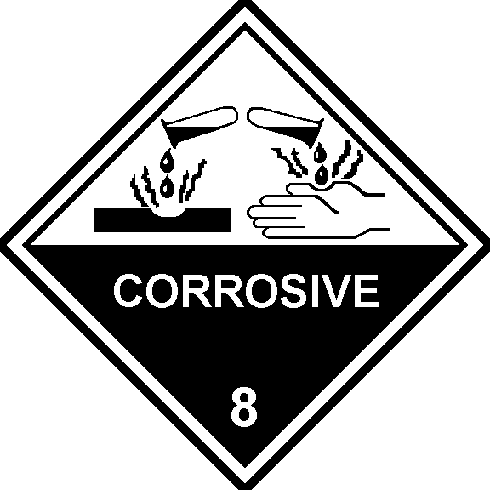Nitric Acid
    - Sulfuric acid
  + Organic Acids
    - Acetic Acid
    - Propionic acid
* Alkaline, or basic, corrosives:
  + Sodium hydroxide
  + Potassium hydroxide
* Corrosive dehydrating agents:
  + Phosphorous pentoxide
  + Calcium oxide
* Corrosive oxidizing agents:
  + Halogen gases
  + Hydrogen peroxide (concentrated)
  + Perchloric acid
* Organic corrosive:
  + Butylamine

**Health Consequences**

Extreme caution should be taken when handling corrosive chemicals, or severe injury may result.

1. Concentrated acids can cause painful and sometimes severe burns.
2. Inorganic hydroxides can cause serious damage to skin tissues because a protective protein layer does not form. Even a dilute solution such as sodium or potassium hydroxide can saponify fat and attack skin.
3. At first, skin contact with phenol may not be painful, but the exposed area may turn white due to the severe burn. Systemic poisoning may also result from dermal exposure.
4. Skin contact with low concentrations of hydrofluoric acid (HF) may not cause pain immediately but can still cause tissue damage if not treated properly. Higher concentrations of HF (50% or greater) can cause immediate, painful damage to tissues.

**Safe Handling Guidelines for Corrosives**

To ensure safe handling of corrosives, the following special handling procedures should be used:

1. Always store corrosives properly. Segregate acids from bases and inorganics from organics. Refer to the Chemical Storage section of this chapter for more information.
2. Always wear a laboratory coat, gloves and chemical splash goggles when working with corrosives. Wear other personal protective equipment, as appropriate.
3. To dilute acids, carefully add the acid to the water, not the water to the acid. This will minimize any reaction.
4. Corrosives, especially inorganic bases (e.g., sodium hydroxide), may be very slippery; handle these chemicals with care and clean any spills, leaks, splashes, or dribbles immediately.
5. Work in a chemical fume hood when handling fumes acids or volatile irritants (e.g., ammonium hydroxide).
6. A continuous flow eye wash station should be in every work area where corrosives are present. An emergency shower should also be within 55 feet of the area.

**Corrosive Example: Perchloric Acid**

Perchloric acid is a corrosive oxidizer that can be dangerously reactive. At elevated temperatures, it is a strong oxidizing agent and a strong dehydrating reagent. Perchloric acid reacts violently with organic materials. When combined with combustible material, heated perchloric acid may cause a fire or explosion. Cold perchloric acid at less than 70% concentration is not a very strong oxidizer, but its oxidizing strength increases significantly at concentrations higher than 70%. Anhydrous perchloric acid (>85%) is very unstable and can decompose spontaneously and violently.

When using perchloric acid, remember the following:

* 1. Be thoroughly familiar with the special hazards associated with perchloric acid before using it.
  2. If possible, purchase 60% perchloric acid instead of a more concentrated grade.
  3. Always wear rubber gloves and chemical splash goggles while using perchloric acid. Consider also wearing a face shield and rubber apron if splashing is likely.
  4. Store perchloric acid inside secondary containment (such as a Pyrex dish) and segregated from all other chemicals and organic materials. Do not store bottles of perchloric acid in wooden cabinets or on spill paper.

More information on perchloric acid contact EH&S.

***IMPORTANT:*** *Heated digestions with perchloric acid require a special fume hood with a wash-down system. A perchloric acid fume hood should also be used when handling highly concentrated (greater than 70%) perchloric acid. Refer to the “Laboratory Ventilation Equipment” section of Chapter 5 – How to Protect Yourself for more information on these hoods.*

*9.2 FLAMMABLES*

A flammable chemical is any solid, liquid, vapor, or gas that ignites easily and burns rapidly in air. Consult the appropriate SDS before beginning work with flammables.

**Flashpoint, Boiling Point, Ignition Temperature, and Class**

Flammable chemicals are classified according to flashpoint, boiling point, fire point, and auto-ignition temperature.

* 1. Flash Point (FP) is the lowest temperature at which a flammable liquid’s vapor burns when ignited.
  2. Boiling Point (BP) is the temperature at which the vapor pressure of a liquid is equal to the atmospheric pressure under which the liquid vaporizes. Flammable liquids with low BPs generally present special fire hazards.
  3. Fire Point is the temperature at which the flammable liquid will burned.
  4. Auto-ignition Temperature is the lowest temperature at which a substance will ignite without an ignition source.

Flammable liquids are classified according to how easily they burn. The following table illustrates flammable class characteristics as defined by NFPA 45:

|  |  |  |  |
| --- | --- | --- | --- |
| **FLAMMABLE CLASS** | **FLASHPOINT (°F)** | **BOILING POINT (°F)** | **EXAMPLES** |
| 1A | <73 | <100 | Ethyl ether  "Flammable" aerosols |
| 1B | <73 | ≥100 | Acetone Gasoline Toluene |
| 1C | ≥73 | <100 | Butyl alcohol Methyl isobutyl ketone Turpentine |
| 2 | 100 - 140 | --- | Cyclohexane Kerosene Mineral spirits |
| 3A | 140 - 199 | --- | Butyl cellosolve |
| 3B | >200 | --- | Cellosolve Ethylene glycol Hexylene glycol |

The following table provides examples of common flammables and their flashpoint and class.

|  |  |  |
| --- | --- | --- |
| **CHEMICAL** | **FLASHPOINT (°F)** | **FLAMMABLE CLASS** |
| Acetone | 0 | 1B |
| Benzene | 12 | 1B |
| Butyl Acetate | >72 | 1C |
| Carbon Disulfide | -22 | 1B |
| Cyclohexane | -4 | 1B |
| Diethylene Glycol | 225 | 3B |
| Diethyl ether | -49 | 1A |
| Ethanol | 55 | 1B |
| Heptane | 25 | 1B |
| Isopropyl Alcohol | 53 | 1B |
| Methanol | 52 | 1B |
| Pentane | <-40 | 1A |
| Toluene | 40 | 1B |

**Conditions for a Fire**

Improper use of flammable liquids can cause a fire. The following conditions must exist for a fire to occur:

* Flammable material (i.e., fuel) must be present in sufficient concentration to support a fire.
* Oxygen or an oxidizer must be present.
* An ignition source (i.e., heat, spark, etc.) must be present.

When working with flammables, always take care to minimize vapors which act as fuel.

**Safe Handling Guidelines for Flammables**

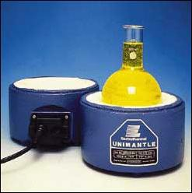

1. Handle flammable chemicals in areas free from ignition sources.
2. Never heat flammable chemicals with an open flame. Use a water bath, oil bath, heating mantle, hot air bath, hot plate, etc. Such equipment should be intrinsically safe, with no open sparking mechanisms.

***NOTE:*** *When using an oil bath, make sure the temperature is kept below the oil flash point.*

1. Use ground straps when transferring flammable chemicals between metal containers to avoid generating static sparks.
2. Work in an area with good general ventilation and use a fume hood when there is a possibility of dangerous vapors. Ventilation will help reduce dangerous vapor concentrations, thus minimizing this fire hazard.
3. Restrict the amount of stored flammables in the laboratory, and minimize the amount of flammables present in a work area.

***NOTE:*** *The NFPA has established formal limits on the total amounts of flammable liquids that may be stored or used in laboratories. (NFPA 30 and 45)*

1. Only remove from storage the amount of chemical needed for a particular experiment or task.

*9.3 SOLVENTS*

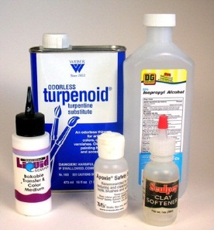Organic solvents are often the most hazardous chemicals in the work place. Solvents such as ether, alcohols, and toluene, for example, are highly volatile and flammable. Perchlorinated solvents, such as carbon tetrachloride (CCl4), are non-flammable. But most hydrogen-containing chlorinated solvents, such as chloroform, are flammable.

When exposed to heat or flame, chlorinated solvents may produce carbon monoxide, chlorine, phosgene, or other highly toxic gases.

Always use volatile and flammable solvents in an area with good ventilation or preferably in a fume hood. Never use ether or other highly flammable solvents in a room with open flames or other ignition sources present, including non-intrinsically safe fixtures.

**Solvent Exposure Hazards**

Health hazards associated with solvents include exposure by the following routes:

* Inhalation of a solvent may cause bronchial irritation, dizziness, central nervous system depression, nausea, headache, coma, or death. Prolonged exposure to excessive concentrations of solvent vapors may cause liver or kidney damage. The consumption of alcoholic beverages can enhance these effects.
* Skin contact with solvents may lead to defatting, drying, and skin irritation.
* Ingestion of a solvent may cause severe toxicological effects. Seek medical attention immediately.

The odor threshold for the following chemicals exceeds acceptable exposure limits. Therefore, if you can smell it, you may be overexposed — *increase ventilation immediately!* Examples of such solvents are:

* Chloroform
* Benzene
* Carbon tetrachloride
* Methylene chloride

***NOTE:*** *Do not depend on your sense of smell alone to know when hazardous vapors are present. The odor of some chemicals is so strong that they can be detected at levels far below hazardous concentrations (e.g., xylene).*

Some solvents (e.g., benzene) are known or suspected carcinogens.

**Reducing Solvent Exposure**

To decrease the effects of solvent exposure substitute hazardous solvents with less toxic or hazardous solvents whenever possible. For example, use hexane instead of diethyl ether, benzene or a chlorinated solvent.

**Solvent Example: DMSO**

Dimethyl sulfoxide (DMSO) is unique because it is a good solvent with many water-soluble as well as lipid-soluble materials. Due to these properties, dimethyl sulfoxide is rapidly absorbed and distributed throughout the body.

DMSO can facilitate absorption of other chemicals – such as grease, oils, cosmetics – that may contact the skin.

* While DMSO alone has low toxicity, when combined with other, more toxic chemicals it can cause the more toxic chemical to be absorbed more readily through the skin.
* Some medications, such as liniment, also contain DMSO.

While relatively stable at room temperature, DMSO can react violently to other chemicals when heated.

Wear impervious clothing and personal protective equipment (laboratory coat, gloves, etc.) to prevent skin exposure. Use chemical splash goggles and/or a face shield if splashing may occur.

*9.4 TOXINS AND IRRITANTS*

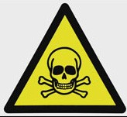

The toxicity of a chemical refers to its ability to damage an organ system (kidneys, liver), disrupt a biochemical process (e.g., the blood-forming process) or disrupt cell function at some site remote from the site of contact. Any substance, even water, can be harmful to living things under the right conditions.

The **biological effects** – whether beneficial, indifferent or toxic – of all chemicals are dependent on a number of factors, including:

* Dose (the amount of chemical to which one is exposed)
* Duration of exposure (both length of time and frequency)
* Route of entry:
  + Ingestion
  + Absorption through the skin
  + Inhalation
  + Injection

***NOTE:*** *Inhalation and dermal absorption are the most common methods of chemical exposure in the workplace.*

* Individual response and history
* One’s exposure to other chemicals
* Mixing the toxin with other chemicals

The most important factor in toxicity is the dose-time relationship. In general, the more toxin to which an individual is exposed, and the longer they are exposed to it, the stronger their physiological response will be. However, an individual’s response can also depend on several other factors, including:

* + Health
  + Gender
  + Genetic predisposition
  + An individual’s exposure to other chemicals
  + Previous sensitization

***NOTE:*** *When a person becomes sensitized to a chemical, each subsequent exposure may often produce a stronger response than the previous exposure.*

* + Chemical mixtures

***NOTE: Combining*** *a toxic chemical with another chemical can increase the toxicity of either or both chemicals.*

***IMPORTANT:*** *Minimize exposure to any toxic chemical.*

**General Safe Handling Guidelines**

1. Read the appropriate SDS.
2. Be familiar with the chemical’s exposure limits.
3. Use a chemical fume hood.
4. *Always* wear appropriate PPE.
5. *Never* eat, drink, or use tobacco products around toxins or store them near any hazardous chemicals.
6. Avoid touching your face or other exposed skin with contaminated gloves or other contaminated materials.
7. Store toxic gases in a gas exhaust cabinet.

**Acute Toxins vs. Chronic Toxins**

The dose-time relationship forms the basis for distinguishing between acute toxicity and chronic toxicity.

The **acute toxicity** of a chemical is its ability to inflict bodily damage from a single exposure. A sudden, high-level exposure to an acute toxin can result in an emergency situation, such as a severe injury or even death. Examples of acute toxins include the following:

* Hydrogen cyanide
* Hydrogen sulfide
* Nitrogen dioxide
* Ricin
* Organophosphate pesticides
* Arsenic

***IMPORTANT:*** *Do not work alone when handling acute toxins. Use a fume hood to ensure proper ventilation, or wear appropriate respiratory protection if a fume hood is not available*.

**Chronic toxicity** refers to a chemical's ability to inflict systemic damage as a result of repeated exposures, over a prolonged time period, to relatively low levels of the chemical. Such prolonged exposure may cause severe injury. Examples of chronic toxins include the following:

* Mercury
* Lead
* Formaldehyde

Some chemicals are extremely toxic and are known primarily as acute toxins. Some are known primarily as chronic toxins. Others can cause either acute or chronic effects.

The toxic effects of chemicals can range from mild and reversible (e.g. a headache from a single episode of inhaling the vapors of petroleum naphtha that disappears when the victim gets fresh air) to serious and irreversible (liver or kidney damage from excessive exposures to chlorinated solvents). The toxic effects from chemical exposure depend on the severity of the exposures. Greater exposure and repeated exposure generally lead to more severe effects.

**Types of Toxins**

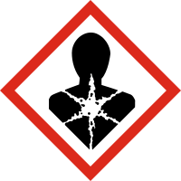**Carcinogens** are materials that can cause cancer in humans or animals. Several agencies including OSHA (Occupational Safety & Health Administration), NIOSH (The National Institute for Occupational Safety and Health), and IARC (International Agency for Research on Cancer) are responsible for identifying carcinogens.

There are very few chemicals known to cause cancer in humans, but there are many suspected carcinogens and many substances with properties similar to known carcinogens.

Examples of known carcinogens include the following:

* Asbestos
* Benzene
* Tobacco smoke
* Hexavalent Chromium
* Aflatoxins

Zero exposure should be the goal when working with known or suspected carcinogens. Workers who are routinely exposed to carcinogens should undergo periodic medical examinations.

**Reproductive toxins** are chemicals that can adversely affect a person’s ability to reproduce.

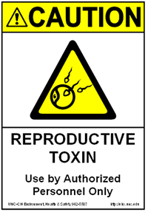

**Teratogens** are chemicals that adversely affect a developing embryo or fetus. Heavy metals, some aromatic solvents (benzene, toluene, xylenes, etc.), and some therapeutic drugs are among the chemicals that are capable of causing these effects. In addition, the adverse effects produced by ionizing radiation, consuming alcohol, using nicotine and using illicit drugs are recognized.

While some factors are known to affect human reproduction, knowledge in this field (especially related to the male) is not as broadly developed as other areas of toxicology. In addition, the developing embryo is most vulnerable during the time before the mother knows she is pregnant. Therefore, it is prudent for all persons with reproductive potential to minimize chemical exposure.

**Sensitizers** may cause little or no reaction upon first exposure. Repeated exposures may result in severe allergic reactions.

Examples of sensitizers include the following:

* Isocyanates
* Nickel salts
* Beryllium compounds
* Formaldehyde
* Diazomethane
* Latex

**NOTE:** *Some people who often use latex-containing products may develop sensitivity to the latex. A sensitized individual’s reaction to latex exposure can eventually include anaphylactic shock, which can result in death. To minimize exposure to latex, use non-latex containing gloves, such as nitrile gloves.*

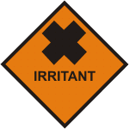**Irritants** cause reversible inflammation or irritation to the eyes, respiratory tract, skin, and mucous membranes. Irritants cause inflammation through long-term exposure or high concentration exposure. For the purpose of this section, irritants do not include corrosives.

Examples of irritants include the following:

* Ammonia
* Formaldehyde
* Halogens
* Sulfur dioxide
* Poison ivy
* Phosgene
* Dust
* Pollen
* Mold

**Mutagens** can alter DNA structure. Some mutagens are also carcinogens. Examples of mutagens are:

* Ethidium bromide
* Nitrous acid
* Radiation

**Neurotoxins** are chemicals that affect the nervous system. Examples of neurotoxins include:

* Methanol
* Many snake and insect venoms
* Botulinum toxin

*9.5 REACTIVES AND EXPLOSIVES*

**Reactive chemicals** may be sensitive to either friction or shock, or they may react in the presence of air, water, light, heat, or other chemicals. Some reactive chemicals are inherently unstable and may quickly decompose on their own, releasing energy in the process. Others form toxic gases when reacting.

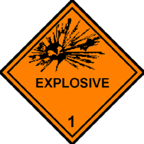

**Explosive chemicals** decompose or burn very rapidly when subjected to shock or ignition. Reactive and explosive chemicals produce large amounts of heat and gas when triggered, and thus are extremely dangerous.

Follow these guidelines when handling and storing reactive and explosive chemicals:

* 1. Read the appropriate SDS and other pertinent fact sheets on the chemical. Be familiar with chemical specific handling and storage requirements.
  2. Follow Standard Operating Procedures and to have a Plan of Action established for how to handle emergency situations.
  3. Isolate the chemical from whatever causes a reaction.

1. Store reactives separate from other chemicals.
2. Store reactives in a cool/dry area.
3. Keep reactive chemicals out of sunlight and away from heat sources.
   1. Know where emergency equipment is located and how to use it.

Examples of reactive compounds include the following:

|  |  |
| --- | --- |
| **REACTIVE CLASSIFICATION** | **CHEMICAL EXAMPLES** |
| Acetylenic compounds | Acetylene  Copper(I) acetylide |
| Azides | Benzenesulfonyl azide  Lead (II) azide |
| Azo compounds | Azomethane  Diazomethane |
| Chloro/perchloro compounds | Lead perchlorate  Potassium chlorite  Silver chlorate  Perchloric Acid (Anhydrous) |
| Fulminates | Copper (II) fulminate  Silver fulminate |
| Nitro compounds | Nitromethane  Trinitrotoluene (TNT) |
| Nitrogen-containing compounds | Silver amide  Silver nitride |
| Organic peroxide formers | Diethyl ether  Isopropyl ether |
| Picrates | Picric acid (dry)  Lead picrate |
| Peroxides | Diacetyl peroxide  Zinc peroxide |
| Strained ring compounds | Benzvalene  Prismane |
| Polymerizable compounds | Butadiene  Vinyl chloride |

**SECTION 10: PROTECTING ONESELF WHEN WORKING WITH CHEMICALS**

For information on ways to protect oneself when working with chemicals, including information on personal protective equipment, engineering controls, and how to respond to chemical spills and exposures, see Chapter 5 of this manual, which is titled, “How to Protect Yourself.”

**SECTION 11: CHEMICAL WASTE DISPOSAL**

Chemical waste must be disposed of as hazardous waste. For information on chemical waste disposal, see Chapter 4 – Laboratory Waste Disposal.

**SECTION 12: TRANSPORTING HAZARDOUS MATERIALS**

The U.S. Department of Transportation regulates the shipment of hazardous materials. Anyone who packages, receives, unpacks, signs for, or transports hazardous chemicals must be trained and certified in Hazardous Materials Transportation. Warehouse personnel, shipping and receiving clerks, truck drivers, and other employees who pack or unpack hazardous materials must receive this training as well. Contact EH&S for more information on shipping and receiving hazardous chemicals.

**What is a hazardous material?** A hazardous material is defined as any substance or material which has the potential to cause harm to humans, animals, or the environment, either by itself or through interaction with other factors.

**Hazardous materials may include items such as, but not limited to:**

* Laboratory chemicals (including research samples)
* Dry ice
* Radioactive materials
* Compressed gases
* Biological agents
* Equipment or instruments that contain hazardous materials
* Lithium batteries and other rechargeable batteries

**The following procedures should be taken prior to packaging and/or shipping hazardous materials:**

1. Any questions on packaging, labeling, and the classification of hazardous materials should immediately be directed to Adrian Dominguez, Safety/Risk Director, by phone at ext. 2756 or via email at [adrian.dominguez@tamiu.edu](mailto:adrian.dominguez@tamiu.edu) with at least 1 week notice.
2. Prior to the shipping of any hazardous material, EH&S must review and approve the packaging and the method for transportation that will be used.
3. An appropriate carrier (such as FedEx) must be used to ship hazardous materials.
4. If proper documentation is incomplete packages will not be accepted.
5. The shipper is responsible for all shipping costs.
6. International Shipping will require an additional [Export Control form](http://www.tamiu.edu/adminis/support/documents/ShippingExportControlComplianceForm-Revised07162014.pdf).

For additional information please contact the University Mail Room at 956-326-2353 or [mailroom@tamiu.edu](mailto:mailroom@tamiu.edu).

**CHAPTER 4: LABORATORY WASTE DISPOSAL**

Disposal of hazardous materials is regulated by various federal and state agencies. Laboratory waste very often includes hazardous chemical, biological, or radiological materials. Thus, proper disposal of laboratory waste is not only prudent, it is mandatory. Environmentally sound disposal methods prevent harm to the water, land, and air and by extension, to people as well. Proper disposal techniques also protect waste handlers from harm.

Laboratory waste disposal can be broken down into five categories – hazardous (chemical) waste, biological waste, radioactive waste, glass waste, and metal (sharps) waste – which are discussed below.

**SECTION 1: HAZARDOUS CHEMICAL WASTE**

The term “hazardous waste” refers to hazardous *chemical* waste. If waste chemicals contain infectious materials or biological hazards, the waste must be treated first as biological waste. Once the biological hazard has been eliminated, then the waste can be treated as hazardous waste. Any waste containing radioactive materials must be treated as radiological waste.

Disposal of hazardous waste is governed by the Environmental Protection Agency (EPA) and by the Texas Commission on Environmental Quality (TCEQ) through Federal and State regulations. TAMIU complies with hazardous waste disposal regulations by following the [TAMIU Hazardous Waste Management](http://www.tamiu.edu/adminis/safety/LAB_SAFETY.shtml).

Laboratory personnel can ensure compliance with the Hazardous Waste Management Program by following a few simple steps:

1. *Never* dispose of chemicals improperly. Improper disposal includes:
   1. pouring chemicals down the drain;
   2. leaving uncapped chemical containers in the fume hood to evaporate off the chemical; *and*
   3. disposing of chemicals in the regular trash.
2. Collect waste in a leak proof container that is in good condition, that can be securely closed, and that is appropriate for the given chemical.

***NOTE:*** *If a large waste container (>10 gallons) is warranted, contact EH&S* *for assistance.*

1. When reusing a container to collect chemical waste, completely deface or remove the original label.
2. Label the container:
   1. The words “Hazardous Waste” must be written on the container, or a Hazardous Waste Disposal Tag must be affixed to the container. (See “Hazardous Waste Disposal Tags and Waste Collection” below.)
   2. Identify the contents of the waste container on the container itself and on the tag (if attached). Example: Nitric Acid Waste, or Phenol Waste.
3. Do *not* mix incompatible waste chemicals in a single container. Use separate waste containers for different waste streams.
4. Do *not* overfill the waste container.

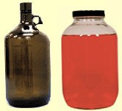

1. For liquid hazardous waste:
   * 1. Do not fill jugs and bottles past the shoulder of the container.
     2. Fill closed head cans (5 gallons or less), leaving approximately two inches of space between the liquid level and the top of the container.
     3. Fill closed head drums (larger than 5 gallons), leaving approximately four inches of space.
2. For solid hazardous waste materials, do not fill beyond the weight capacity of the container, and leave at least two inches head space for closure. *Do not fill past shoulder.*
3. Keep waste containers closed. Waste containers should only be open when adding or removing material.

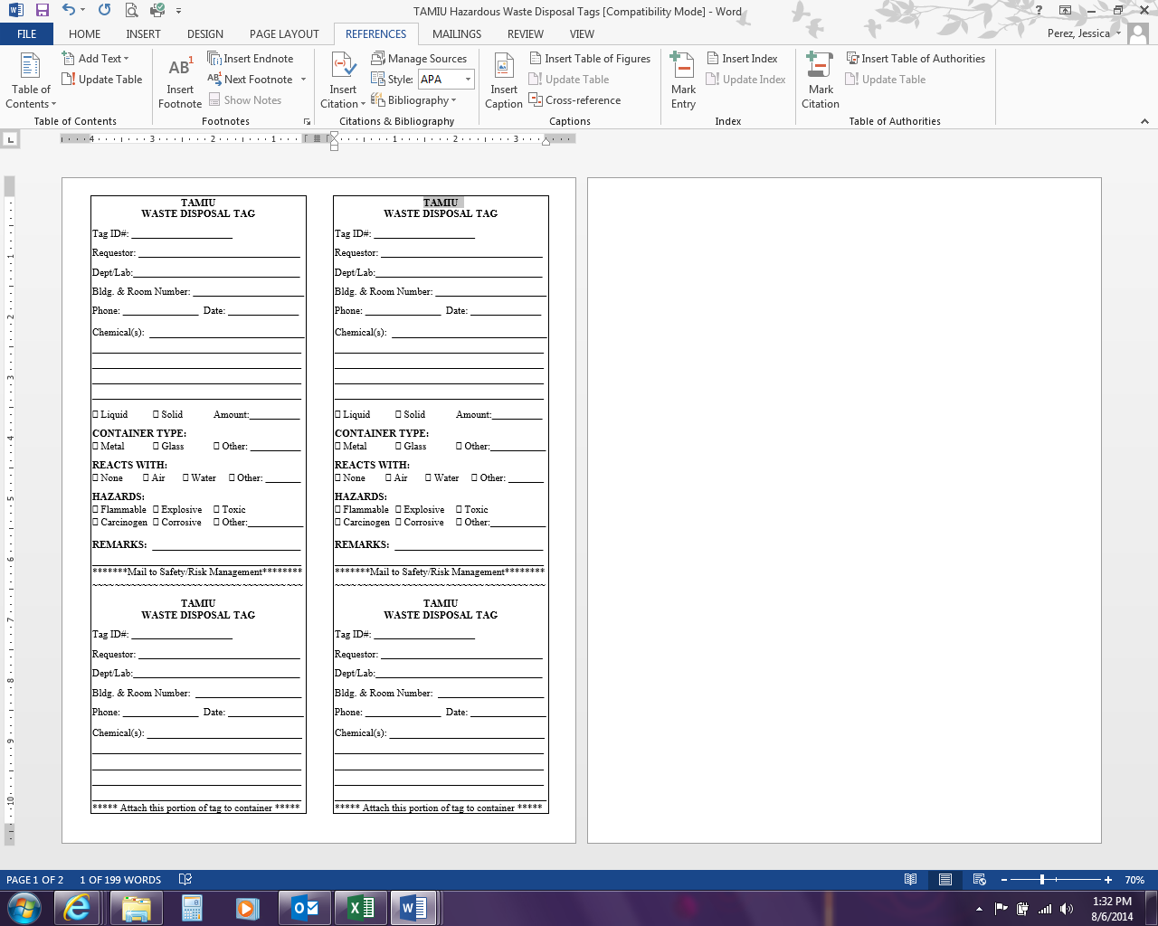*1.1 HAZARDOUS WASTE DISPOSAL TAGS AND WASTE COLLECTION*

When the waste container is ready for disposal, it should be tagged with a Hazardous Waste Disposal Tag. These tags may be obtained from EH&S. Fill out the tag following the guidelines below:

1. Completely fill out both the upper and lower sections of the tag. (This information is essential for record keeping.)
2. The "REQUESTOR" is the person in charge of the laboratory.
3. Use full chemical names or common names. Chemical formulas or abbreviations are not acceptable.
4. List all chemical components, including water. Long lists may be continued on the back of the tag.
5. Indicate the percent concentration of potentially explosive materials such as picric acid and nitro compounds.
6. Place additional hazard information in REMARKS.
7. Attach the tag to the container with a string which encircles the container, rubber bands and tape may also be used. Wire is not acceptable.

***NOTE:*** *Do not fill in the Accumulation Start Date on the waste tag. EH&S* *will date the tags after they pick up the waste containers.*

The bottom section of the properly completed tag must be mailed/emailed to EH&S. After the tag is received, the Hazardous Waste Management team will collect the waste.

***NOTE:*** *Some departments have satellite waste disposal areas, where waste containers may be accumulated for pick-up. If waste is taken to a satellite accumulation area, the waste tag should remain intact. For more information, contact EH&S.*

*1.2 DISPOSING OF EMPTY CHEMICAL CONTAINERS*

Empty chemical containers may be disposed of in the regular trash provided the following EPA requirements are met:

1. Containers must not contain free liquid or solid residue.
2. Containers must be triple rinsed.
3. Product labels must be defaced or removed.
4. Container lids or caps must be removed.
5. Render metal containers and plastic jugs unusable by punching holes in the bottom of the containers before disposing of them in the regular trash. (It is not necessary to break empty glass containers.)

***IMPORTANT:*** *Containers that do not meet the requirements mentioned here must be treated as hazardous waste.*

Refer to the [Hazardous Waste Management Program](http://www.tamiu.edu/adminis/safety/LAB_SAFETY.shtml) for more information on hazardous waste disposal procedures and regulations as well as information on waste reduction and minimization.

**SECTION 2: BIOLOGICAL WASTE**

The Texas Department of State Health Services (TDSHS) and the Texas Commission on Environmental Quality (TCEQ) regulate the disposal of biohazardous materials. Biohazardous materials include organisms or substances derived from biological materials or organisms that may be harmful to humans, animals, plants, or the environment. *Biohazardous waste* includes any waste materials that contain biohazardous materials, such as

* Waste (including blood) from *and* bedding or litter used by infectious animals
* Bulk human blood or blood products and waste materials contaminated with human blood
* Microbiological waste (including pathogen-contaminated disposable culture dishes and disposable devices used to transfer, inoculate, and mix pathogenic cultures)
* Biological pathogens
* Sharps
* Any recombinant (rDNA) materials and products of genetic manipulation

***IMPORTANT:*** *All biohazardous material must be decontaminated prior to disposal.*

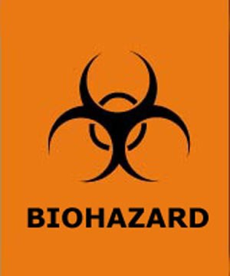

Biohazardous waste mixed with hazardous chemical or radioactive waste must be treated to eliminate the biohazard *prior* to disposal. After treatment, the waste can be managed as either hazardous chemical waste or as radiological waste.

There are strict safety requirements regarding segregation, labeling, packaging, treatment (including documentation), and transportation of biohazardous waste. The guidelines below should be followed:

1. Do not mix biological waste with chemical waste or other laboratory trash.
2. Segregate hazardous biological waste from nonhazardous biological waste.
3. Clearly label each container of untreated biohazardous waste and mark it with the Biohazard Symbol.
4. It is recommended to label nonhazardous biological waste as "NONHAZARDOUS BIOLOGICAL WASTE."

For information on biological waste treatment methods and disposal requirements, contact EH&S.

**SECTION 3: GLASS WASTE**

Glassware should never be disposed of in the regular trash. Pasteur pipettes and broken glass can break through trash bags and cut individuals who handle trash. Follow these guidelines when disposing of broken glass:

* Do not pick up broken glass with bare or unprotected hands. Use a brush and dust pan to clean up broken glass. Remove broken glass in sinks by using tongs for large pieces and cotton held by tongs for small pieces and slivers.
* Glass contaminated with biological agents must be decontaminated by thermal or chemical treatment before disposal.
* Glassware contaminated with chemical or radiological materials must also be decontaminated prior to disposal. If decontamination is not possible, the glass should be disposed of as hazardous or radioactive waste.
* Place non-contaminated broken glass in a rigid, puncture resistant container such as a sturdy cardboard box. Mark the box “Non-Contaminated Broken Glass.” Once the box is three-quarters full, seal it shut. The box should then be placed in the dumpster by laboratory personnel. *Custodial staff are not responsible for disposing of glass waste containers.*

***NOTE:*** *If broken glass is commingled with metal sharps, it must be treated as sharps waste and encapsulated before for disposal.*

**SECTION 4: METAL SHARPS**

All materials that could cause cuts or punctures must be contained, encapsulated, and disposed of in a manner that does not endanger other workers. Needles, blades, etc. are considered biohazardous even if they are sterile, capped, and in the original container. The following guidelines apply to handling and disposing of sharps:

1. Metal sharps must be segregated from all other waste.
2. Sharps that have been used with chemical or biological materials should be decontaminated prior to disposal whenever possible.
3. Sharps that have radiological contamination must be disposed of as radiological waste.
4. Dispose of sharps in a rigid container, such as a sturdy plastic jar or a metal can.
5. When the container is three-quarters full, encapsulate the sharps with Plaster of Paris or some other solidifying medium.
6. Once the contents are encapsulated, seal the sharps container, label it “Encapsulated Sharps,” and take it to the dumpster.

***NOTE:*** *Laboratory personnel are responsible for sharps disposal. Custodial staff are not responsible for encapsulating and/or disposing of metal sharps waste.*

**SECTION 5: RADIOACTIVE WASTE**

Radioactive materials, depending upon the license, are regulated by the State of Texas or the Nuclear Regulatory Commission, and these regulations/rules are enforced by EH&S. All radioactive wastes shall be disposed of through EH&S or via written procedures approved by EH&S.

**CHAPTER 5: HOW TO PROTECT YOURSELF**

**SECTION 1: ADMINISTRATIVE CONTROLS**

Protecting oneself when working in a hazardous environment begins with administrative controls, which includes administrative actions, documented training, and pre-planning.

*1.1 ADMINISTRATIVE ACTIONS*

Departments are expected to enforce safety standards through administrative actions in a variety of ways. For instance, employee performance evaluations should reflect that laboratory personnel are following TAMIU safety standards and protocols in their work areas. Also, it is each department’s responsibility to establish whether safety performance should be included in the grading criteria for laboratory courses.

Appropriate safety signage is another way departments can promote safety in laboratories. Signs indicating the hazards present in the laboratory can be posted on laboratory doors. Signs pointing to the location of safety equipment in or near the laboratory can minimize the consequences of an incident by enabling employees to quickly locate needed equipment. Emergency contact information should be posted outside each laboratory door to make is easier for emergency responders to obtain needed information quickly. A template for emergency contact information may be found by contacting EH&S.

**And finally, departments should ensure that all laboratory employees receive proper training for the hazards in their work areas and that such training is properly documented and filed.**

*1.2 EMPLOYEE HAZARD COMMUNICATION TRAINING*

Before entering a laboratory, all new laboratory employees, including teaching assistants, must receive training on the hazards they will encounter in their work area. This training includes both general and work area specific Hazard Communication Training. Hazard communication training is required by the Texas Hazard Communication Act (THCA).

**General Training**

General hazard communication training is provided online through Train-Traq.

**Work Area Specific Training**

Work area specific training is provided by the principal investigator, laboratory manager and/or laboratory supervisor. This training should focus on the specific hazards in the employee’s work area, such as chemical hazards, equipment hazards, biological hazards, etc. Work area specific training should also include the location of SDSs, the proper use of personal protective equipment, the location and proper use of safety equipment (fume hoods, biological safety cabinets, etc.), the location and use of emergency equipment (showers, eyewashes, fire extinguishers, spill kits, etc.), and the proper response to emergency situations (fires, chemical spills, etc.).

Training should also be provided for new hazards that are introduced into the work area. If new information becomes available for an existing hazard, additional training on that information should be provided.

**Training Documentation**

Employee safety training must be documented and records maintained for at least five years per the THAC. Completion of the on-line Hazard Communication Training course is documented in Train-Traq. A copy of this record should be maintained in the employee’s personnel records.

Documentation of Work Area Specific Training should include the date of training, specific topics covered, the name of the person providing the training, and the signature of the trainee. Space is provided on the Hazard Communication Training Record for work area specific training.

*1.3 ADDITIONAL TRAINING OPTIONS*

In addition to Hazard Communication Training, EH&S provides other training opportunities for TAMIU laboratory employees. A list of training courses provided by EH&S is available by contacting EH&S.

*1.4 STUDENT SAFETY*

**Student Training and Acknowledgement Forms**

Per the TAMIU Hazard Communication Program, “Students enrolled in Laboratory Courses will receive appropriate safety information and instruction if class work involves hazardous chemicals; the instructor or class supervisor will provide this training.”

Laboratory students must be provided a written notice of known potential laboratory hazards and a copy of safety rules at the beginning of the semester or summer term. Each student must sign a Student Acknowledgement Form, which indicates they have received and read the rules for that course. Students who have not signed the acknowledgement form shall not be permitted in the laboratory. The signed forms shall be retained by the department for at least a year following the end of the semester or term the course was taken.

Instruction on safe and proper use of laboratory equipment should also be provided to students as needed. Student training should be documented through written course instructions.

**Departmental Oversight of Student Safety**

It is recommended that departments with teaching laboratories periodically conduct self-evaluations to ensure teaching assistants are enforcing safety rules and students are complying with them. These evaluations should be documented, as should any discrepancies found and steps taken to correct them.

*1.5 PRE-PLANNING*

Many laboratory hazards can be minimized by pre-planning. Before beginning work on a new project, the associated hazards should be considered carefully. What are the sources of danger? Are there chemical, equipment, or electrical hazards? Consider also the risk of an accident or exposure occurring, and what the impact of that incident would be. Also, conduct a thorough safety review of new apparatuses.

Once the hazards have been identified, steps to minimize risk should be implemented. This includes utilizing engineering controls (such as fume hoods) and personal protective equipment. If the hazard is chemical, another option would be to substitute a less hazardous chemical. Or perhaps the project can be designed in such a way as to separate incompatibles, such as electrical equipment and water.

Careful planning is essential to a safe laboratory!

**SECTION 2: LABORATORY VENTILATION EQUIPMENT**

Ventilation in a laboratory is a very important aspect of laboratory safety. General room exhaust is not sufficient to protect the laboratory worker who uses hazardous chemicals, works with biological agents or uses equipment that generates excess heat. Additional engineering controls are required. This section discusses different types of laboratory ventilation.

*2.1 CHEMICAL FUME HOODS*

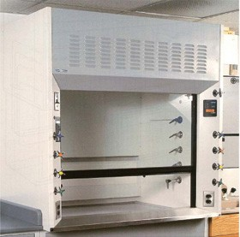Chemical fume hoods provide primary containment in a chemical laboratory. They exhaust toxic, flammable, noxious, or hazardous fumes and vapors by capturing, diluting, and removing these materials. Fume hoods also provide physical protection against fire, spills, and explosions.

For optimum performance and most effective protection, chemical fume hoods should be located away from doorways, supply air vents, and high-traffic areas. Air currents created by passers-by can cause turbulence in a fume hood, which can result in contaminated air being drawn back out of the hood and into the room.

Similarly, a supply air vent located directly above a fume hood can also cause turbulence in the hood.

TAMIU requires that all chemical fume hoods be ducted to the outside of the building and operate with an average face velocity that is consistent with industry standards. The acceptable range for the average face velocity of a general purpose chemical hood is 95 – 120 feet per minute (fpm). The minimum face velocity at any one measuring point should be at least 80 fpm. (The *face* of the hood is the opening created when the hood sash – the movable glass window at the front of the hood – is in the open position.)

**Types of Fume Hoods**

*Standard Fume Hoods* (aka Constant Air Volume (CAV) fume hoods)

These hoods exhaust a constant volume of air. The velocity of the air passing through the face of a standard fume hood is inversely related to the open face area. Thus, if the sash is lowered, the inflow air velocity increases.

***IMPORTANT:*** *Face velocity that is too high may cause turbulence, disturb sensitive apparatus, or extinguish Bunsen burners.*

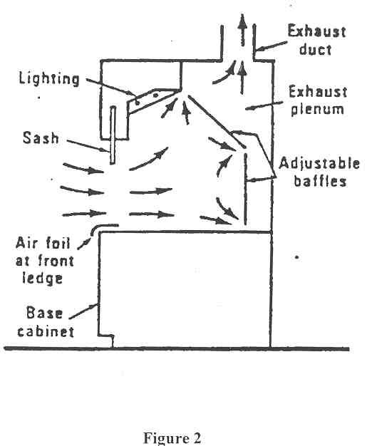

Diagram of a Standard Fume Hood

*Bypass Fume Hoods*

Bypass fume hoods are also constant air volume hoods, but with an improved design. These hoods are designed with a grille-covered opening above the sash. When opened, the sash blocks the grille and does not allow air through. However, as the sash is lowered, air is drawn through the grille, allowing a constant exhaust volume without increasing the velocity of air at the face of the hood. This design helps keep the room ventilation system balanced and helps eliminate the problems with turbulence that high face velocity can cause.

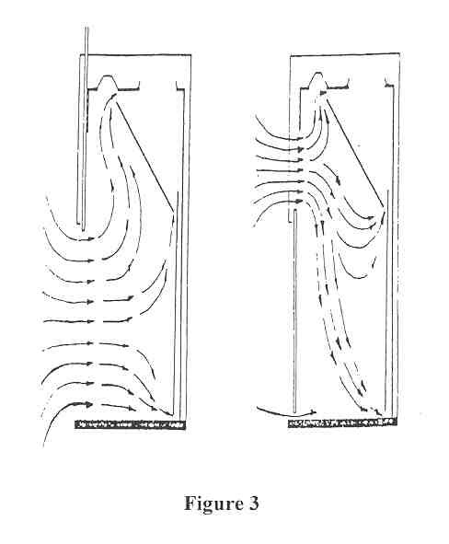

Diagram of a Bypass Fume Hood

(Left – with sash open; Right – with sash lowered)

*Auxiliary Air Fume Hoods*

Auxiliary air fume hoods are also known as "supplied air" or “make-up air” hoods. They use an outside air supply for 50% to 70% of the hood's exhaust requirements. This type of hood is designed to reduce utility costs and conserve energy by reducing the amount of conditioned room air that is pulled through the hood. One disadvantage, however, is that additional ductwork and fans increase the overall cost of these hoods. Also, if the supplied air is tempered, the energy savings is negated, while if it is not tempered, the user may be working under hot or cold air, depending on the season. Untempered air may also cause condensation in the hood, which can lead to rusting of the hood. The face velocity of an auxiliary air fume hood may vary.

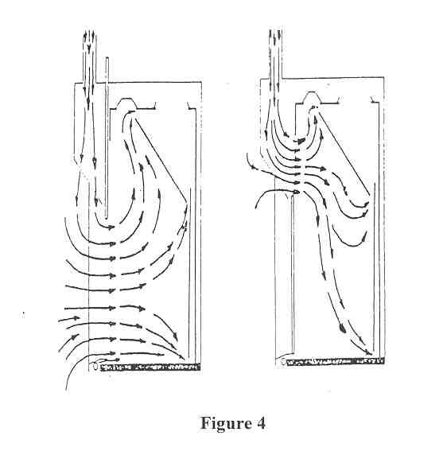

Diagram of an Auxiliary Air Fume Hood

(Left – with sash open; Right – with sash lowered)

*Variable Air Volume Fume Hoods*

Just as their name suggests, variable air volume (VAV) hoods are designed to vary the amount of air being exhausted from the fume hood based on the sash position. By varying the exhausted air, these hoods are able to maintain a constant face velocity, no matter where the sash is positioned. VAV hoods are often equipped with an audio/visual alarm to notify the user if the hood is not operating properly.

*Special Fume Hoods*

Special fume hoods are necessary when working with certain chemicals and operations. Examples of special fume hoods include the following:

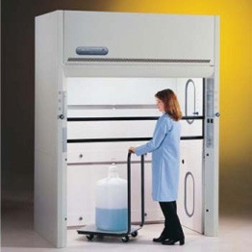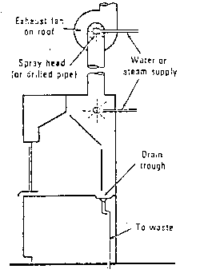**Perchloric acid fume hoods:** Anyone working with perchloric acid must use a perchloric acid fume hood. These special fume hoods are equipped with a water spray system to wash down the entire length of the exhaust duct, the baffle, and the wall of the hood. Perchloric acid vapors can condense on the hood ductwork, forming dangerous, explosive metal perchlorates. Also, perchloric acid can react with organic materials to form organic perchlorates, which are also explosive. For this reason, organic solvents should *never* be used or stored in a perchloric acid fume hood, and the hood should be labeled “Perchloric Acid Use Only; No Organic Chemicals”. The water wash down system, used periodically or after each use of the hood, removes any perchlorates or organic materials that may have accumulated in the hood exhaust system. The wash down system should be activated *only* when the exhaust fan has been turned off, so that complete coverage can be achieved.

**Walk-in hoods:** These fume hoods have single vertical sashes or double vertical sashes and an opening that extends to the floor. These hoods are typically used to accommodate large pieces of equipment.

**Radioisotope hoods:** These hoods are labeled for use with radioactive materials. The interiors of these hoods are resistant to decontaminating chemicals. These hoods are also often equipped with High Efficiency Particulate Air (HEPA) filtration.

**Ductless hoods:** Ductless hoods are designed with a filtration system. However, the filters are not appropriate for use with all chemicals. Also, it is difficult to know when the filters need to be replaced, even if a strict change-out schedule is followed. TAMIU and EH&S do NOT approve of ductless fume hoods.

**Fume Hood Safety Considerations**

The potential for glass breakage, spills, fires, and explosions is great within a fume hood. To ensure safety and proper fume hood performance, follow these guidelines:

* 1. Know how to properly operate a fume hood before beginning work.
  2. Fume hoods provide the best protection when the fume hood sash is in the closed position.
  3. Inspect the fume hood before starting each operation, including any airflow monitors. Do not use the hood if it is not functioning properly; call EH&S to have it checked.
  4. Keep traffic in front of the fume hood to a minimum and walk slowly when passing by the hood, especially when work is being conducted in the hood. This will reduce the likelihood of creating turbulence in the hood.
  5. Use the appropriate type of hood for the work being conducted. For example, when using perchloric acid, use a perchloric acid fume hood.
  6. Keep the area in front of the hood clear of obstructions. This will allow room for laboratory workers to move about and will allow sufficient airflow to the hood.
  7. Place equipment and chemicals at least six inches behind the fume hood sash. This practice reduces the chance of exposure to hazardous vapors.
  8. Do not allow equipment and chemicals to block baffle openings. Blocking these openings will prevent the hood from operating properly.
  9. Keep loose paper out of the fume hood. Paper or other debris that enter the exhaust duct of the hood can interfere with the hood’s ventilation.
  10. Do not store excess chemicals or equipment in fume hoods.
  11. Elevate any large equipment within the hood at least three inches to allow proper ventilation under the equipment.
  12. When working in a fume hood, set the sash at the lowest working height, about 12 – 15 inches from the base of the hood opening. Close the sash completely when no one is standing at the hood working in it. The only time the sash should be completely open is while setting up equipment.

***IMPORTANT: A*** *fume hood’s sash is designed to protect the user from dangerous chemical gases and vapors, chemical splashes and potentially flying debris. The sash should be positioned to protect the user’s face, neck and upper body. The lower the sash position, the more area of the user’s body will be protected.*

* 1. Do not defeat sash stops by removing them or altering their design or function.
  2. Wear personal protective equipment, including protective eyewear, as appropriate. The hood does not replace PPE.
  3. Keep laboratory doors closed. Laboratory ventilation systems are designed to operate with the doors closed.
  4. Do not alter/modify the fume hood or associated duct work. If additional equipment needs to be ventilated, contact EH&S for an evaluation.
  5. Clean up spills in the hood immediately*.*

***IMPORTANT:*** *If a power failure or other emergency occurs (e.g., building fire or fire within the fume hood), close the fume hood sash and ensure safe shutdown of the lab, paying special attention to equipment that may be reenergized when power is restored.*

**Fume Hood Inspections**

Fume hoods should and will be tested at least annually. Recertification by a third-party contractor will be coordinated by EH&S. Fume hoods should also be tested in the following circumstances:

* When an employee requests an inspection.
* After major repair work.
* After a fume hood is moved.

Fume hood testing includes measuring the velocity of airflow through the face of the hood as well as a general inspection of the hood’s condition (sash, lighting, noise level, etc.). If you suspect a problem with your fume hood, contact Environmental Health & Safety.

*2.2 OTHER LABORATORY VENTILATION SYSTEMS*

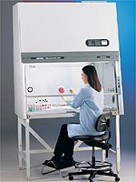**Biological Safety Cabinets (BSCs)**

BSCs provide containment for pathogenic materials and are not intended for use as a chemical fume hood. When used and maintained correctly, Class II biosafety cabinets protect the user from exposure to harmful biological agents and also protect the product from contamination by filtering the air inside the cabinet through High Efficiency Particulate Air (HEPA) filters. Before using a biological safety cabinet, laboratory personnel should be thoroughly trained on how to properly use and maintain the cabinet.

Follow these instructions for safe use of a biological safety cabinet:

* 1. Only biosafety cabinets that are certified according to National Sanitation Foundation (NSF) Standard # 49 may be used with pathogenic or recombinant DNA materials. BSCs must be certified upon installation, upon being moved, after major repair, and at least annually.

1. EH&S contracts with a company to certify and service BSCs. Contact EH&S for more information.
2. BSCs that are not certified annually or that fail certification will be tagged “Not Safe For Use with Pathogens.”
   1. Locate biosafety cabinets away from doorways and high traffic areas. As with chemical fume hoods, rapid movement in or near the cabinet can create turbulence, causing contaminants to be drawn out of the cabinet and into the general laboratory area.
   2. Restrict entry into the laboratory when work is being conducted in the BSC.
   3. Turn off UV lights before beginning work in a BSC.
   4. Disinfect the biosafety cabinet prior to beginning and after completing work in the cabinet.
   5. Allow the cabinet to operate without activity at least 15-20 minutes before and after use. This will allow all the air in the cabinet to circulate through the HEPA filters, removing any contaminants that may be present.
   6. Keep the BSC clear of clutter and loose paper. Only place items that are needed in the cabinet.
   7. Keep clean items and dirty items segregated in the BSC.
   8. Provide a waste container inside of the cabinet and keep it covered.
   9. Always wear appropriate personal protective equipment.
   10. Keep face away from the BSC opening.
   11. Never use a Bunsen burner in a biosafety cabinet. Dangerous levels of gas can build up in the cabinet. Also, heat from the open flame can damage the HEPA filters.
   12. Clean up spills in the BSC immediately.

**Canopy Hoods**

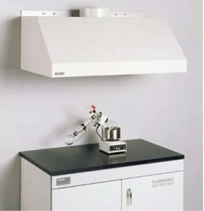

These hoods capture upward moving contaminants and are good for heat- producing operations only. Canopy hoods should not be used as chemical fume hoods, as workers may be exposed to contaminants if they work under the hood.

**Glove Boxes**

Glove boxes are designed to be leak-tight and can be used with highly toxic or air-reactive chemicals and materials. Some glove boxes may also be appropriate for use with some radioactive materials. The leak-tight design provides a controlled atmosphere, protecting both the product and the worker by preventing vapors/moisture, gases, and particulates from entering or leaving the box.

**Laminar Flow Hoods**

Also known as clean benches, laminar flow hoods provide a continuous flow of HEPA filtered air across the work surface. This design helps prevent contamination of the product, but does not offer any protection to the worker. Laminar flow hoods should only be used with non-hazardous materials.

**Snorkel Hoods**

Snorkel hoods are small fume exhaust duct connections. They are designed with flexible ducts and are able to be positioned directly over a work area at the bench. For best performance, the snorkel hood should be placed within six inches of the item needing ventilation. Snorkel hoods should *only* be used to exhaust heat and nuisance odors. They should never be used with highly toxic or flammable chemicals.

**SECTION 3: PERSONAL PROTECTIVE EQUIPMENT**

Personal Protective Equipment (PPE) includes all clothing and work accessories designed to protect employees from workplace hazards. Protective equipment should not replace engineering, administrative, or procedural controls for safety – it should be used in conjunction with these controls. Employees *must* wear protective equipment as required and when instructed by a supervisor.

***IMPORTANT:*** *Personal protective equipment is used to prevent exposure or contamination. PPE should always be removed before coming in contact with other individuals or before going in or near elevators, break rooms, classrooms, bathrooms, etc*.

*3.1 ARM AND HAND PROTECTION*

Arms and hands are vulnerable to cuts, punctures, burns, bruises, electrical shock, chemical spills, and amputation. Forms of hand protection available to employees include but are not limited to:

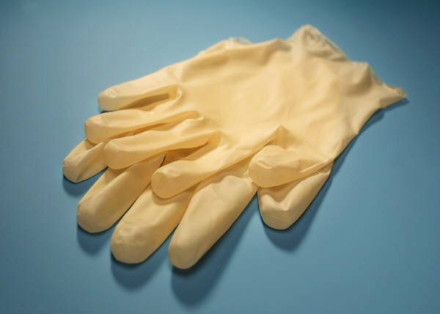

* Disposable exam gloves
* Chemical resistant gloves (rubber, nitrile, neoprene, etc.)
* Non-asbestos heat-resistant gloves
* Metal-mesh gloves for meat cutters
* Kevlar or Dynema gloves for cut resistance
* Bite-resistant gloves

Always wear the appropriate hand and arm protection. Double your hand protection by wearing multiple gloves when necessary (e.g., two pairs of disposable gloves for work involving biological hazards). For arm protection, wear a long-sleeved shirt, a laboratory coat, chemical-resistant sleeves, or gauntlet-length gloves.

Follow these guidelines to ensure arm and hand safety:

1. Inspect and test new gloves for defects.
2. Always wash your hands before and after using gloves.
3. Wash reusable chemical-protective gloves with soap and water before removing them.
4. Do not reuse disposable gloves. Turn disposable gloves inside-out as you remove them to avoid contaminating your hands.
5. Do not wear gloves near moving machinery; the gloves may become caught.
6. Do not wear gloves with metal parts near electrical equipment.

***IMPORTANT:*** *Gloves are easily contaminated. Avoid touching surfaces such as telephones, door knobs, etc. when wearing gloves.*

*3.2 BODY PROTECTION*

Hazards that threaten the torso tend to threaten the entire body. A variety of protective clothing, including laboratory coats, long pants, rubber aprons, coveralls, and disposable body suits are available for specific work conditions, including the following:

* Rubber, neoprene, and plastic clothing protect employees from most acids and chemical splashes.
* Laboratory coats, coveralls, and disposable body suits protect employees and everyday clothing from contamination by chemicals, biological materials, dirt and grime, etc.
* Welding aprons provide protection from sparks.
* Chain mail aprons provide protection for meat cutters.

Launder reusable protective clothing separate from other clothing.

*3.3 HEARING CONSERVATION*

If you work in a high noise area, preventing hearing loss is of utmost importance. Whenever possible, attempts should be made to control noise levels through engineering controls or operational changes before resorting to hearing protection. Equipment that is operating loudly than usual may just need maintenance. Also, installing noise attenuating devices in an inherently noisy environment may alleviate noise levels. If, however, the noise level cannot be controlled sufficiently, hearing protection should be employed.

If you suspect that your laboratory environment exceeds acceptable noise levels, contact EH&S for help. EH&S has instruments for measuring decibel levels and can make recommendations on possible ways to reduce the noise level or on types of hearing protection that would be appropriate for the situation.

*3.4 EYE AND FACE PROTECTION*

Employees must wear protection if hazards exist that could cause eye or face injury. Eye and face protection should be used in conjunction with equipment guards, engineering controls, and safe practices.

***NOTE:*** *Unless it is documented that there is no potential for eye injury to occur, safety glasses are required in laboratories. Chemical splash goggles should be worn when handling chemical materials.*

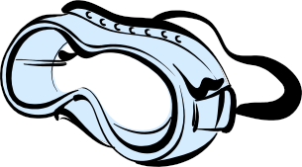Always wear adequate eye and face protection when performing tasks such as grinding, buffing, welding, chipping, cutting, pouring chemicals or pipetting. Safety glasses or goggles should be worn in case of impact hazard. Chemical splash goggles provide the most effective eye protection against chemical splashes as well as protection against impact.

Follow the information below regarding eye protection:

1. If you wear prescription glasses, goggles or other safety protection should be worn over the glasses.
2. Safety glasses with side-shields provide protection to eyes and are four times as resistant as prescription glasses to impact injuries.
3. Goggles protect against impacts, sparks, chemical splashes, dust, etc, but not all goggles provide the same type of protection. There are specific goggles for:
   * 1. Wood-working or other impact hazards
4. Chemical splash hazards
5. Laser hazards
6. UV hazards
7. Welding hazards
8. A face shield is designed to protect the face from some splashes or projectiles, but does not eliminate exposure to vapors.

***NOTE:*** *Goggles or safety glasses with side shields must be worn under a face shield.*

*3.5 FOOT PROTECTION*

To protect feet and legs from falling objects, moving machinery, sharp objects, hot materials, chemicals, or slippery surfaces, employees should wear closed-toed shoes, boots, foot-guards, leggings, or safety shoes as appropriate. Safety shoes are designed to protect people from the most common causes of foot injuries — impact, compression, and puncture. Foot protection is particularly important in laboratory work.

***IMPORTANT:*** *Do not wear sandals, open-toed shoes, open-backed shoes, or* *Crocs in laboratories, shops, or other potentially hazardous areas.*

Chemically resistant shoes may be necessary when working with certain materials, such as corrosives. Special foot protection is also available for protection against static electricity, sparks, live electricity, and slipping. For more information on specialty foot protection, contact EH&S.

*3.6 HEAD PROTECTION*

Accidents that cause head injuries are difficult to anticipate or control. With some exceptions, head protection is generally not needed in a laboratory environment. However, if hazards exist in the laboratory that could cause head injury, employees should try to eliminate the hazards, but they should also wear head protection.

*3.7 RESPIRATORY PROTECTION PROGRAM*

TAMIU uses engineering, administrative, and procedural controls to protect people from dangerous atmospheres, including harmful mists, smoke, vapors, oxygen deficient environments, and animal dander. When these controls cannot provide adequate protection, respiratory protection may be necessary.

People who use respiratory protection must be physically capable of using and wearing the equipment. In some cases, a physician must determine if an employee is healthy enough to use a respirator. In addition, *all* people required to wear respirators must be formally trained and instructed in proper equipment usage.

Choosing the right respirator for the job is equally important to knowing how to use it. There are many types of respirators, and each type protects against different hazards. EH&S will help individuals select the best respirator for their needs.

***IMPORTANT:*** *Respirators are available in different sizes. Always fit test a respirator to select the correct size.*

Environmental Health & Safety can provide training and fit testing for personnel who need respiratory protection.

This manual was reproduced with the special permission of the department of Environmental Health & Safety in Texas A&M University.