The Attendees Panel
In Collaborate with the Ultra Experience
The Attendees Panel provides a list of all Participants, Presenters and Moderators in the session. This panel can be viewed by clicking on the Attendee icon located in the Collaborate Panel. This icon displays the number of current session attendees and will dynamically adjust as attendees enter and leave the session.

Understanding the Attendees Panel
Use the screenshot of the Attendees Panel to the right to explore its functionality.
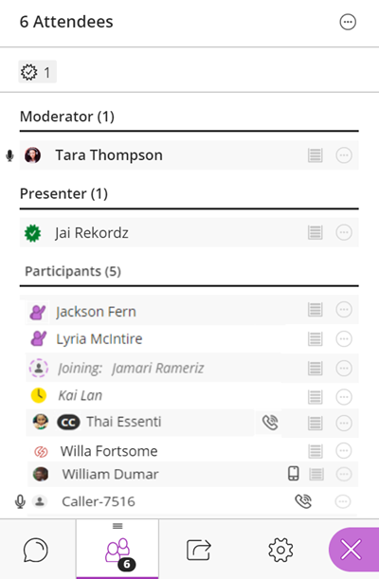
- Kai has stepped away. This is demonstrated by the yellow clock displayed on his profile picture.
- Jackson and Lyria have both raised their hands. We know Jackson did so first because his name displays first in the Attendees list.
- Tara and Caller-7516 have their audio transmission enabled. When transmitting audio, a microphone displays next to a user’s name in the Attendees Panel. Tara is speaking. Her microphone displayed as full indicating audio input is detected. The Caller’s microphone icon is empty, indicating that while his audio is turned on, the mic is not transmitting sound. He could have muted his phone for example.
- William has joined via a mobile device. We know this because of the mobile icon that displays next to his name.
- Jai has been promoted to presenter. With presenter rights, Jai can upload, share, and annotate content. By sharing content, Jai can effectively stop any sharing currently in progress by other moderators/presenters.
- Someone has joined using anonymous dial-in telephony, as indicated by the Caller-7516 user with a phone icon next to his name.
- Jamari is in the process of joining the session. He is not yet fully connected as is evident by the purple dashed circle around his profile avatar.
- Jai agrees with what is being said. We know this because of the green check mark that has replaced her profile picture
- Thai has been promoted to captioner. The CC by her name let’s us know this.
- William has joined the session via mobile devise as indicated by the icon next to his name.
- Willia’s connection has been flagged as unresponsive by the system and Collaborate will being reconnecting within 20 seconds.

Detaching the Attendees Panel
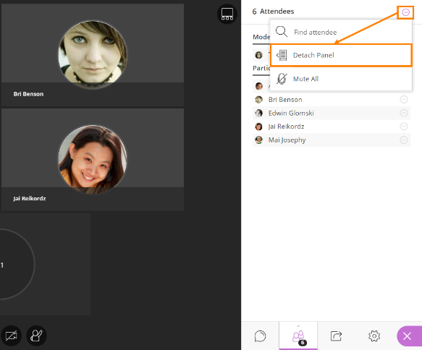
Also available is the ability to detach the Attendees Panel, allowing users to leave the Attendees Panel open while chatting with other users, accessing share content features and my settings. There are two ways to detach the Attendees Panel.

More Options
Users can open the Collaborate panel and select Attendees. Select More options at the top of the panel and select Detach Panel from the options that appear. Any video, content, whiteboard and application shared are moved to the left to make room for the panel.

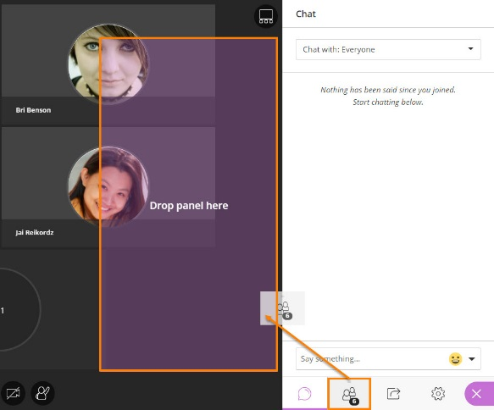
Drag and Drop
With the Collaborate panel open, users can also drag-and-drop the Attendees icon to the Media Space. A bounding box appears in the Media Space dynamically adjusting the displayed content so you can still see everything.

When detached, the Attendees Panel functions just as it does when part of the Collaborate Panel tools. From here, moderators can still manage session attendees, individually, or as a whole, see raised hand, away, telephony, and network indicators, access Attendee Controls to promote/demote roles, remove attendees and mute active audio transmissions, and access the More options ellipsis.

Your browser remembers where you last placed the Attendees Panel is and keeps it there for next time.

The detached panel can be closed at any time by selecting the More options ellipsis at the top of the panel and selecting Merge Panel or by dragging and dropping the detached panel back on to the Collaborate Panel.
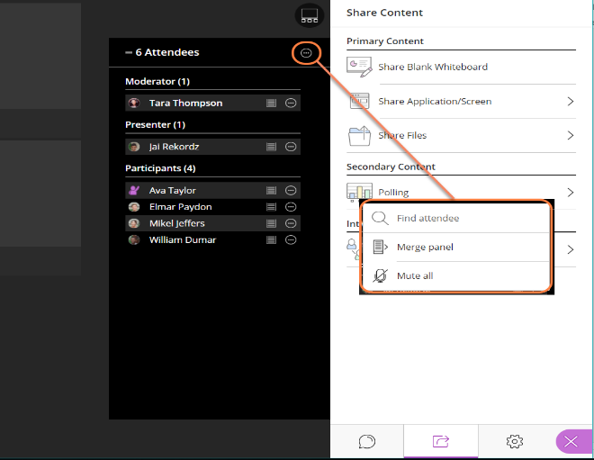

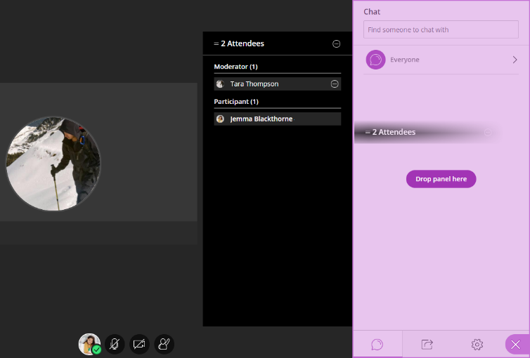
Managing Participants

Understanding Roles
Moderators use the Attendee Controls to promote and demote elevated roles, lower raised hands, and remove attendees from the session. When elevating attendees to Moderator, keep in mind that these participants will then be able to promote and demote other users, and remove session attendees as well. The primary Moderator, the moderator of record for the session, cannot be removed by anyone and maintains ultimate authority over all attendees.
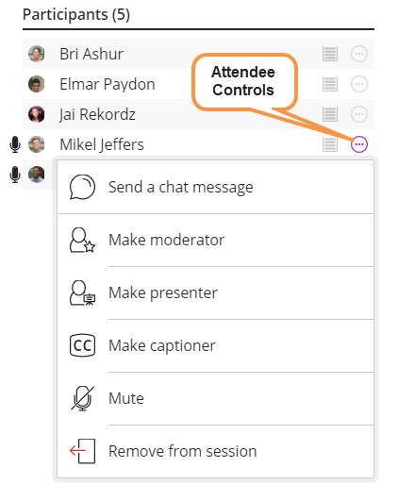
- Moderators have full control over the content being shared and can end a presenter’s or another moderator’s content share. Moderators also have the ability to enable or disable session and notification settings.
- Presenters can upload, share, and annotate content. By sharing content, presenters can effectively stop any sharing currently in progress by other moderators/presenters.
- Participants have the ability to enable and disable visual and audio notification related to participants entering and leaving the room as well as chat posts.
- Captioners type what is being said during a session. Other participants can view what is being typed in real time. You can have multiple captioners at a time if desired.

Raised Hands
When a participant raises their hand, an icon appears next to their name in the Attendees Panel and their name is moved to the top of the Participant’s section of the Attendee list so they are easily seen. As hands are lowered, these participants return to their alphabetical placement within the list. When more than one hand is raised, a number will appear on each hand indicating where they are in the queue (the order in which hands were raised).
To lower a participant’s hand:
- Click the icon to expand the Attendee Controls.
- Select Lower hand.

User Connectivity Indicators
Users can tell at a glance of the Attendees Panel who in the session might be having trouble connecting. Indicators have been added that tell you when someone is in the process of joining your session, if users are connected, how their connection is, and who is using telephony.
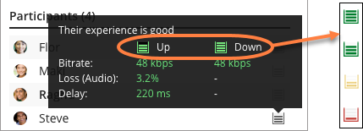
To view a user’s connectivity status, hover over their network indicator in the Attendees Panel.

