Editing a SMARTS/GENIUS PROFILE

Step 1: Log on to www.infoed.org

Step 2: If you are working from off-campus, input TAMIU’s Username: spininternational and Password: spintexas

Step 3: Click on Genius at the top of your screen.

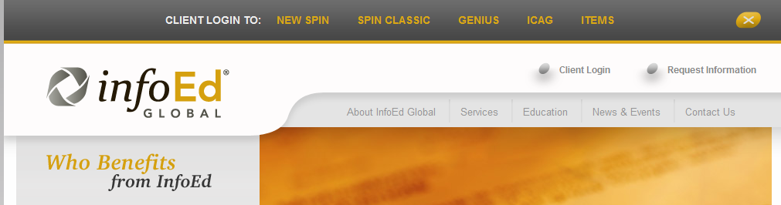

Step 4: Click on the Edit Existing Profile link on the top of the page.

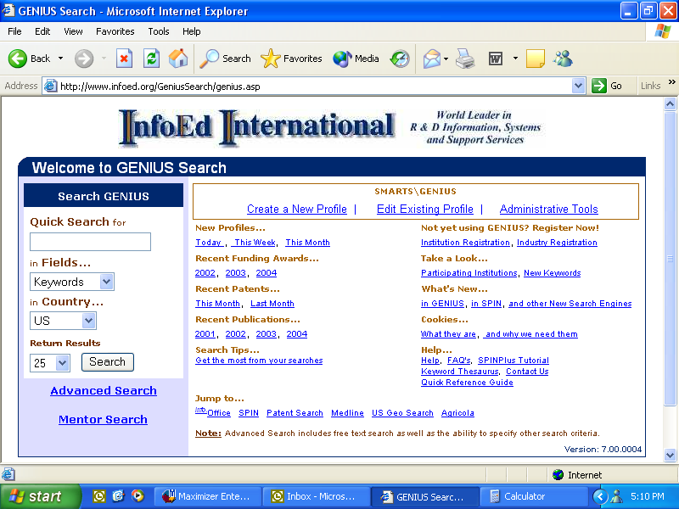

Step 5: You will be taken to this page below where you will click on General.
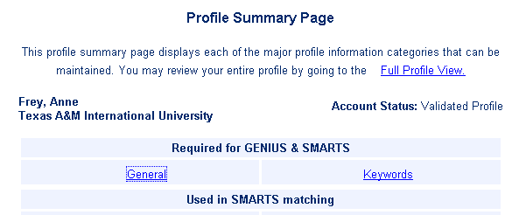

Step 6: This page is where you will make any edits to your profile.

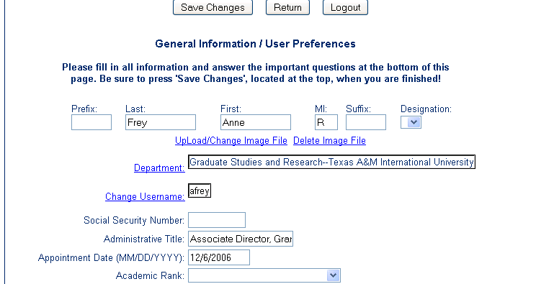

Don’t forget to save any changes you have made.
For questions call the Office of Research and Sponsored Projects at 326-3028 or send an email to celeste.kidd@tamiu.edu during normal office hours.
For InfoEd Technical Support call 1-800-727-6427.

